485 Rain and Sonw Sensor
Instuction Manual
JXBS-3001-YX
Ver1.2

PRODUCT BRIEF INTRODUCTION

Product Overview
Rain and snow sensors are mainly used to detect whether there is rain or snow in nature. The sensor adopts AC impedance measurement method, the electrode has a long service life, and there will be no oxidation problems. The rain and snow sensor can be widely used in the qualitative measurement of the presence or absence of rain and snow in the environment, greenhouses, breeding, construction, buildings, etc. It is safe and reliable, beautiful in appearance, and easy to install.

Functions and Features
Adopting AC impedance measurement form, the AC impedance method can effectively prevent the electrode from oxidizing and electrolyzing, and greatly improve the service life. The rain and snow measurement results are accurate, and the false alarm rate is almost zero.
Optional heating function. When the temperature is low, the snow heating function is automatically activated to accelerate the removal of snow and ice, and the measurement rate is accelerated.

Main Parameters
Parameters | Content
DC power supply | 12V-24V DC
Output signal | RS485 output/switch output
Switch type | Normally open contact
Detection object | Rain and snow and other precipitation weather
Power consumption | ≤0.15W(@12V DC , 25℃)  ≤2.5W(@Heating state)
Working environment | -20℃-60℃ 0-95%RH
Switching power | 120VAC/24VDC
Heating function on temperature | 10℃

System Framework Diagram
This sensor can be connected and used alone. First, use a 12V DC power supply. The device can be directly connected to a PLC with a 485 interface, and it can be connected to a single-chip computer through a 485 interface chip. The single-chip microcomputer and PLC can be programmed through the modbus protocol specified later to cooperate with the sensor. At the same time, use USB to 485 to connect to the computer, and use the sensor configuration tool provided by our company for configuration and testing.
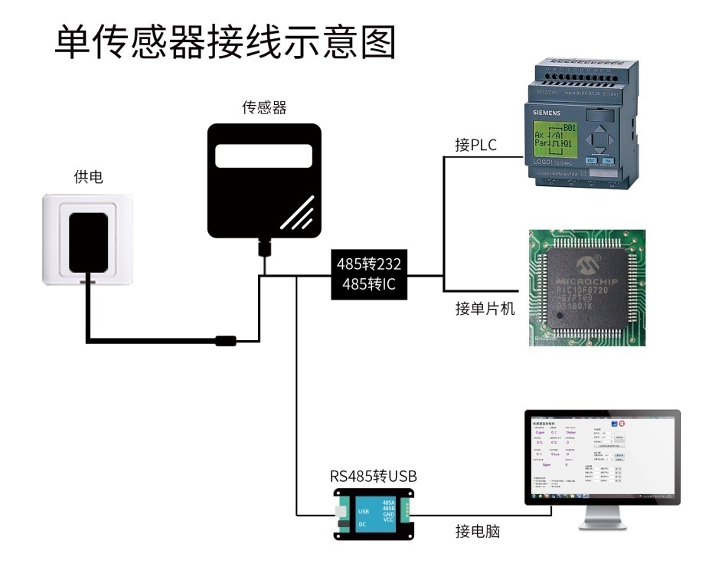
This product can also be used by combining multiple sensors on a single 485 bus. Please follow the "485 bus field wiring rules" (see appendix) when performing 485 bus combination. In theory, one bus can be connected to more than 16 485 sensors. If you need to connect more 485 sensors, you can use a 485 repeater to expand more 485 devices, and the other end is connected to a PLC with a 485 interface through a 485 interface chip. Connect the single-chip microcomputer, or use USB to 485 to connect to the computer, and use the sensor configuration tool provided by our company for configuration and testing.
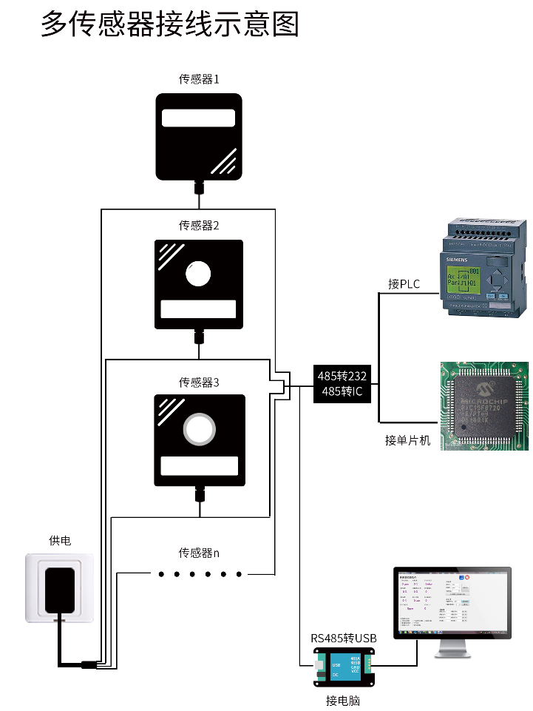

HARDWARE CONNECTION

Check Before Equipment Installing
Please check the equipment list before installing the equipment:
Name | Quantity
High precision sensor | 1
12V waterproof power supply | 1(optional)
USB to 485 device | 1(optional)
Warranty card/certificate | 1

Interfase Description
The power interface is a wide-voltage power input that can be 12-24V. When wiring the 485 signal wire, pay attention to the two wires A and B not reversed, and the addresses of multiple devices on the bus cannot conflict.
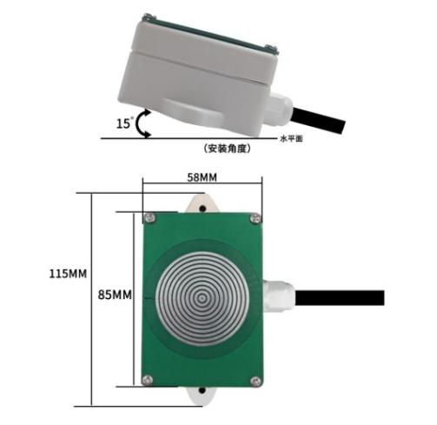
485/switch type rain and snow
 | Wire  color | Description
Power supply | Brown | Positive power supply (12-24VDC)
 | Black | Negative power
Communication | Yellow | 485-A/switch quantity
 | Blue | 485-B/switch quantity
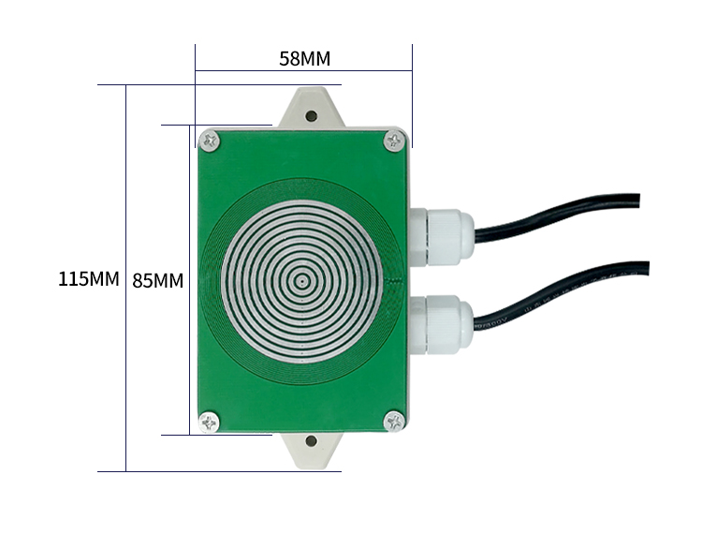
1
2
485+ switch type rain and snow
(1: Switch quantity 2: 485)
 | Wire color | Description
Power supply | Brown | Positive power(12-24VDC)
 | Black | Negative power
communication | Yellow | 485-A
 | Blue | 485-B
Switch quantity | Yellow | Switch quantity
 | Blue | Switch quantity

Note: Please be careful not to connect the wrong wiring sequence, the wrong wiring will cause the equipment to burn.
The power of the switch is small. If you need to connect power devices, please connect the intermediate relay. For details, please refer to the additional manual.
The factory default provides 0.6 meters long wire, customers can extend the wire as needed or wire in order.
Note that there is no yellow line in the line sequence that may be provided in some factory batches. At this time, the gray line is equivalent to replace the yellow line.

Installation Matters
In order to avoid long-term water accumulation during equipment installation, the installation should have a certain inclination angle, generally about 15°, and the installation method can be installed with expansion screws. The specific dimensions are shown below:

Automatic Heating
The default setting of the system is to turn on automatic heating at 10°C. Only when there is rain or snow, the automatic heating is turned on, otherwise the automatic heating function will not be turned on.
In order to interfere with insects above 10°C, automatic heating is not turned on by default.

CONFIGURATION SOFTWARE INSTALLATION AND USAGE
Our company provides supporting "sensor monitoring software", which can easily use the computer to read the sensor parameters, and flexibly modify the device ID and address of the sensor.

Connect the Sensor to the Computer
After connecting the sensor to the computer through USB to 485 and providing power supply, you can see the correct COM port in the computer (check the COM port in "My Computer-Properties-Device Manager-Port").
As shown in the figure above, your serial port number is COM10 at this time, please remember this serial port, you need to fill in this serial port number in the sensor monitoring software.
If the COM port is not found in the device manager, it means that you have not inserted the USB to 485 or the driver has not been installed correctly, please contact a technician for help.

Use of Sensor Monitoring Software
The configuration interface is as shown in the figure. First, obtain the serial port number and select the correct serial port according to the method in chapter 3.1, and then click to automatically obtain the current baud rate and address to automatically detect all devices and baud rates on the current 485 bus . Please note that you need to ensure that there is only one sensor on the 485 bus when using the software to automatically obtain it.
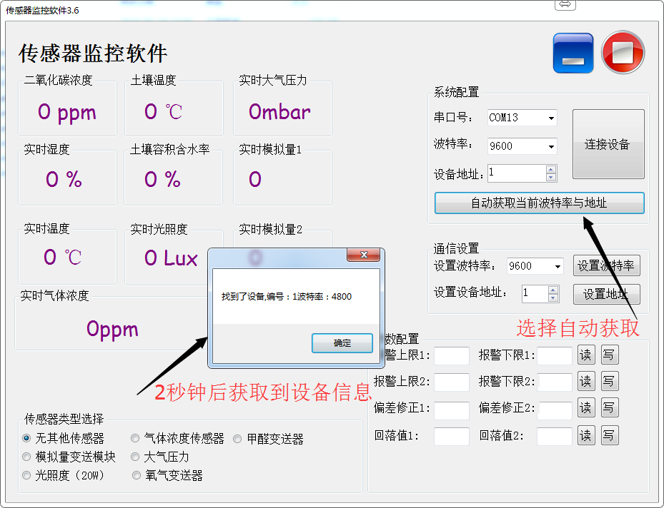
Then click to connect the device to get the sensor data information in real time.
If your device is a gas concentration sensor, please select "gas concentration sensor" in the sensor type, "formaldehyde transmitter" for formaldehyde sensor, "analog transmitter module" for analog transmitter, and "atmospheric pressure" for atmospheric pressure sensor Sensor", select "Illuminance 20W" for illuminance sensor, select "Oxygen transmitter" for oxygen sensor, select the default "No other sensor" for other sensors.

Modify the Baud Rate and Device ID
When the device is disconnected, click the device baud rate and set address in the communication settings to complete the related settings. Please note that after setting, please restart the device, and then "automatically obtain the current baud rate and address" to find the address And the baud rate has been changed to the address and baud rate you need.
If you need to use modbus commands to modify the baud rate and address, you can refer to the appendix "How to use modbus commands to modify the baud rate and address".

COMMUNICATION PROTOCOL

Basic Communication Parameters
Parameters | Content
Coding | 8-bit binary
Data bit | 8-bit
Parity bit | Naught
Stop bit | 1 bit
Error calibration | CRC lengthy cyclic code
Baud rate | 2400bps/4800bps/9600bps can be set, the factory default is 9600bps
Coding | 8-bit binary

Data Frame Format Definition
Using Modbus-RTU communication protocol, the format is as follows:
Time for initial structure ≥ 4 bytes
Address code = 1 byte
Function code = 1 byte
Data area = N bytes
Error check = 16-bit CRC code
Time to end structure ≥ 4 bytes
Address code: It is the function indicator of the transmitter. This transmitter only uses the function code 0x03 (read register data).
Data area: The data area is a specific address, which is unique in the communication network (factory default 0x01).
Function code: command communication data sent by the host, pay attention to the 16bits data high byte first!
CRC code: two-byte check code.
Interrogation frame
Check code  Low bit | Address code | Function code | Register  initial address | Register length | Check code  High bit
1byte | 1byte | 1byte | 2 bytes | 2 bytes | 1 bytes
Reply frame
Address code | Function code | Effective bytes | First data area | Second data area | Nth data area
1byte | 1byte | 2 bytes | 2 bytes | 2 bytes | 2 bytes

Register Address
Register address | PLC configuration address | Content | operating
0010H | 40011 | Check whether it is raining (1 means rain occurs, 0 means normal) | Read only
0100H | 40101 | Device address (0-252) | Read and write
0101H | 40102 | Baud rate (2400/4800/9600) | Read and write

Communication Protocol Example and Explanation
Interrogation frame
Address code | Function code | Initial address | Data length | Check code low bit | Check code high bit
0x01 | 0x03 | 0x00 0x10 | 0x00 0x01 | 0x85 | 0xcf
Response frame (for example, when rain is read)
Address code | Function code | Returns the number of valid bytes | Data area | Check code low bit | Check code high bit
0x01 | 0x03 | 0x02 | 0x00 0x01 | 0xB8 | 0x9A
Rain conditions:
0001 H (hexadecimal) = rain has occurred

APPENDIX
485 Device Field Wiring Manual: Describes the wiring guidelines for 485 products, please check and follow the guidelines, otherwise it may cause unstable communication.
Revision of temperature and humidity deviation of 485 sensor: describes how to confirm and adjust temperature and humidity deviation when you feel that there is a deviation in temperature and humidity.
Using modbus to modify device baud rate and address: describes if you do not use software, use modbus commands to modify the baud rate and slave station number.
How to use single-chip microcomputer for 485 communication: describes how to use 51 single-chip microcomputer to read sensor information, and popularize some basic knowledge.
How to calculate CRC16: Describes how to calculate CRC16 in modbus RTU protocol and an example C language program.
How to use and set the product alarm function: Describes the optional product alarm function, how to use it, how to wire and other issues.

Warranty and After-sales
The warranty clauses follow the sensor after-sales clauses of Weihai Jingxun Changtong Electronic Technology Co., Ltd., two years for the sensor host circuit part, one year for gas-sensitive probes, and three months for accessories (housing/plug/cable, etc.)

