INSTRUCTION MANUAL
Explosion-proof methane sensor
JXBS-4001-CH₄
VER1.0

WeihaiJXCTElectronicTechnologyCo.,Ltd.

Ⅰ Brief Introduction
1.1 Product Overview
The explosion-proof methane sensor adopts the professional test methane concentration sensor probe as the core detection device, which has the characteristics of wide measuring range, high precision, good linearity, good generality, convenient use, easy installation, long transmission distance and moderate price.
1.2 Primary Parameters
PARAMETERS | TECHNICAL SPECIFICATIONS
MEASUREMENT RANGE | 0-100%LEL
MEASURING MODE | Catalytic combustion
CH₄ ACCURACY | 3%F.s
TIMEWARRANTY PERIOD | 2 years ( Host ) / 1 year ( Sensor )
RESPONSE | less than 15 seconds
BAUD RATE | 2400/4800/9600
COMMUNICATION PORT | RS485
POWER SUPPLY | Bus-powered,12-24VDC
POWER CONSUMPTION | ≤1.5W（@12V DC , 25℃）
OPERATING TEMPERATURE | 0-50℃
WORKING HUMIDITY ENVIRONMENT | 15-90% RH （no condensation)
CASE SIZE | 172×142×90mm³
EXPLOSION-PROOF GRADE | Exd ⅡCT6

Ⅱ Hardware Connections
2.1 CHECKING BEFORE INSTALLATION
Check the list of devices before installation:
Name | Number
THE EXPLOSION-PROOF SENSOR DEVICE | 1
12V POWER ADAPTER | 1(Optional)
THE USB TO 485 DEVICE | 1(Optional)
WARRANTY CARD / CERTIFICATE | 1
2.2 Interface Description
Wide voltage power input can be 12-24V. When wiring the 485 signal line, pay attention that the two A / B lines cannot be reversed, and the addresses between multiple devices on the bus cannot conflict.
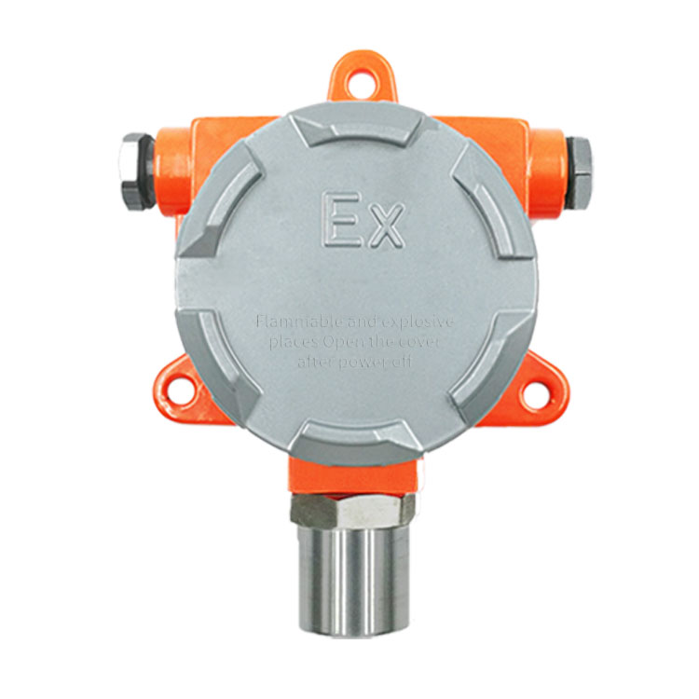
 | Line Color |  | Description
Power | Brown |  | Power supply Positive ( 12-24V DC )
 | Black |  | Power supply Negative
Communication | Yellow ( Gray ) |  | 485-A
 | Blue |  | 485-B
Factory by default to provide 0.6 meters long wire, customers can be on demand to extend the wire or according to the form sequential wiring.
2.3 Installation Description
The explosion-proof sensor is wall-mounted and can be fixed by three 8mm fixing holes. Customers can use expansion screws or bolts. The size and position of the fixing hole are as follows:
Please ensure the installation direction during installation.
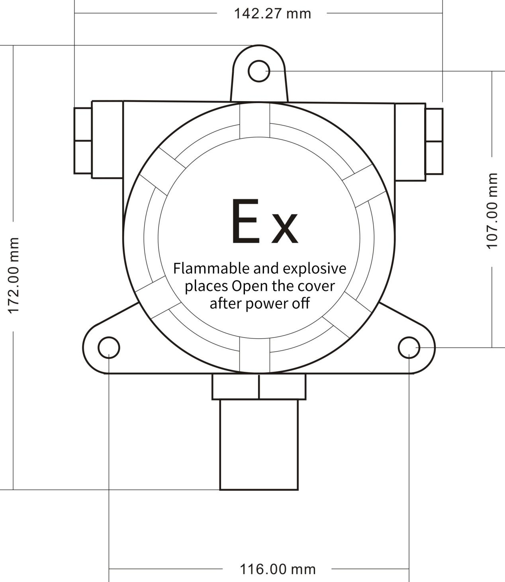
Without display sensor size and installation drawing
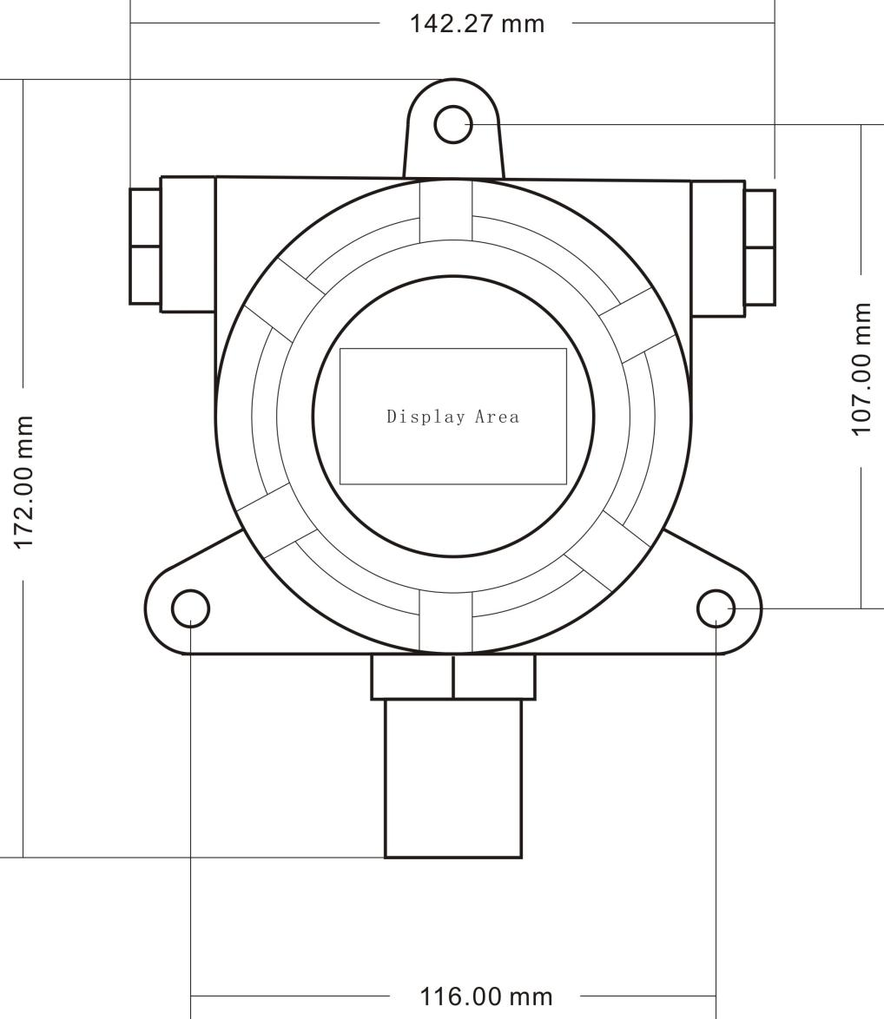
Sensor size and installation drawing with display window

Ⅲ Digital sensor communication protocol
3.1 Communication Basic Parameters
PARAMETERS | CONTENT
Coding | 8-bit binary
Data bits | 8 bit
Parity bit | No
Stop bit | 1 bit
Error checking | CRC (redundant loop code)
Baud rate | 2400 bps/ 4800 bps/ 9600 bps can be set factory defaults to 9600 bps
3.2 Data frame format definition
Modbus-RTU communication protocol is adopted, the format is as follows:
Time for initial structure ≥ 4 bytes
Address code = 1 byte
Function code = 1 byte
Data area = N bytes
Error check = 16-bit CRC
Time to end structure ≥ 4 bytes
Address code: It is the address of the transmitter and is unique in the communication network (factory default 0x01).
Function code: The function instruction of the command issued by the host, this transmitter only uses the function code 0x03 (reading register data).
Data area: The data area is the specific communication data. Note that the high byte of the 16bits data comes first!
CRC code: two-byte check code.
Inquiry frame
address code | function code | Register start address | Register length | Low check bit | Check code high
1 byte | 1 byte | 2 bytes | 2 bytes | 1 byte | 1 byte

Response frame
address code | function code | Number of valid bytes | Data area | Second data area | Nth data area
1 byte | 1 byte | 1 byte | 2 bytes | 2 bytes | 2 bytes
3.3 Register Address
Register Address | Plc Configuration Address | Content | Operation
0000H | 40001 | Temperature ( Unit 0.1℃) | Read-Only
0001H | 40002 | Humidity ( Unit 0.1%RH) | Read-Only
0006H | 40007 | Methane( unit 0.1%) | Read-Only
0100H | 40101 | Device Address (0-252) | R/W
0101H | 40102 | Baud Rate (2400/4800/9600) | R/W
3.4 Communication protocol examples and explanations
3.4.1 Read Device Address 0x01's methane Concentration
Inquiry Frame
Address Code | Function Code | Start Address | Data Length | CRC_L | CRC_H
0x01 | 0x03 | 0x00  0x06 | 0x00  0x01 | 0x64 | 0x0B
Answer Frames( For example, the reading is 0.02% )
Address Code | Function Code | Returns to The Number Of Valid Bytes | Methane Value | Check Digit Low | Check Digit High
0x01 | 0x03 | 0x02 | 0x00 0x02 | 0x39 | 0x85
Methane:
0x0002(hexadecimal)=2=> methane=0.02%
3.4.2 Read Device Address 0x01's Temperature And Humidity Value
Inquiry Frame
Address Code | Function Code | Start Address | Data Length | CRC_L | CRC_H
0x01 | 0x03 | 0x00,0x00 | 0x00,0x02 | 0xC4 | 0x0B
Answer Frame
Address Code | Function Code | Number Of Valid Bytes | Humidity Value | Temperature Value | CRC_L | CRC_H
0x01 | 0x03 | 0x04 | 0x02  0x92 | 0xFF  0x9B | 0x5A | 0x3D
Temperature：
When the temperature is lower than 0 ℃, upload it in two's complement form
FF9BH ( hexadecimal ) =-101=> Temperature =-10.1 ℃
Humidity：
0292H ( hexadecimal ) =658=> Humidity =65.8%RH
3.4.3 Read Device Address 0x01's Temperature And Humidity, methane Concentration Value
Inquiry Frame
Address Code | Function Code | Start Address | Data Length | CRC_L | CRC_H
0x01 | 0x03 | 0x00,0x00 | 0x00,0x07 | 0x04 | 0x08
Answer Frame
Address Code | Function Code | Number Of Valid Bytes | Humidity Value | Temperature Value
0x01 | 0x03 | 0x0E | 0x03  0x14 | 0x01  0x1B
8 Useless Bytes |  | Methane Value | CRC_L | CRC_H
0x00 ... |  | 0x00  0x28 | 0x50 | 0x3B
Temperature：
When the temperature is lower than 0 ℃, upload it in two's complement form
011B H ( hexadecimal ) =283=> Temperature =28.3 ℃
Humidity：
0314 H ( hexadecimal ) =788=> Humidity =78.8%RH
Methane:
0x28(hexadecimal)=40=>Methane=0.40%

IV Meaning and Conversion of Analog Sensor Parameters
4.1 Analog 4-20mA Current Output
Current Value | CH₄
4mA | 0%LEL
20mA | 100%LEL
Formula P _{(CH4)}=(I-4mA)*6.25%
where the unit of P is% and the unit of I is mA.
For example, the data collected in the current situation is 8.125 mA, and the value of CH₄ is calculated at 25.78% LEL.
4.2 Analogue 0-10V Voltage Output
Voltage Value | CH₄
0V | 0%LEL
10V | 100%LEL
The formula is P_{(CH4)}= V (voltage) /100%
The unit of P is ppm and the unit of V is mV.
For example, the data collected in the current case is 3515 mV, and the value of the calculated CH₄ is 35.15%LEL at this time.
4.3 Analogue 0-5V voltage output
Voltage Value | CH₄
0V | 0%LEL
5V | 100%LEL
The formula P _{(CH4)}= V _{(voltage)}/50%
where the unit of P is% and the unit of V is mV.
For example, the data collected in the current situation is 4228mV, and the value of CH₄ is 84.56% LEL.

V Frequently Asked Questions and Quality Assurance
5.1 Digital devices cannot be connected to a PLC or computer
The possible reasons are as follows:
● The computer has multiple COM ports, and the selected port is incorrect.
● The device address is wrong, or there are devices with duplicate addresses (the factory defaults are all 1).
● Baud rate, check mode, data bit, stop bit error.
● The host polling interval and waiting for response time are too short, both need to be set above 200ms.
● The 485 bus is disconnected, or the A and B wires are reversed.
● Too many devices or wiring is too long, you should supply power nearby, add 485 booster, and increase 120Ω terminal resistance.
● ● The USB to 485 driver is not installed or damaged.
● ● Equipment is damaged.
5.2 Warranty and after sales
The warranty terms are in accordance with the sensor after-sales clauses of Weihai Jingxun Changtong Electronic Technology Co., Ltd. The warranty period is two years for the main circuit of the sensor, one year for the gas-sensitive probe, and three months for the accessories (shell, plug, cable, etc.)

