INSTRUCTION MANUAL
LIGHTNESS TRANSMITTER

Weihai JXCT Electronic Technology Co., Ltd.
Ⅰ Brief Introduction
1.1 Product overview
The transmitter is widely used in agricultural greenhouses, flower culture and other occasions requiring illumination and temperature and humidity monitoring. Three parts of the sensor input power supply, induction probe, signal output are completely isolated. safe and reliable, beautiful appearance and convenient installation.
Analog output is adopted, which is flexible and can output current type or voltage type. Three wire system or four wire system can be used for wiring.

1.2 Functional features
This product adopts the high sensitivity sensitive probe, the signal is stable, the precision is high. It has the characteristics of wide measuring range, good linearity, good waterproof performance, convenient use, easy installation, long transmission distance and so on.

1.3 Primary parameters

1.3.1 basic parameters

PARAMETERS | TECHNICAL SPECIFICATIONS
Light Intensity Range | 0-65535Lux/0-20,0000Lux
Maximum Power Consumption | 1.2W
Light Intensity Accuracy | ±7%(25℃)
Power Supply | 12V-24VDC
Working Temperature | -25℃-85℃
Working Humidity | 0%RH-80%RH
Long Term Stability | ≤5%/y
Response Time | 0.1s
Boundary Dimension | 110×85×44mm³
Current Output Type | 4mA-20mA
Current Output Load | ≤600Ω
Voltage Output Type | 0-5V/0-10V
Voltage Output Load | ≤250Ω
Consume Power | <1.15W
Working Pressure Range | 0.9-1.1atm

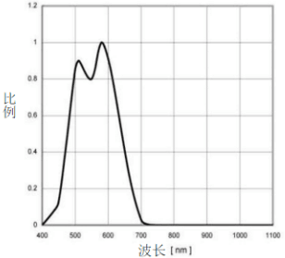
1.3.2 lightness parameters
Figure 1:Influence of different wavelengths of light on Lightness
As shown in Figure 1, the most accurate wavelength is about 580nm, and the scale coefficient is 1.
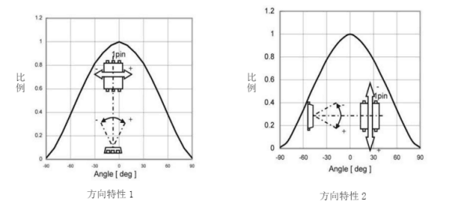
Figure 2: Schematic diagram of light angle influence
As shown in Figure 2, the angle has a great influence on the accuracy of the illumination, so the user should pay attention to the change of the angle when using. Take the upper part as the irradiation reference.
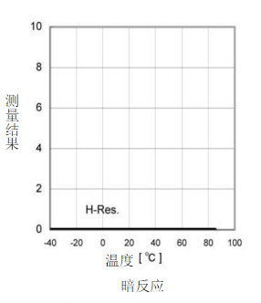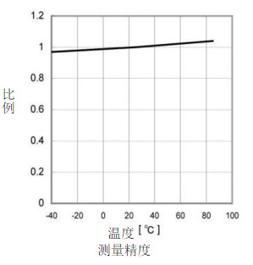
Figure 3: Schematic diagram of different temperature effects
As shown in the figure above, the temperature has little influence on the illumination module, and the accuracy is the highest when the temperature is about 20℃. With the temperature increasing (decreasing), it changes linearly.

1.4 Probe parameters and selection
Model | Range | Scope Of Application | Resolving Power
20W | 200000Lux | Outdoor daylight intensity measurement | 1Lux
6W | 65535Lux | Indoor light intensity measurement | 1Lux

1.5 System frame diagram
When the system needs to connect an analog quantity version sensor, you only need to supply power to the equipment, at the same time, connect the analog quantity output line to the DI interface of the single-chip microcomputer or PLC, and write the corresponding acquisition program according to the conversion relationship in the following paper.
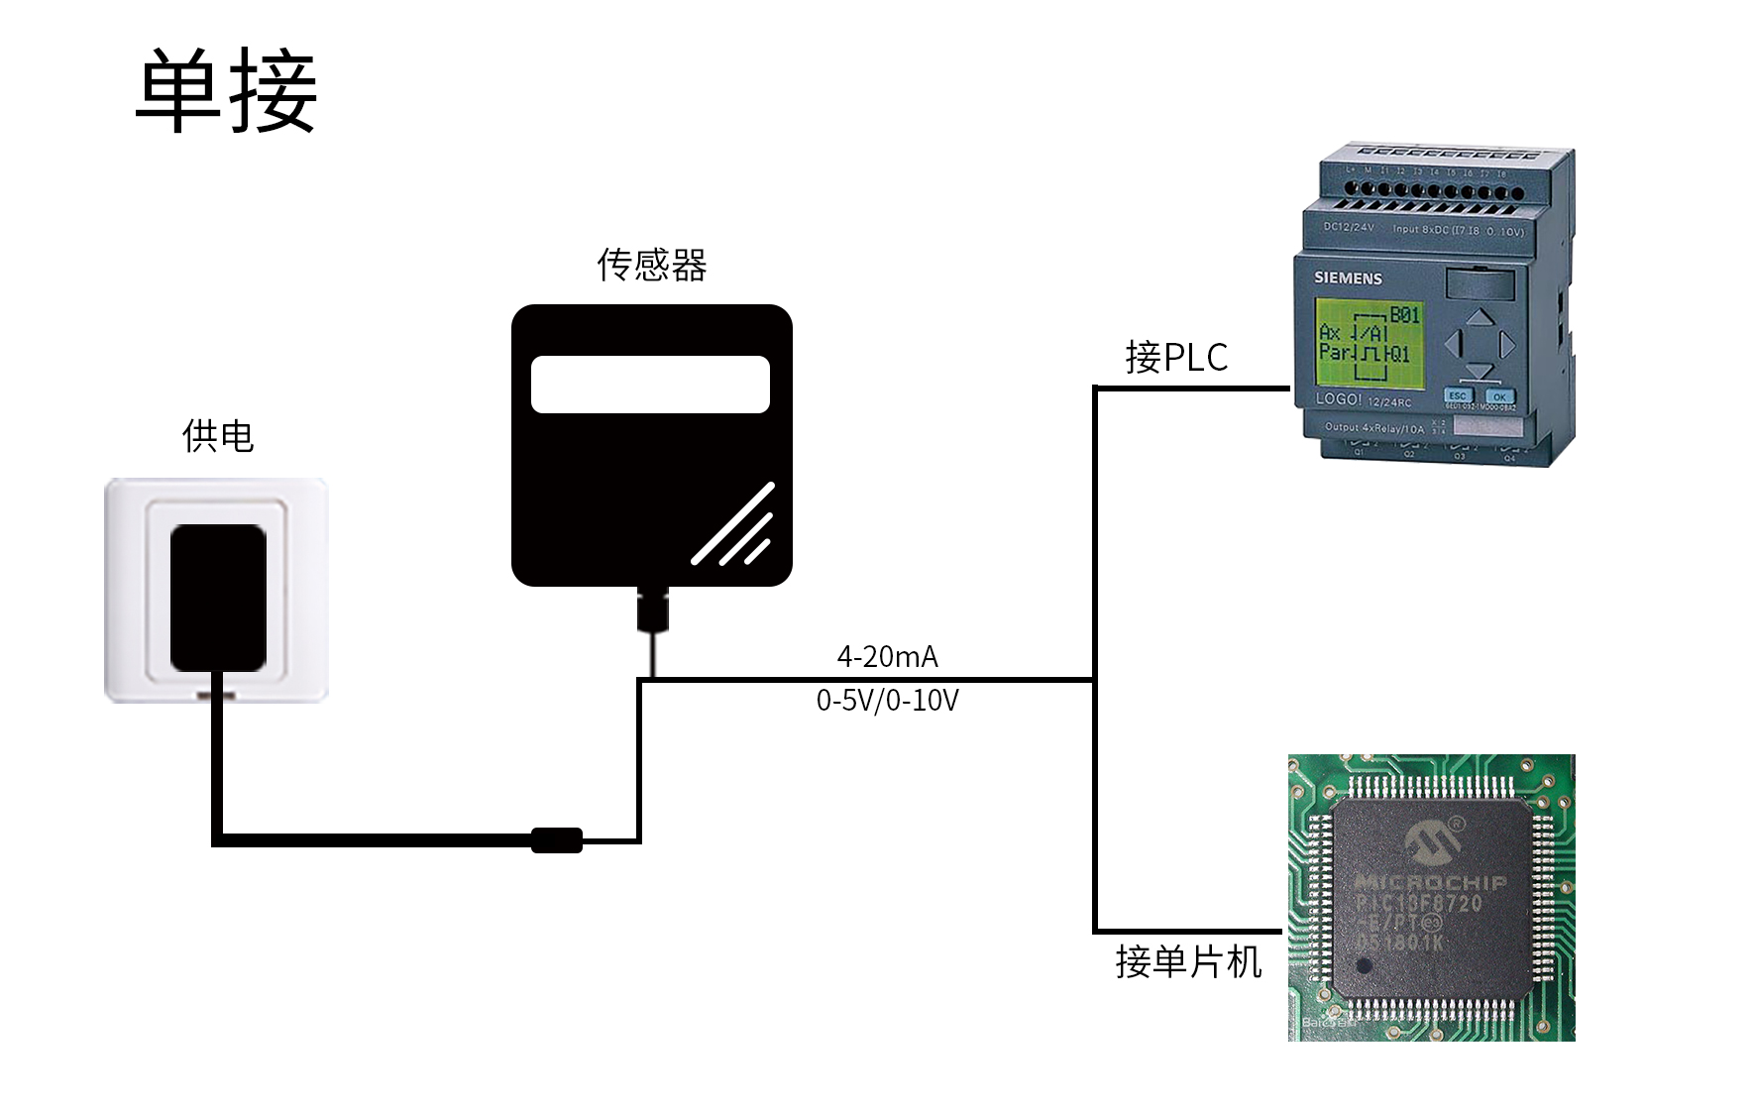
When the system needs to access multiple analog quantity versions of sensors, it needs to connect each sensor to each different analog quantity acquisition port of single-chip computer or the DI interface of PLC, and write the corresponding acquisition program according to the conversion relationship in the following paper.
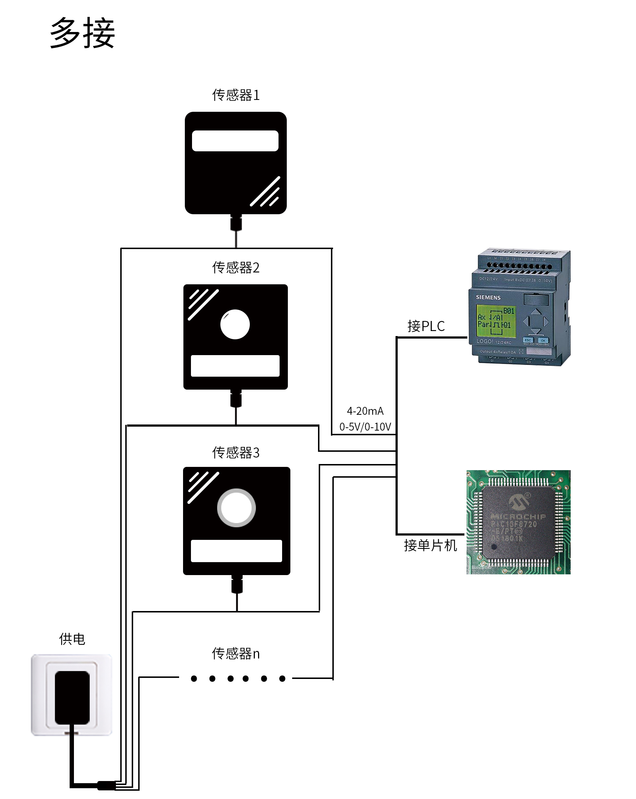

Ⅱ HARDWARE CONNECTIONS
2.1 Checking before installation
Check the list of devices before installation:
Name | Number
THE SENSOR DEVICE | 1
12V POWER ADAPTER（Optional） | 1
WARRANTY CARD / CERTIFICATE | 1

2.2 Interface description
The power interface is wide-voltage power input 12-24V. Analog products should pay attention to the positive and negative signal lines. Do not reverse the positive or negative of the current/voltage signal lines.

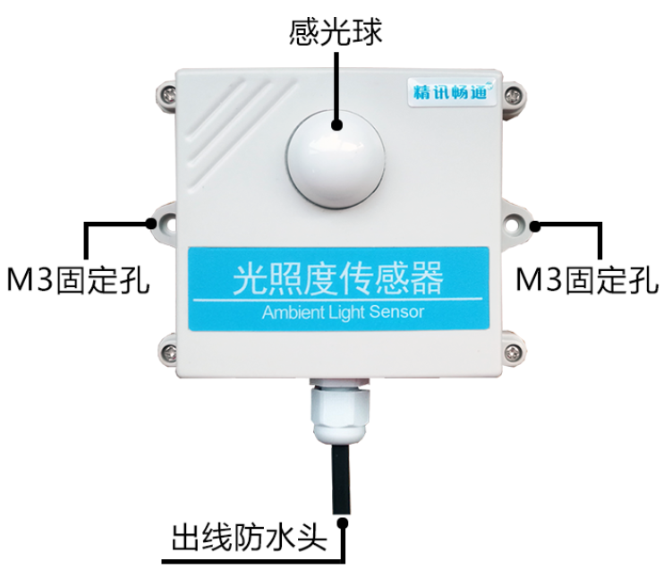
 | Line Color | Description
Power | Brown | Power supply Positive ( 12-24V DC )
Power | Black | Power supply Negative
Communication | Yellow(Gray) | Voltage/current output Positive
Communication | Blue | Voltage/current output negative

Caution: please be careful not to connect the wrong wire sequence, which will cause the equipment to burn down. At the same time, it must be noted that the positive output of voltage/current is an active output, and the positive output of voltage/current must not be connected to the positive position of power supply, which will definitely lead to burnout.
0.6m long wire is provided by default, and customers can extend the wire or wire in sequence as required.
Note that there is no yellow line in the line sequence that may be provided in some factory batches. At this time, the gray line is equivalent to replace the yellow line.

2.3 Installation instructions
It is necessary to place the sensor in a wind and rain proof environment, 90 ° vertical to the ground wall hanging, keep the sensor vent facing down to prevent water from entering.
At the same time, in order to ensure the accuracy of measurement, please install the lightness transmitter in a well ventilated position.

Ⅲ WIRING INSTRUCTIONS
Analog sensor wiring is simple, only need to connect the wire with the designated port of the equipment. The equipment supports 3 / 4-wire wiring mode.
3.1 Typical four-wire wiring
The yellow (gray) line of the sensor is the positive signal connecting to the acquisition equipment, as shown in the figure below is the wiring mode of current type sensor, which connects the power line of the sensor (brown line and black line) to the power supply; the current flow direction is from the sensor to the acquisition equipment; the blue line of the sensor is the negative signal connecting the signal positive signal to the current acquisition equipment, and the current flow direction is from the acquisition equipment to the sensor.
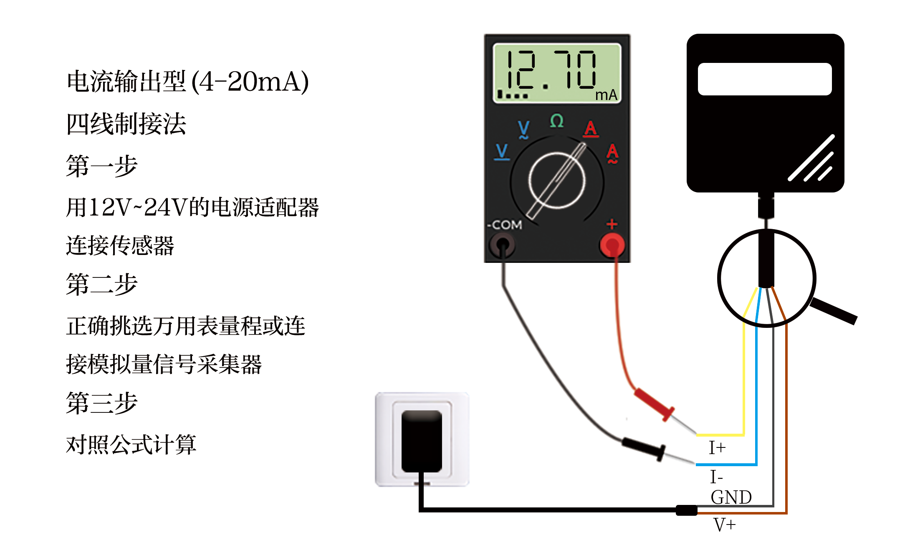
The following figure shows the voltage sensor connection mode. The power line (brown line and black line) of the sensor is connected to the power supply; the yellow (gray) color line of the sensor is the signal that is connected to the acquisition device. Positive, yellow (gray) The voltage of the line is the output voltage; the blue line of the sensor is the signal that the signal is being connected to the voltage acquisition device, and the voltage of the blue line is the reference voltage, which is consistent with the voltage of the black line being 0V.

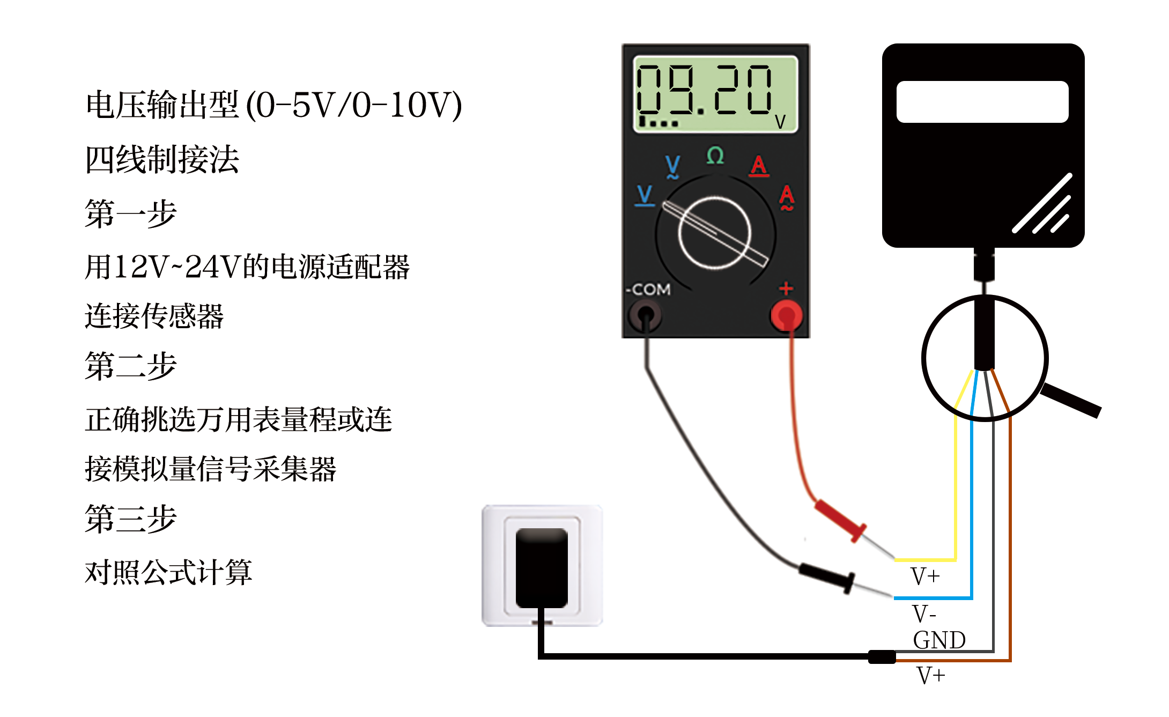
3.2 Typical three-wire connection mode
For the typical three wire system, compared with the four wire system, the blue wire can be omitted. In the sensor, the blue wire and the black wire are short circuited in the sensor, so the blue wire can be omitted.
For the three wire current connection mode, after connecting the power line (brown line and black line) of the sensor to the power supply, only the yellow (gray) line of the sensor needs to be the signal that is being connected to the current collection equipment.
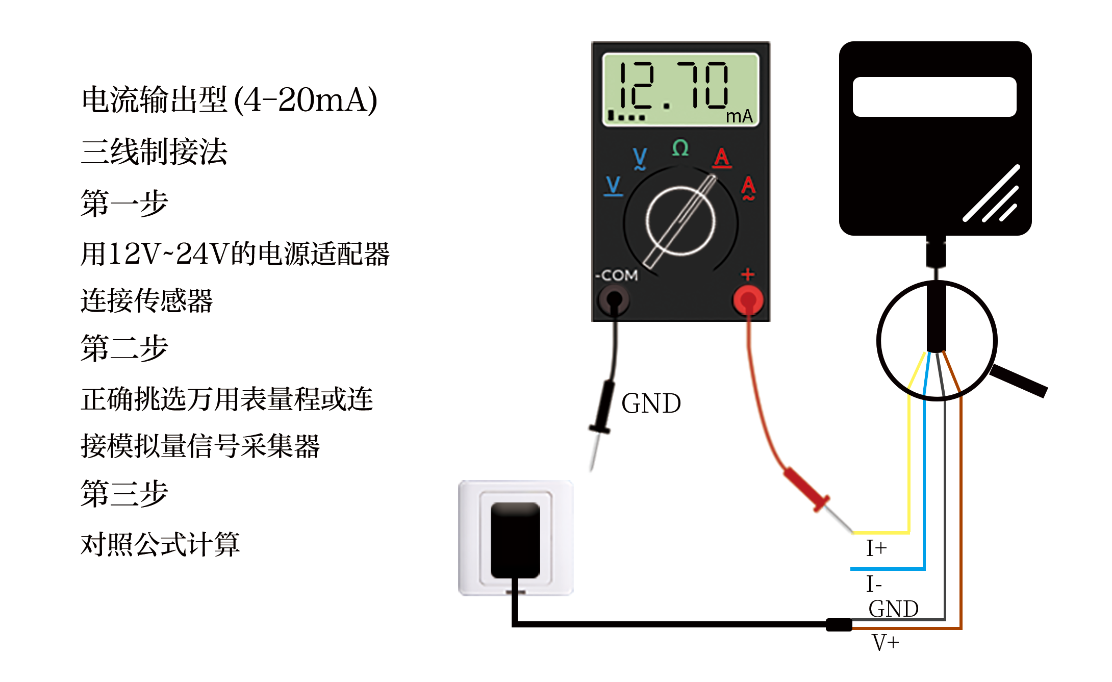
For the three wire voltage connection mode, after connecting the power line (brown line and black line) of the sensor to the power supply, only the yellow (gray) line of the sensor needs to be the signal positive connected to the voltage acquisition equipment.
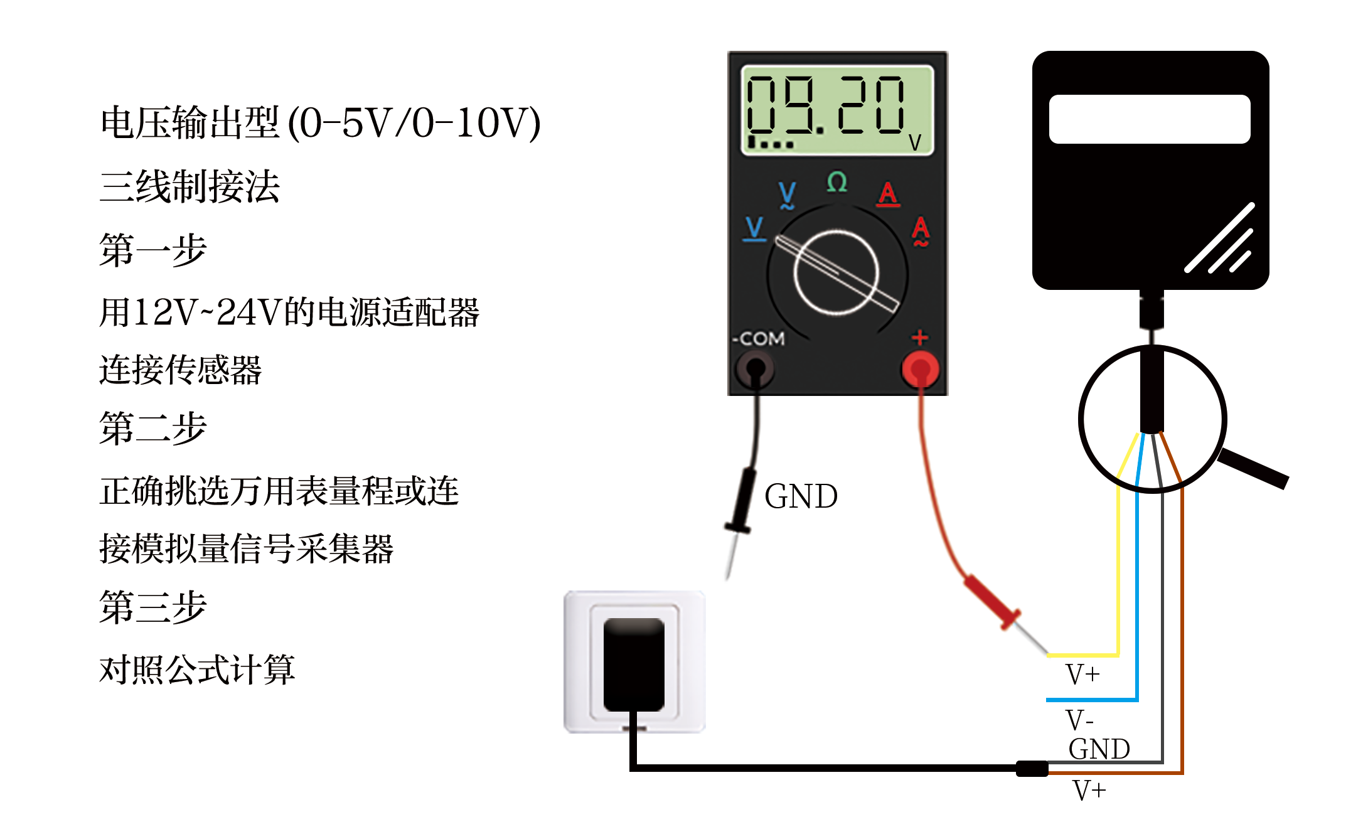Ⅳ ANALOG PARAMETERS MEANING
4.1 Analog 4-20mA current loop
Current Value | Low Light Intensity | Medium Light Intensity | High Light Intensity
4mA | 0Lux | 0Lux | 0Lux
20mA | 10000Lux | 65535Lux | 200000Lux
1. When the selection range is 0-10000lux
The calculation formula is P (light) = (I (current) - 4mA) * 625lux
Where P is in lux and I in mA.
For example, the data collected in the current situation is 8.125mA, at this time, the calculated light intensity value is 5078.13lux maximum range.
2. When the selection range is 0-65535lux
The calculation formula is P (light) = (I (current) - 4mA) * 4095.9375lux
Where P is in lux and I in mA.
For example, the data collected in the current situation is 8.125mA, at this time, the calculated light intensity value is 16895.74lux maximum range.
3. When the range is 0-20wlux
The calculation formula is P (light) = (I (current) - 4mA) * 12500lux
Where P is in lux and I in mA.
For example, the data collected in the current situation is 8.125mA, at this time, the calculated light intensity value is 51562.5lux maximum range.
4.2 Analogue 0-10V voltage output
Current Value | Low Light Intensity | High Light Intensity
0V | 0Lux | 0Lux
10V | 65535Lux | 200000Lux
1. When the selected range is 0-65535lux
The calculation formula is P (light) = V (voltage)×6.5535lux
Where P is in lux and V is in mV.
For example, in the current situation, the collected data is 3515mV, and the calculated light intensity is 23035.55lux.
2. When the range is 0-20wlux
The calculation formula is P (light) = V (voltage) × 20lux
Where P is in lux and V is in mV.
For example, in the current situation, the collected data is 3515mV, and the calculated light intensity is 70300lux.
4.3 Analogue 0-5V voltage output
Current Value | Low Light Intensity | High Light Intensity
0V | 0Lux | 0Lux
5V | 65535Lux | 200000Lux
1. When the selection range is 0-65535lux
The calculation formula is P (light) = V (voltage)×13.107lux
Where P is in lux and V is in mV.
For example, in the current situation, the collected data is 4228mV, and the calculated light intensity is 55416.396lux.
2. When the range is 0-20wlux
The calculation formula is P (light) = V (voltage) × 40lux
Where P is in lux and V is in mV.
For example, in the current situation, the collected data is 3515mV, and the calculated light intensity is 140600lux.

