Instructions for Smart Gas Module Sensor JXM-O₃
V2.0
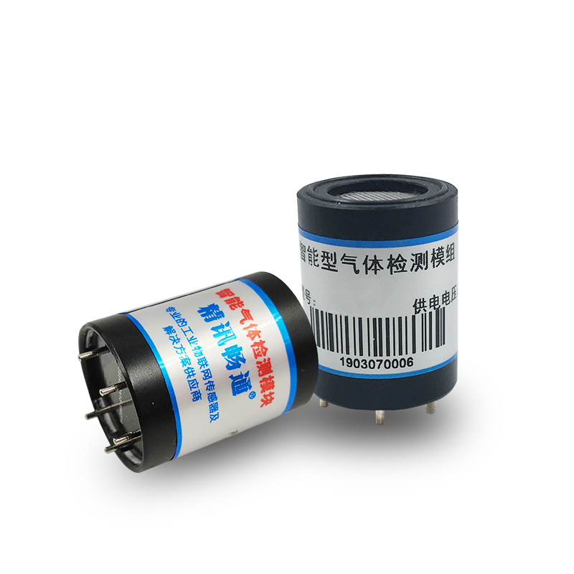

Chapter 1 Product Introduction
1.1 Product overview
The JXM series is an intelligent gas detection module with a built-in high-precision electrochemical sensor, which outputs the gas concentration signal as a digital signal required by the customer through a patented circuit.
The sensor is equipped with high-precision amplification, noise removal processing, and temperature compensation processing. At the same time, each sensor is calibrated with standard gas before leaving the factory to ensure that the sensor module that the customer obtains directly outputs usable and accurate gas concentration information.
1.2 Product features
•Patent variable gain amplifier circuit, high sensitivity and high resolution.
•The factory has been calibrated, no need for secondary calibration, use directly.
•Small size, easy to install, intrinsically safe design.
•Support multiple interfaces including digital and analog.
1.3 Product parameters
parameter | Technical index
Detection gas | Ozone (O3)
Measuring range | 0-20ppm (default)
Resolution | 0-100ppm (optional)
Precision | 0.01ppm
Response time | ≤±3% of reading (25℃)
Detection principle | Generally less than 15 seconds
Baud rate | Electrochemistry
communication method | 2400/4800/9600
Power supply | TTL/Modbus RTU
Power consumption | 5V±2%
Operating temperature | ≤0.2W
Working humidity environment | -10 to 50°C
Dimensions | 0-95%RH (no condensation)
Material | Height: 29.5mm (±0.25mm)
1.4 Pin description

The following figure (table) is the pin description of the module, as shown in figure (table):

number | definition
1 | VO
2 | VCC
3 | GND
4 | 485A/RXD
5 | 485B/TXD

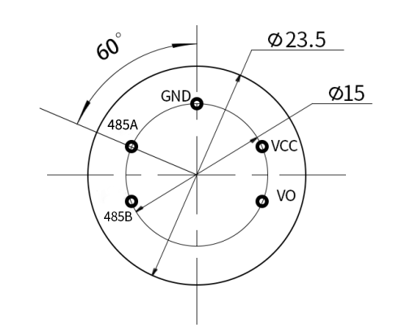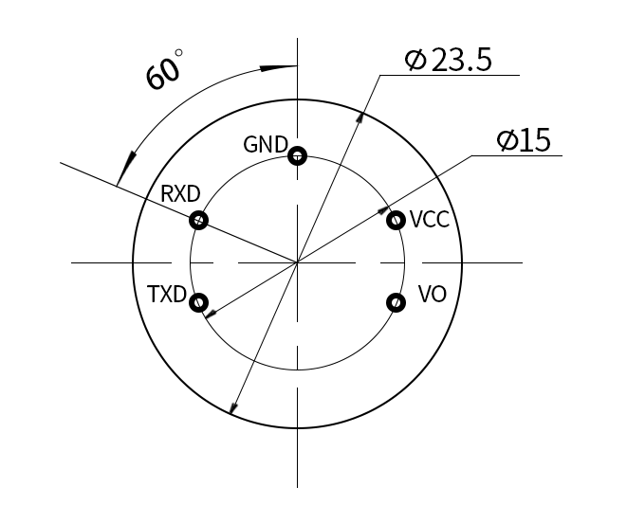
485 communication pin diagram TTL communication pin diagram
1.5 Product size
The following figure is the size of the module, which is installed and used according to the size, as shown in the figure:
Chapter 2 Communication Protocol
The module communication developed by our company is divided into two communication methods: TTL and Modbus RTU. Among them, the module has two working modes, namely the active reporting mode and the inquiry mode. The default working mode is the active reporting mode; if you need to change to the inquiry mode, you need to enter the following inquiry command:
Send: FF 01 03 02 00 00 00 00 05 can be switched to inquiry mode
Send: FF 01 03 01 00 00 00 00 04 can be switched to active reporting mode
The communication mode 0x01 represents active reporting, and 0x02 represents inquiry
2.1 TTL communication method
2.1.1 Basic communication parameters
parameter | content
coding | 8-bit binary
Data bit | 8-bit
Parity bit | no
Stop bit | 1 person
Wrong calibration | CRC lengthy cyclic code
Baud rate | 2400bps/4800bps/9600 bps can be set, the factory default is 9600bps
coding | 8-bit binary
2.1.2 Communication commands
(1) Active reporting mode-07
 | Accept（RX）
Start bit | Address | Command word | Resolution bit | Gas concentration |  | -- | -- | -- | checksum
0xFF | 0x01 | 0X07 | 0x02 | 高字节 | 低字节 | 0 | 0 | 0 | 0x3A
The resolution represents the number of decimal places: as shown in the following table
分辨率位 | 分辨率系数
0x00 | 1
0x01 | 0.1
0x02 | 0.01
0x03 | 0.001
其中气体浓度值=(气体浓度高位*256+气体浓度低位)*分辨率系数。
例如：读出的通讯字节为 FF 01 07 02 01 35 00 00 00 3D
其中气体浓度值读出来为0x01 0x35，转换为10进制为1和53；分辨率位位0x02，查表分辨率系数位0.01，则计算：
气体浓度=（1*256+53）*0.01=3.09 ppm
- Inquiry mode-07

transmission（TX）
Start bit | Address | Command word | -- | -- | -- | -- | -- | checksum
0xFF | 0x01 | 0x07 | 0 | 0 | 0 | 0 | 0 | 0x07
Example sending: FF 01 07 00 00 00 00 00 07 Ask for a value
 | 接受（RX）
Start bit | Address | Command word | Resolution bit | Sensor concentration |  | -- | -- | -- | checksum
0xFF | 0x01 | 0x07 | 0x02 | High byte | low byte | 0 | 0 | 0 | 0x3A
For example: the read communication byte is FF 01 07 02 01 35 00 00 00 3D
Representative gas concentration=(1*256+53)*0.01=3.09ppm (see the preceding text for specific meaning)
2.2 Modbus RTU communication mode
2.2.1 Basic communication parameters
parameter | parameter
coding | coding
Data bit | Data bit
Parity bit | Parity bit
Stop bit | Stop bit
Wrong calibration | Wrong calibration
Baud rate | Baud rate
coding | coding
2.2.2 Data frame format definition
Adopt Modbus-RTU communication protocol, the format is as follows:
Initial structure >= 4 byte time
Address code = 1 byte
Function code = 1 byte
Data area = N bytes
Error check = 16-bit CRC code
End structure >= 4 bytes time
Address code: the address of the transmitter, which is unique in the communication network (factory default 0x01).
Function code: The command function prompt sent by the host, this transmitter only uses function code 0x03 (read memory data).
Data area: The data area is the specific query data area, pay attention to the 16bits data high byte first
CRC code: two-byte check code.
Inquiry frame
Address code Function code Register start address Register length Check code low bit Check code high bit | Address code Function code Register start address Register length Check code low bit Check code high bit | Address code Function code Register start address Register length Check code low bit Check code high bit | Address code Function code Register start address Register length Check code low bit Check code high bit | Address code Function code Register start address Register length Check code low bit Check code high bit | Address code Function code Register start address Register length Check code low bit Check code high bit
1byte | 1byte | 2byte | 2byte | 1byte | 1byte
Reply frame
Address code Function code Number of valid bytes Data area 1 Second data area Nth data area | Address code Function code Number of valid bytes Data area 1 Second data area Nth data area | Address code Function code Number of valid bytes Data area 1 Second data area Nth data area | Address code Function code Number of valid bytes Data area 1 Second data area Nth data area | Address code Function code Number of valid bytes Data area 1 Second data area Nth data area | Address code Function code Number of valid bytes Data area 1 Second data area Nth data area
1 byte | 1byte | 1 byte | 2 byte | 2 byte | 2 byte

2.2.3 Register address
Register address | PLC configuration address |  | Content | Operation
0006H | 40007 | Gas concentration (unit ppm) Read only |  | Gas concentration (unit ppm) Read only
0100H | 40101 | Device address (0-252) read and write |  | Device address (0-252) read and write
0101H | 40102 | Baud rate (2400/4800/9600) |  | Baud rate (2400/4800/9600)
2.2.4 Communication protocol example and explanation
(1) Read the gas value of the device address 0x01
Inquiry frame
Address code | Function code | Start address | Data length | Check code  Low bit | Check code high bit
0x01 | 0x03 | 0x00,0x06 | 0x00,0x01 | 0x64 | 0x0B
Reply frame
Address code | Function code | Start address | Data length | Check code  Low bit | Check code high bit
0x01 | 0x03 | 0x02 | 0x00,0x10 | 0x78 | 0x35
Gas concentration:
0x00 0x10 (hexadecimal)=16 (decimal) => gas concentration=0.16ppm
Chapter 3 Appendix
3.1 Notes
(1) It is forbidden to plug and unplug the sensor on the module. Wrong use will cause irreversible damage.
(2) It is forbidden to weld the pins of the module directly, and the sockets of the pins can be welded.
(3) The module should avoid contact with organic solvents (including silica gel and other adhesives), coatings, chemicals, and oils.
(4) Do not pass over-range high-concentration gas, it will cause irreversible damage.
(5) The module must not withstand excessive impact or vibration.
(6) The module needs to be warmed up for more than 3 minutes when it is powered on for the first time.
(7) Do not apply this module to systems involving personal safety.
(8) Do not install the module in a strong air convection environment
3.2 Warranty and after-sales
The warranty clauses follow the sensor after-sales clauses of Weihai Jingxun Changtong Electronic Technology Co., Ltd., two years for the sensor host circuit part, one year for gas-sensitive probes, and three months for accessories (housing/plugs/cables, etc.).

