Instructions for Smart Gas Module Sensor

JXM-NO2
V2.0
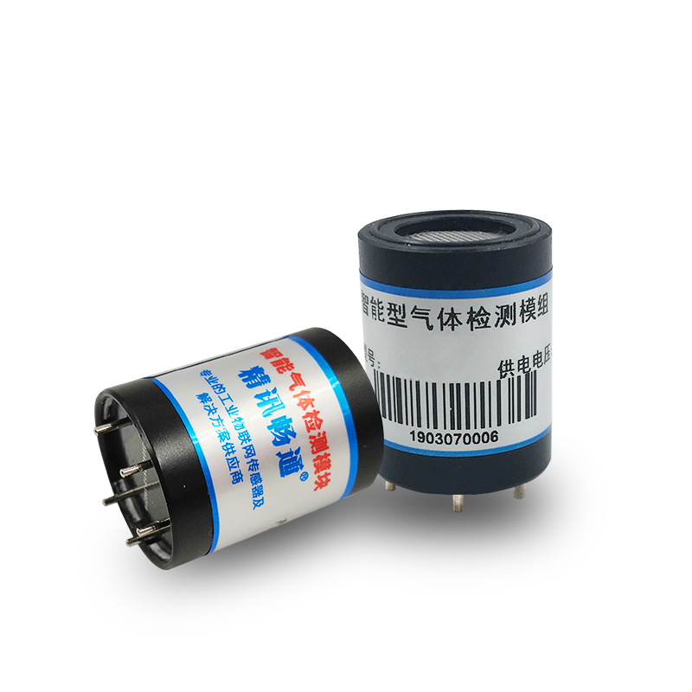
Chapter 1 Product Introduction

  - Product overview
The JXM series is an intelligent gas detection module with a built-in high-precision electrochemical sensor, which outputs the gas concentration signal as a digital signal required by the customer through a patented circuit.
The sensor is equipped with high-precision amplification, noise removal processing, and temperature compensation processing. At the same time, each sensor is calibrated with standard gas before leaving the factory to ensure that the sensor module that the customer obtains directly outputs usable and accurate gas concentration information.

  - Features
- Patent variable gain amplifier circuit, high sensitivity, high resolution
- The factory has been calibrated, no need for secondary calibration, use directly
- Small size, easy to install, intrinsically safe design
- Support multiple interfaces including digital and analog

  - Product parameters
parameters | Technical index
Detection gas | Nitrogen Dioxide（NO2）
Measuring range | 0-20ppm（default）  0-2000ppm（Optional）
Resolution | 0.01ppm
Precision | ≤±3% of reading (25℃)
Response time | Generally less than 15 seconds
Detection principle | Electrochemistry
Baud rate | 2400/4800/9600
communication method | TTL/Modbus RTU
Power supply | 5V±2%
Power consumption | ≤0.2W
Operating temperature | -10至50℃
Working humidity environment | 0-95%RH(No condensation)
Dimensions | high：29.5mm（±0.25mm）
Material | Aluminum alloy weight: 10g
  - Pin description
The following figure (table) is the pin description of the module, as shown in figure (table):
Serial number | definition
1 | VO
2 | VCC
3 | GND
4 | 485A/RXD
5 | 485B/TXD

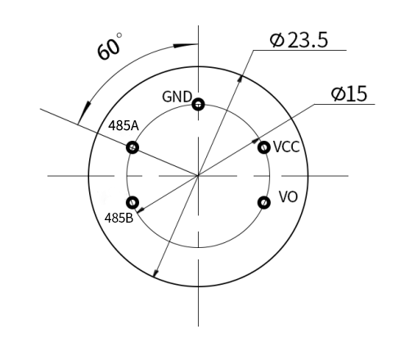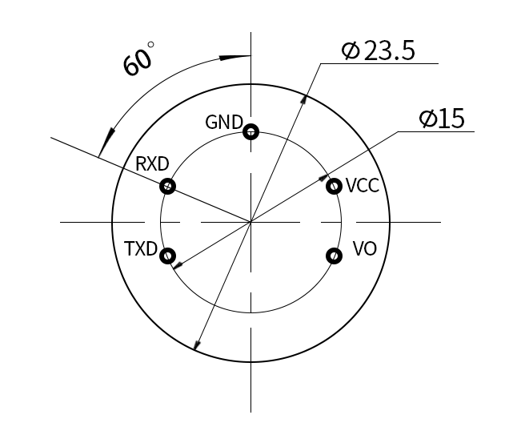
485 communication pin diagram TTL communication pin diagram
  - Product size
The figure below is the size of the module, which can be installed and used reasonably according to the size, as shown in the figure:
Chapter 2 Communication Protocol
The module communication developed by our company is divided into two communication methods: TTL and Modbus RTU. Among them, the module has two working modes, namely the active reporting mode and the inquiry mode. The default working mode is the active reporting mode; if you need to change to the inquiry mode, you need to enter the following inquiry command:
Send: FF 01 03 02 00 00 00 00 05 can be switched to inquiry mode
Send: FF 01 03 01 00 00 00 00 04 can be switched to active reporting mode
The communication mode 0x01 represents active reporting, and 0x02 represents inquiry
2.1 TTL communication method
2.1.1 Basic communication parameters
parameter | content
coding | 8-bit binary
Data bit | 8-bit
Parity bit | no
Stop bit | 1-bit
Wrong calibration | CRC lengthy cyclic code
Baud rate | 2400bps/4800bps/9600 bps can be set, the factory default is 9600bps
coding | 8-bit binary
2.1.2 Communication command
（1）Active reporting mode-07
 | accept（RX）
Start bit | address | Command word | Resolution bit | Gas concentration |  | -- | -- | -- | Checksum
0xFF | 0x01 | 0X07 | 0x02 | High byte | Low byte | 0 | 0 | 0 | 0x3A
The resolution represents the number of decimal places: as shown in the following table
Resolution bit | Resolution factor
0x00 | 1
0x01 | 0.1
0x02 | 0.01
0x03 | 0.001
Among them, gas concentration value = (high gas concentration * 256 + low gas concentration) * resolution coefficient.
For example: the read communication byte is FF 01 07 02 01 35 00 00 00 3D
Among them, the gas concentration value is read as 0x01 0x35, converted to decimal number 1 and 53; the resolution bit is 0x02, and the resolution coefficient bit of the look-up table is 0.01, then calculate:
Gas concentration=(1*256+53)*0.01=3.09 ppm
（2）Inquiry mode-07
send（TX）
Start bit | address | Command word | -- | -- | -- | -- | -- | Checksum
0xFF | 0x01 | 0x07 | 0 | 0 | 0 | 0 | 0 | 0x07
Example sending: FF 01 07 00 00 00 00 00 07 Ask for a value
 | accept（RX）
Start bit | address | Command word | Resolution bit | Sensor concentration |  | -- | -- | -- | v
0xFF | 0x01 | 0x07 | 0x02 | High byte | Low byte | 0 | 0 | 0 | 0x3A
For example: the read communication byte is FF 01 07 02 01 35 00 00 00 3D
Representative gas concentration=(1*256+53)*0.01=3.09ppm (see the preceding text for specific meaning)
2.2 Modbus RTU communication method
2.2.1 Basic communication parameters
parameter | content
coding | 8-bit binary
Data bit | 8-bit
Parity bit | no
Stop bit | 1-bit
Wrong calibration | CRC lengthy cyclic code
Baud rate | 2400bps/4800bps/9600 bps can be set, the factory default is 9600bps
coding | 8-bit binary
2.2.2Data frame format definition
Adopt Modbus-RTU communication protocol, the format is as follows:
Initial structure >= 4 byte time
Address code = 1 byte
Function code = 1 byte
Data area = N bytes
Error check = 16-bit CRC code
End structure >= 4 bytes time
Address code: the address of the transmitter, which is unique in the communication network (factory default 0x01).
Function code: The command function prompt sent by the host, this transmitter only uses function code 0x03 (read memory data).
Data area: The data area is the specific query data area, pay attention to the 16bits data high byte first
CRC code: two-byte check code.
Interrogation frame
address code | function code | Register start address | Register length | Check code low bit | Check code high
1 byte | 1 byte | 2 byte | 2 byte | 1 byte | 1 byte
Reply frame
address code | function code | Effective bytes | Data area | Second data area | Nth data area
1 byte | 1 byte | 1 byte | 2 byte | 2 byte | 2 byte

2.2.3Register address
Register address | PLC configuration address | content | operating
0006H | 40007 | Gas concentration (unit ppm) | Read only
0100H | 40101 | Device address (0-252) | Read and write
0101H | 40102 | Baud rate (2400/4800/9600) | Read and write
2.2.4 Communication protocol example and explanation
（1）Read the gas value of device address 0x01
Interrogation frame

address code | function code | initial address | Data length | Check code low bit | Check code high
0x01 | 0x03 | 0x00,0x06 | 0x00,0x01 | 0x64 | 0x0B
Reply frame
address code | function code | Effective bytes | Gas concentration value | Check code low bit | Check code high
0x01 | 0x03 | 0x02 | 0x00,0x10 | 0x78 | 0x35
Gas concentration:
0x00 0x10 (hexadecimal)=16 (decimal) => gas concentration=0.16ppm
Chapter 3 Appendix
3.1 Precautions
(1) It is forbidden to plug and unplug the sensor on the module. Wrong use will cause irreversible damage.
(2) It is forbidden to weld the pins of the module directly, and the sockets of the pins can be welded.
(3) The module should avoid contact with organic solvents (including silica gel and other adhesives), coatings, chemicals, and oils.
(4) Do not pass over-range high-concentration gas, it will cause irreversible damage.
(5) The module must not withstand excessive impact or vibration.
(6) The module needs to be warmed up for more than 3 minutes when it is powered on for the first time.
(7) Do not apply this module to systems involving personal safety.
(8) Do not install the module in a strong air convection environment
3.2 Warranty and after-sales
The warranty terms follow the sensor after-sales terms of Weihai Jingxun Changtong Electronic Technology Co., Ltd., for the sensor host circuit part, the warranty is 1 year, the gas-sensitive probe is guaranteed for 6 months, and the accessories (shell/plug/cable, etc.) are guaranteed for 3 months.

