Instructions For Using the Smart Gas Module Sensor JXM-NO
V2.0
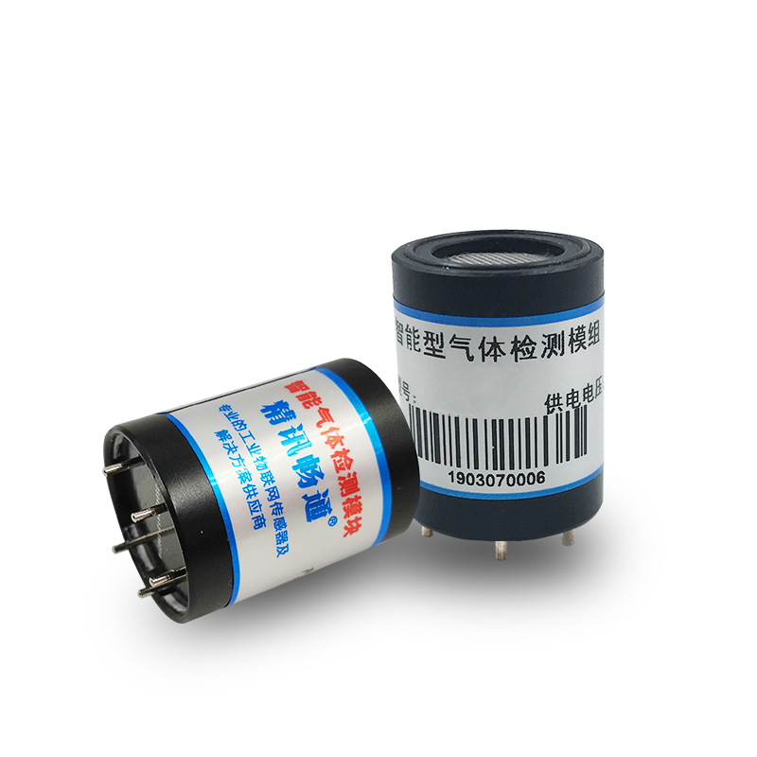
Chapter 1 Product Introduction

1.1Product Overview
The JXM series is an intelligent gas detection module, which has a high-precision electrochemical sensor to output the gas concentration signal as the digital signal that the customer needs through the patented circuit.
The sensor interior has high-precision amplification, noise removal treatment and temperature compensation treatment. At the same time, each sensor is processed through standard gas calibration before leaving the factory to ensure that the customer gets the sensor module to directly output available and accurate gas concentration information.
1.2Product Characteristics
Patent variable gain amplification circuit, high sensitivity, high resolution
Factory calibration and used directly without secondary calibration
Small volume, easy to install, Ben-Ann design
Supports multiple interfaces, including digital and analog quantities
1.3Product Parameter
parameter | qualification
tracer gas | nitric oxide (NO)
measuring range | 0-20.ppm (default), 0-250ppm,
resolution ratio | 0-2000ppm
accuracy | 0.01ppm
response time | ± 3% (25℃)
principle of detection | generally less than 15 seconds
baud rate | electrochemistry
communication mode | 2400/4800/9600
power supply mode | TTL/Modbus RTU
power consumption | 5V±2%
running temperature | ≤0.2W
working humidity environment | -10 to 50℃
outline dimension | 0-95%RH (no condensation)
material quality | high-level: 29.5mm(±0.25mm)

1.4Feet Instructions
The following figure (table) is the pin description of the module, as shown in the figure (table):
order number | definition
1 | VO
2 | VCC
3 | GND
4 | 485A/RXD
5 | 485B/TXD

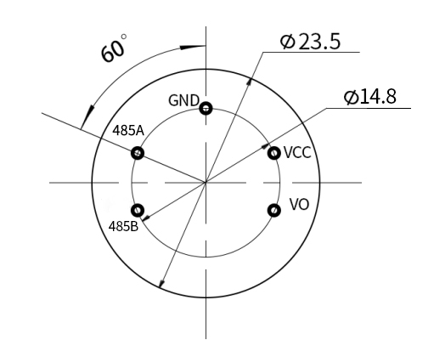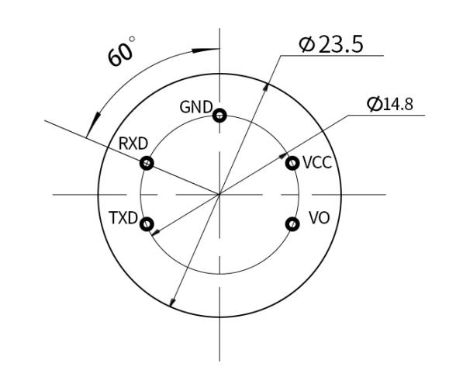
485 Communication pin map TTL communication pin map
1.5 Product Size
The following figure is the size of the module, reasonably installed and used according to the size, as shown in the figure:

Chapter2 Protocol
The module communication developed by our company is divided into two communication modes: TTL and Modbus RTU.Among them, the module has two working modes, respectively, active reporting mode and inquiry mode, the default working mode is active reporting mode; if you need to change to the inquiry mode, you need to input the following inquiry instructions:
Send: The FF 01 03 02 00 00 00 00 05 can be switched to polling mode
Send: The FF 01 03 01 00 00 00 00 04 can be switched to the active reporting mode
The communication mode 0x01 represents the active report, and 0x02 represents the inquiry type
2.1 TTL Communication Mode
2.1.1 Communication Basic Parameters
parameter | content
code | the 8-bit binary
data bit | eight
parity check bit | not have
stop bit | one
error calibration | CRC long cycle code
baud rate | the 2400bps / 4800bps / 9600 bps can be set, with a factory default of 9600bps
code | the 8-bit binary
2.1.2 Communication Command
(1) Active reporting mode-07
 | accept (RX)
start bit | address | CW | Resolution bit | gas concentration |  | -- | -- | -- | check sum
0xFF | 0x01 | 0X07 | 0x02 | gas concentration | lower byte | 0 | 0 | 0x3A | 0x3A
The resolution represents the number of decimal points: as shown in the table below
Resolution bit | Resolution bit
0x00 | 0x00
0x01 | 0x01
0x02 | 0x02
0x03 | 0x03
The gas concentration value = (high gas concentration * 256 + low gas concentration) * resolution coefficient.
For example, the readout communication byte is FF 01 07 02 01 35 00 00 00 3F
The gas concentration value is read as 0x01 0x35 and converted to 10 decimal system as 1 and 53; resolution bit 0x02 and table resolution factor bit 0.01 are calculated:
Gas concentration = (1*256+53)*0.01=3.09 ppm
(2)Inquiry mode-07
transmit by radio (TX)
start bit | address | CW | -- | -- | -- | -- | -- | check sum
0xFF | 0x01 | 0x07 | 0 | 0 | 0 | 0 | 0 | 0x07

Instance sent: FF 01 07 00 00 00 00 00 07 asks a value
 | accept (RX)
start bit | address | CW | Resolution bit | Sensor concentration |  | -- | -- | -- | check sum
0xFF | 0x01 | 0x07 | 0x02 | high byte | lower byte | 0 | 0 | 0x3A | 0x3A

For example, the readout communication byte is FF 01 07 01 01 35 00 00 00 3F
Representative gas concentration = (1*256+53)*0.01=3.09ppm (see above)
2.2 Modbus RTU Communication Mode
2.2.1 Communication Basic Parameters
parameter | content
code | The 8-bit binary
data bit | Eight
parity check bit | not have
stop bit | One
error calibration | CRC long cycle code
baud rate | The 2400bps / 4800bps / 9600 bps can be set, with a factory default of 9600bps
code | The 8-bit binary
2.2.2 Data Frame Format Definition
The Modbus-RTU polling statute is adopted in the following format:
Initial structure> =4 bytes of time
Address code = 1 byte
Function code = 1 bytes
Data zone = N bytes
Error check = 16-bit CRC code
End of the structure> =4 bytes of time
Address code: the address of the transmitter is unique in the polling network (factory default 0x01).
Function code: The command issued by the host prompts that the transmitter only uses the function code 0x03 (read the memory data).
Data area: the data area is the specific inquiry number area, note that 16bits data high bytes are before
CRC code: a two-byte check code.
Ask the frame
address code | FC | register start address | register length | the check code is low | calibration code high
1 byte | 1 byte | 2 byte | 2 byte | 1 byte | 1 byte
acknowledgement frame
address code | FC | number of valid bytes | data area 1 | second data zone | N data zone
1 byte | 1 byte | 1 byte | 2 byte | 2 byte | 2 byte

2.2.3, Register Address
Register address | The PLC configuration address | content | operate
0006H | 40007 | Gas concentration (per unit ppm) | read only
0100H | 40101 | Equipment Address (0-252) | read-write
0101H | 40102 | Porter rate (2400 / 4800 / 9600) | read-write
2.2.4 Communication Protocol Examples and Explanation
(1) Read the gas value of the device address 0x01
Ask the frame
address code | FC | start address | DL | The check code is low | Calibration code high
0x01 | 0x03 | 0x00,0x06 | 0x00,0x01 | 0x64 | 0x0B
acknowledgement frame
address code | FC | Number of valid bytes | Gas concentration value | The check code is low | Calibration code high
0x01 | 0x03 | 0x02 | 0x00,0x10 | 0x78 | 0x35
gas concentration:
0x00 0x10 (16 decimal place) =16 (10 decimal place) => gas concentration =0.16ppm
Chapter 3 Appendix
3.1 Matters Need Attention
(1) Never plug the sensor on the module, and the wrong use mode will cause irreversible damage.
(2) Direct welding of the module pin is prohibited, and the pipe seat can be welded.
(3) Modes shall avoid contact with organic solvents (including silicone gel and other adhesives), coatings, agents and oils.
(4) Do not pass through the overscale range of high concentration of gas, which will cause irreversible damage.
(5) The module shall not withstand impact or vibration.
(6) The first electric use of the module shall be preheated for more than 3 minutes.
(7) Do not apply this module to systems involving personal safety.
(8) Do not install the module in a strong air convection environment
3.2 Quality Assurance And After-sales Service
The warranty terms follow the after-sales terms of Weihai Precision Electronic Technology Co., Ltd., with two years for the sensor host circuit, air probe for one year, and accessories (shell / plug / cable, etc.) for three months.

