Infrared carbon monoxide module sensor

Operating manual
JX-CO-103
Ver1.0

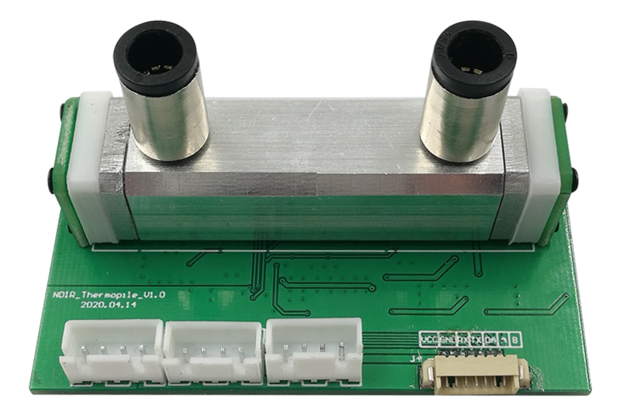

Chapter 1 Product profile

Product overview
The JX-CO-103 series is a sensor to measure carbon monoxide using non-decentralized infrared technology (NDIR).
After the infrared radiation emitted by the infrared light source is absorbed by a certain concentration of the gas to be measured, the spectral intensity proportional to the gas concentration will change, so the spectral intensity change amount can reverse the performance of the gas concentration to be measured. Infrared carbon monoxide sensor module adopts the NDIR infrared absorption and detection principle, which combines advanced optical circuit, precision circuit with intelligent software to form a common infrared CO sensor module.
This product adopts imported MEMS infrared light source and two-channel pyroelectric detector, measurement and reference signal processing, and performs temperature compensation, which can obtain stable and reliable measurement results even under harsh temperature and environmental conditions. It has the unique good selectivity, high sensitivity, no oxygen dependence and long life span of NDIR products.
The JX-CO-103 series product is made of aluminum alloy polishing process and production. This product can be widely used in coal mine gas detection, petroleum and natural gas detection, chemical gas production and air detection process monitoring, and can be installed in chemical industry, coal mine, oilfield, intelligent buildings, sound and optical alarm controllers, robots, automobiles and other applications.

Parameter indicators
Parameters | Technical indicators
Measurement range | 0-1000000ppm（Default）
Measure the resolution | 1ppm，0.1lel
Measurement accuracy | ±5%F.S(25℃)
Response time | < 30s (25℃)
Preup time | < 1min (25℃)
Retain the accuracy | < 3min (25℃)
Operating voltage | 9-24V DC
Average power consumption | <60mA
Working humidity | 0~95%RH(Non-condensation)
Operating temperature | -10~75 ℃, maximum temperature resistance of 85 ℃; temperature compensation range: -10~60 ℃ (factory default)
Stores the temperature | -20~70℃
Infrared light source band | 2 -14 μm

Product specifications
Model number | Measurement range（Unit: ten thousand ppm）
JX-CO-103-5W | 0-5Wppm
JX-CO-103-20W | 0-20Wppm
JX-CO-103-50W | 0-50Wppm
JX-CO-103-100W | 0-100Wppm

Pin definition
The pin definition for the JX-CO2-103 series infrared CO 2 is shown in the following table (Figure):
Pin | Name | Note
1 | VCC | Power supply is 9-24V
2 | GND | Power supply
3 | RX | TTL Level Signal, 3.3V
4 | TX | TTL Level Signal, 3.3V
5 | DA | DA voltage signal
6 | A | 485_A
7 | B | 485_B

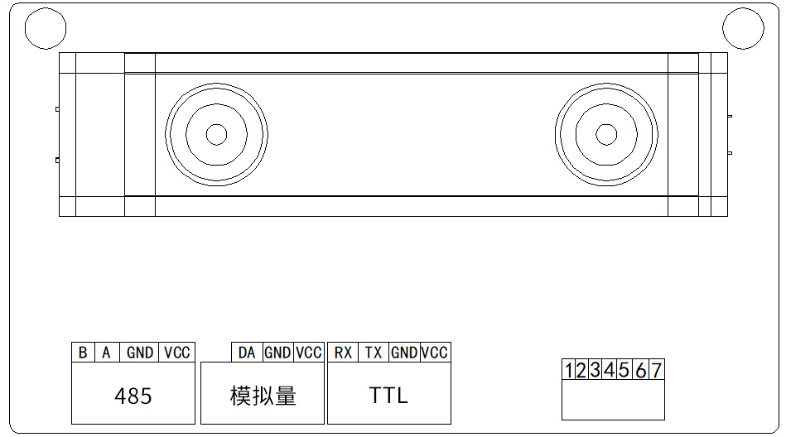
引脚示意图
Note: The sensor interface is 7Pin-1.25mm socket and 34Pin-2.54mm seat connection.
The 485 serial port is the gas concentration value by 485 communication; the analog quantity serial port is to detect the gas concentration value by analog calculation; the TTL serial port is to detect the gas concentration value by TTL module; detect the gas concentration value by different communication methods, please refer to Chapter II Communication Protocol

Product appearance
The following figure is the appearance and structural dimensions of the product, and the mounting hole position, as shown:
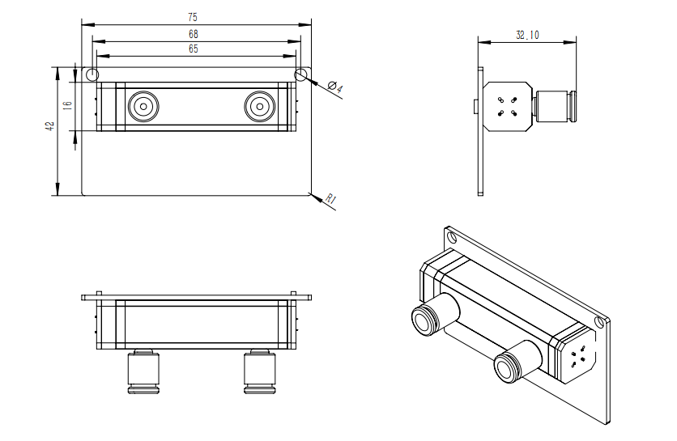
The product installation fixed hole position spacing is 68mm, hole diameter of 3.5mm

Chapter 2 Communication protocol

2.1 Communication protocol
Parameters | Content
Communication address | 0x01（Default）
Porter rate | 9600（Default）
Data bit | 8 bit
Parity check bit | None
Stop the bit | 1
There are two working modes of the module, respectively, active reporting type and passive response type. The default working mode is active reporting mode. Under the active reporting mode, the equipment will send the current concentration value at an interval of 0.5S. The device can be modified to a Q & A type by instruction, which restores the current concentration value only by sending an instruction to the device.
2.2 Communication command
- Active reporting mode

RX(receive) format:
 |  | x | x | x | x | x | x |  | p | p | m | \r | \n
For example: The output 654321ppm format is as follows (hexadecimal):
20 | 20 | 36 | 35 | 34 | 33 | 32 | 31 | 20 | 50 | 50 | 4d | 0D | 0A
Where 0X20 is a hexadecimal code of the space, the output ends with a line change

Or:
 |  | x | x | . | x |  | L | E | L | \r | \n
For example: The output 32.1 LEL format is as follows (hexadecimal):
20 | 20 | 33 | 32 | 2E | 31 | 20 | 4C | 45 | 4C | 0D | 0A
Where 0X20 is a hexadecimal code of the space, the output ends with a line change
Note: 1. If the serial port data shows in ASCII code, the current gas concentration value will be displayed directly.

The 2. unit LEL is the zero boundary point of the gas explosion, and the equipment appearance is the PPM unit by default.
- Set up the communication mode
TX（Send it）The format is as follows
Start position | Address | Command byte | Communication mode | -- | -- | -- | -- | Communication mode
0xFF | 0x01 | 0x03 | 0x** | 0x00 | 0x00 | 0x00 | 0x00 | 0**
RX(receive) format
Start position | Address | Command byte | Status | -- | -- | -- | -- | Checksum
0xFF | 0x01 | 0x03 | 0x** | 0x00 | 0x00 | 0x00 | 0x00 | 0**
send: FF 01 03 01 00 00 00 00 FC You can switch to active reporting
return： FF 01 03 01 01 00 00 00 FB Representative settings were successful
send： FF 01 03 02 00 00 00 00 FB closes active reporting
return： FF 01 03 02 01 00 00 00 The FA for the representative settings were successful
send： FF 01 03 03 01 00 00 00 F9 Passive query for the PPM mode
return： xxxxx+PPM(ASCII code，Value + in PPM)
send： FF 01 03 03 02 00 00 00 The F8 passively queries the LEL mode
return： xx.x+LEL(ASCII code, numerical value + unit LEL)
The communication mode: 0x01 representative active report, 0x02 representative off active reporting, 0x03 representative passive inquiry;
Status 0 x00 in the return directive indicates a failure and 0x01 indicates a success.
- Active inquiry mode

Read the gas concentration value of the module address 0x01 in the following format:
TX（send）：
Address code | Function code | Start address | Data lengths | Check that the code is low | Check the code high level
0x01 | 0x03 | 0x00,0x06 | 0x00,0x02 | 0x24 | 0x0A
RX（Received）：
Address code | Function code | Valid byte | Gas concentration value | Check the code  Low-level | Check the code  High-level
0x01 | 0x03 | 0x04 | 0x00,0x05,0x43,0x21 | 0x5A | 0x3D
Gas concentration value: 54321H(hexagon) =344865 (decimal) => gas concentration =344865ppm
Modify the module device address in the following format:
TX（send）：
Address code | Function code | Start address | Data lengths | Check that the code is low | Check the code high level
0x01 | 0x06 | 0x01,0x00 | 0x00,0x02 | 0x09 | 0xF7
RX（received）：
Address code | Function code | Start address | Data lengths | Check that the code is low | Check the code high level
0x01 | 0x06 | 0x01,0x00 | 0x00,0x02 | 0x09 | 0xF7
send:01 06 01 00 00 02 09 F7 changed the module address 01 to 02.
Modify the module baud rate in the following format:
TX（send）：
Address code | Function code | Start address | Data lengths | Check that the code is low | Check the code high level
0x01 | 0x06 | 0x01,0x01 | 0x00,0x01 | 0x18 | 0x36
RX（Received）：
Address code | Function code | Start address | Data lengths | Check that the code is low | Check the code high level
0x01 | 0x06 | 0x01,0x01 | 0x00,0x01 | 0x18 | 0x36
The send:01 06 01 01 00 01 18 36 module baud rate of 9600 was changed to 4800.
Among them, Data lengths0x00,0x00 represents 2400,0x00,0x01 represents 4800,0x00,0x02 represents 9600.

2.3 DA output (analog voltage signal)
The voltage output range and the corresponding measuring range can be customized according to the customer needs

For example: 0.4-2V corresponds output 0-20W ppm

0-3.3V corresponding output 0-50W ppm

Voltage signal output range is: 0-5V

Chapter 3 Appendix

3.1 Use of precautions
(1) The sensor cavity shall avoid bearing the pressure in any direction during the welding, installation and use of the sensor.

(2) If the sensor needs to be placed in a small space, avoid contact with other charged devices, and prevent static damage to the infrared detector.

(3) The sensor shall be kept away from the heat source and avoid other heat radiation.

(4) The sensor shall be calibrated regularly, with a recommended calibration period of no more than 12 months.

(5) The measured gas passing into the cavity must pass through a dust filter.

(6) To ensure that the sensor can operate normally, the supply voltage must be kept in the 9V-24V DC range, the supply current must be not less than 150mA, not in this range, possible sensor failure, low sensor output concentration or the sensor can not operate properly.

Quality assurance and after-sales service
The warranty clause shall follow the after-sales clause, including two years for the sensor main circuit, one probe and accessories (housing / plug / cable, etc.).

