Infrared sulfur hexafluoride module sensor
instruction manual
JXM-SF6
Ver1.0

Product introduction

Product overview
Non-dispersive infrared technology (NDIR,Non-Dispersive InfraRed) is a method based on the theory of gas absorption. After the infrared radiation emitted by the infrared light source is absorbed by the gas measured at a certain concentration, the spectral intensity proportional to the gas concentration will change, therefore, the change in spectral light intensity can reverse the concentration of the gas to be measured. The infrared carbon dioxide sensor module adopts the principle of NDIR infrared absorption detection, which combines advanced optical path, precision circuit and intelligent software to form a general-purpose infrared SF6 sensor module. This product uses single light source, dual channel detector, measurement and reference signal processing, with good linearity and temperature compensation, can obtain stable and reliable measurement results even under harsh temperature and environmental conditions. It has the characteristics of good selectivity, high sensitivity, no oxygen dependence and long life that are unique to NDIR products.
It can be widely used in HVAC and fresh air control, indoor air quality monitoring, agricultural and animal husbandry production process monitoring, and can be installed in intelligent buildings, ventilation systems, controllers, wall-mounted use, robots, applications such as automobiles.

Parameter indicators
Parameters | Technical indicators
Measurement range | 0-1000ppm/0-3000ppm/0-5000ppm/0-10000ppm
Measurement accuracy | ± 2%F.S(25 ℃)
Response time | <30s
Warm-up time | <3min
Reach accuracy | <15min
Working voltage | 9 ~ 24VDC
Average power consumption | <60mA
Working humidity | 0 ~ 95% RH (non-condensation)
Working temperature | 0~50 ℃
Storage temperature | -20~50 ℃

Pin definition
Pin | Name | Remarks
1 | VCC | 12V(9~24V)
2 | GND | Power ground
3 | RX | TTL level signal, 3.3V
4 | TC | TTL level signal, 3.3V
5 | PWM | PWM output (CO2 concentration)
6 | -- | Reserved
7 | -- | Reserved
Note: The sensor interface is a 7Pin-2.54 pin connection.

Product appearance
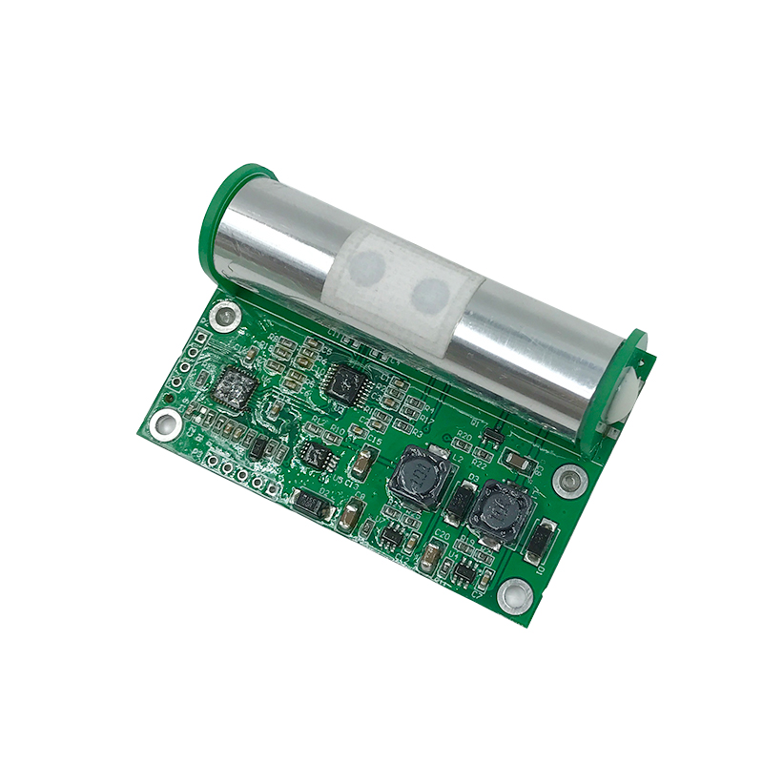

Communication protocol
Serial communication protocol: 9600,8,N,1 (baud rate 9600, no check bit, stop bit 1) total length 32 bytes, communication period: 1 second
Sensor active Upload concentration value, in the following format:
 |  | X | X | X | X | X |  | P | P | m | \r | \n
For example: output 12345 the PPM format is as follows (Hexadecimal):
20 | 20 | 3 1 | 3 2 | 3 3 | 3 4 | 3 5 | 20 | 70 | 70 | 6D | 0D | 0A
Among them 0X20 for spaces hexadecimal code, the output ends with a line break. , and does not retain decimal places

Reporting method
The gas module is divided into active reporting and passive inquiry. The default is active reporting mode.
Passive inquiry instructions:
FF 01 03 02 00 00 00 05 (This command is switched to inquiry upload)
FF 63 63 00 00 6F 6B 0D 0A (return answer frame indicates successful setting)
Proactively report instructions:
FF 01 03 01 00 00 00 04 (This command is switched to active upload)
FF 63 63 00 00 6F 6B 0D 0A (return answer frame indicates successful setting)

PWM input out (example)
SF6 concentration output range : 0ppm to 5000ppm SF6
Cycle : 1004ms ± 5%
How to obtain the calculation formula of the current SF6 concentration value through PWM:
Forward pulse width = PPM concentration value/5+2ms;
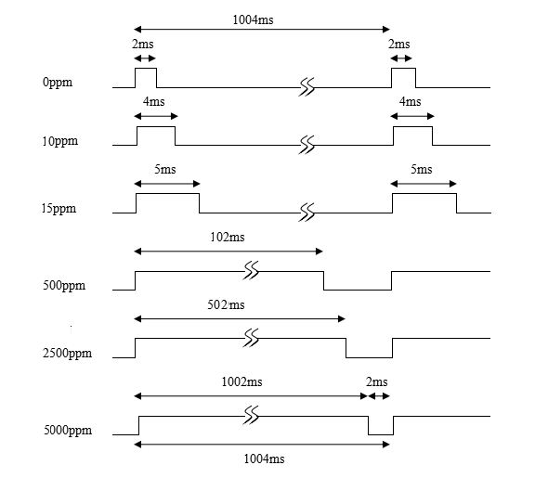

Appendix

Precautions for installation and use
This product interface uses a single row of needle spacing of 2.54mm;
Do not use the sensor for a long time in an environment with high dust density, please use the sensor within the power supply range of the sensor, and pay attention to the polarity of the power supply.

Warranty and after-sales
The warranty terms follow the after-sales terms, for the sensor host Circuit part of the warranty for two years, gas-sensitive probes for one year, accessories (Shell/plug/cable, etc.) warranty for three months.

