Residual chlorine in aqueous solution
Transmitter instructions
JXBS-3001- residual chlorine
Ver2.0

Product Profile

Product Overview
The residual chlorine tester is one of the intelligent on-line chemical analysis instruments. It is widely used in the continuous monitoring of residual chlorine value and temperature in thermal power, chemical fertilizer, metallurgy, environmental protection, pharmaceutical, biochemical, food and tap water solutions.
The monitoring data can be connected to the computer to realize the remote monitoring and recording through the MODBUS-RTU output connection recorder, and the RS485 interface can also be connected to the computer to realize the monitoring and recording through the MODBUS-RTU protocol. At the same time, the device has two relay interface, can set alarm point output

Functional characteristics
The probe is composed of residual chlorine glass electrode and silver chloride reference electrode. The signal is stable and the precision is high. With wide measurement range, good linearity, good waterproof performance, easy to use, easy to install, modular design of board, assembly configuration, use of 2.4-inch 128*64 dot screen, isolation RS485 output, less interference, isolation communication, residual chlorine measurement, temperature measurement, upper and lower limit control, high output, RS485 communication, configurable temperature manual, automatic compensation function, can set high and low alarm function and hysteresis, can set buzzer, LCD backlight switch function, increase universal password function, etc

Main parameters
Parameter Name | Parameters
DC Power Supply | 9-24V DC
Electricity consumption | ≤0.15 W (@12VDC ,25℃)
Measuring accuracy | ±5% or 0.05mg/L
Residual chlorine capacity | 0~2mg/L
Residual chlorine resolution | 0.001 mg/L
Output signal | 485/4-20 mA/0-10V
Working temperature | 5~50℃
Repeatability | ±4%
Product size
Probe size | 155 mm*12mm( Length*diameter)
Medium PH Range | 4~9 PH

Note: Probe cable length default is 5 m

Topology of product usage
The typical aqueous solution control system is shown in the following figure, including a whole system with control box as the core, in which the control box is connected with residual chlorine probe and the output acquisition processing is displayed. At the same time, the equipment can output RS-485 signal or analog signal to computer, PLC、 single chip microcomputer, etc.
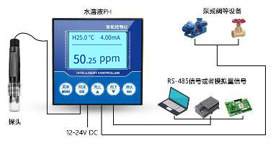

Hardware connection

Inspection of equipment before installation
Check the equipment list before installing the equipment:
Name of name | Quantity
LCD instrument control box | 1 unit
Conductivity probe | 1
12V waterproof power | 1(optional)
USB to 485 equipment | 1(optional)
Warranty card/certificate | 1

Interface description (primary function)
There are 14 terminals left on the back of the instrument. Next to each terminal, there are printed characters indicating what number of terminals the terminal is. The terminal has different functions. The specific functions are shown in the following table
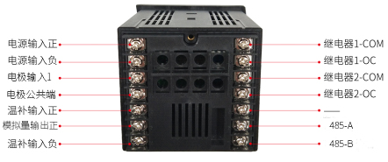
Terminal primary function:
Terminal | Primary function | Terminal | Primary function
8 | Power input positive | 1 | Relay 1- COM
9 | Power input negative | 2 | Relay 1- OC
10 | Electrode input 1 | 3 | Relay 2- COM
11 | electrode common end | 4 | Relay 2- OC
12 | Temperature supplement input positive | 5 | -
13 | Analog output positive | 6 | 485- A
14 | Negative temperature input | 7 | 485- B

When using, there will be labels on the probe line. Please follow the label to connect the warm patch line to 12 and 14 terminals (no polarity), at the same time, the electrode is positively connected to terminal 6, the electrode is negatively connected to terminal 7, and the electrode connection is polar.
Please be careful not to connect the wrong wiring sequence, the wrong wiring will cause the equipment to burn down. Please do not close the charged product to the signal terminal, which may cause trouble.

Interface function (second function)
Because the control box is widely used and has a variety of functions, there is a second function definition in some interfaces. Please note that the second function is a specific case selection. If the product you choose does not have a second function interface, you can skip this chapter.
Terminal 2 Function:
Terminal | Second function | Terminal | Primary function
8 | No | 1 | No
9 | No | 2 | No
10 | No | 3 | No
11 | No | 4 | No
12 | No | 5 | Electrode input 2
13 | Analog output | 6 | No
14 | No | 7 | electrode common end

Control box installation
The installation mode of the control box sensor is embedded installation mode, the product size is shown below.
Transmitter Front Dimension
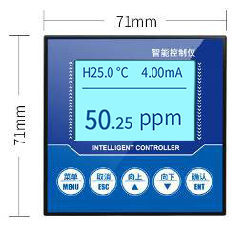

Side dimensions of transmitter
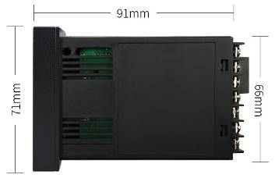

Install with a rectangular incision on the instrument cabinet or mounting panel, as shown below. Insert the instrument into the instrument cabinet and fix it with the installation frame on the back.
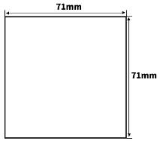
This instrument is disk mounted. Please install indoors, avoid wind and rain and direct sunlight. In order to prevent the internal temperature of this instrument from rising, please install it in a well ventilated place. When installing this instrument, please do not tilt left and right, as far as possible horizontal installation.
Special note: this instrument function is mainly detection and monitoring function, not specially used for control instrument, this instrument is equipped with relay switch output, generally used for alarm warning, if the user uses this function to participate in loop control, If the instrument failure may lead to major accidents or damage other equipment, emergency stop circuit and protection circuit must be set up, otherwise the company is not responsible.

Electrode installation
Electrodes are very precise components, must use the correct installation, the wrong installation will lead to electrode damage or irreversible damage. The electrode is piped. Immersion type. Flange installation can be.
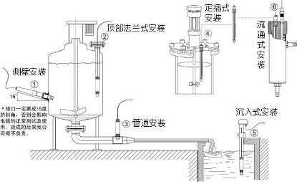
Please do not put the electrode directly into the water, should choose the electrode mounting bracket or circulation cup fixed. Before installation, be sure to use raw material belt (3/4 thread) to do waterproof and sealing work to avoid water entering the electrode, resulting in short circuit of electrode cable.
During the water stoppage, it is necessary to ensure that the electrode is immersed in the measured liquid or put on the protective cap of the inner protective liquid. In winter, the low temperature and long-term water stoppage should be added to the antifreeze device or recovered from the indoor water storage. Otherwise, it will shorten the service life.

Instrumentation function and use

Product interface and keys
The first line shows the current temperature and analog current,

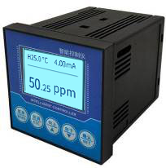
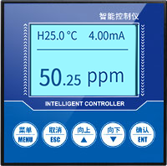
Identification | Key Name | Functional description
MENU | Menu keys | Click to enter the menu under Monitor Interface  Click Exit Menu Interface
ESC | Cancel key | You can return the upper layer between the relevant upper and lower layers under the menu interface
↑ | Upper key | Scroll data display under Monitor Interface  Select the menu under Menu Interface  Modify associated values under Settings
↓ | Down key | Scroll data display under Monitor Interface  Select the menu under Menu Interface  Modify associated values under Settings
NET | Confirm key | Locked Data Display under Monitor Interface  Enter submenu or confirm changes under menu interface

Settings menu
In the normal display interface, use the menu key to enter the enter password interface, the default password is four 0.
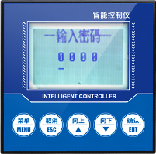
After entering the password correctly, press OK to enter the menu interface,

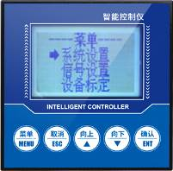
System Settings: includes buzzer and backlight settings, password changes and factory settings.
"Signal setting ": includes signal one, signal two; signal includes: electrode type and temperature compensation.
"Equipment calibration" includes residual chlorine calibration, residual chlorine modification, ORP calibration, ORP modification, EC calibration and EC modification.
"Remote Settings" includes RS485 and current fluctuations;
The alarm setting includes residual chlorine alarm, ORP alarm and EC alarm.
Information Query includes software and hardware versions.

4.2.1 System Settings
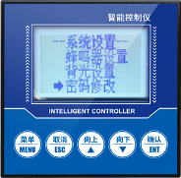
Buzzer Settings: Set the buzzer switch when alarm.
Backlight Settings: Background brightness and screen time can be set.
Password Modification: You can open or close a password and change it.
Does "factory setting" restore pre-factory setting
4.2.2 signal settings
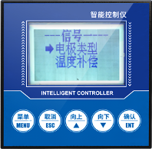
Electrode type: set the type of electrode, residual chlorine electrode and conductivity electrode two types.
Temperature compensation: set up automatic or manual temperature compensation, temperature range-20-80℃

4.2.3 Online Calibration
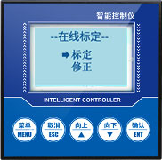
Residual chlorine calibration: after entering the residual chlorine calibration screen, the residual chlorine electrode is put into the 4.00 residual chlorine standard solution for a moment. After the number is stable, press the confirmation key, then put the residual chlorine electrode in the 6.86 residual chlorine standard solution for a moment. number is stable, press the confirmation key. Finally, put the residual chlorine electrode into 9.18 residual chlorine standard solution In the standard solution, stand still for a moment. After the number is stable, press the confirmation key to show that after the calibration is successful, the residual chlorine calibration process is over.
Residual chlorine correction: the measured residual chlorine can be corrected.

4.2.4 remote settings
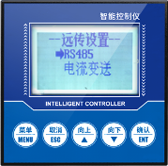
Remote Settings: includes 485 and analog communication modes. RS485： set the address and baud rate of 485 communication.
Current timing: set 4-20 mA output corresponding values and 20 mA corresponding values.

4.2.5 Alarm Settings
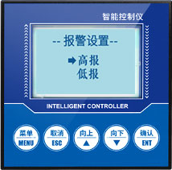
Residual chlorine high report: when the measured value is greater than the high report suction value, the high report relay absorbs, when the measured value is less than the high report disconnect value, the high report relay disconnects.
Residual chlorine understatement: when the measured value is less than the underreported suction value, the underreported relay is sucked, and when the measured value is greater than the underreported disconnection value, the underreported relay is disconnected.

4.2.6 Information Query
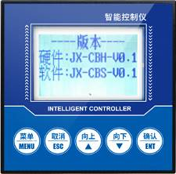
Version information: query the current hardware and software version, strong traceability.

Chapter 5 485 Interface Communication Protocol

Basic communications parameters
Parameters | Content
Code | 8-bit binary
Data bits | 8
parity bit | No
Stop position | 1 person
Error calibration | CRC long loop code
baud rate | bps/4800bps/9600bps 2400, factory default 9600 bps
Code | 8-bit binary

Data frame format definition
Adopt the Modbus-RTU protocol as follows:
Initial structure >=4 bytes time
Address =1 byte
Function =1 byte
Data =N bytes
Error check =16-bit CRC code
End structure >=4 bytes of time
Address code: the address of the transmitter, unique in the inquiry network (factory default 0 x01).
Function code: the host sends the instruction function prompt, this transmitter only uses the function code 0 x03( reads the memory data).
Data area: data area is a specific query area, note that 16 bits data high byte before
CRC code: two-byte check code.
Question frame
Address code | Functional code | Register Start Address | Register length | Check the low bit | Check the high bit
1 byte | 1 byte | 2 bytes | 2 bytes | 1 byte | 1 byte
Response frames
Address code | Functional code | Number of valid bytes | Data area I | Second Data Area | N data area
1 byte | 1 byte | 1 byte | 2 bytes | 2 bytes | 2 bytes

Register address
Register address | PLC Configuration Address | Content | Operation
0001H | 40002 | Temperature (℃0.1) | Read only
0002H | 40003 | Residual chlorine value (unit 01 residual chlorine).0 | Read only
0100H | 40101 | Equipment address (0-252) | Read and write
0101H | 40102 | baud rate (2400/4800/9600) | Read and write

Examples of communication protocols and explanations

Read residual chlorine values x01 device address 0
Question frame
Address code | Functional code | Starting address | Data length | Check the low bit | Check the high bit
x01 0 | x03 0 | x00,0x02 0 | x00,0x01 0 | x 25 0 | xCA 0
Answer frame (e.g. reads NTU 189 residual chlorine)
Address code | Functional code | Number of valid bytes | Residual chlorine value | Checking code  Low | Checking code  High
x01 0 | x03 0 | x02 0 | x00 0 xBD 0 | x78 0 | x35 0
Residual chlorine:
00BD H( hexadecimal)=189=> residual chlorine =1 residual chlorine.89

Read the temperature value x01 device address 0
Question frame
Address code | Functional code | Starting address | Data length | Check the low bit | Check the high bit
x01 0 | x03 0 | x00,0x01 0 | x00,0x01 0 | xd5 0 | xca 0
Response frames
Address code | Functional code | Number of valid bytes | Temperature value | Checking code  Low | Checking code  High
x01 0 | x03 0 | x02 0 | x00 0  xAF 0 | xDB 0 | xBF 0
Temperature:
00AF H( hexadecimal)=175=> temperature =17.5℃

Equipment address 0 x01 temperature, residual chlorine concentration
Question frame
Address code | Functional code | Starting address | Data length | Check the low bit | Check the high bit
x01 0 | x03 0 | x00,0x01 0 | x00,0x02 0 | x 95 0 | xCB 0

Response frames
Address code | Functional code | Number of valid bytes | Temperature value | Residual chlorine value | Checking code  Low | Checking code  High
x01 0 | x03 0 | x04 0 | x 01 0  x 1b 0 | x00 0  x 28 0 | xDB 0 | xBF 0
Temperature:
011B H( hexadecimal)=283=> temperature =28.3℃
Residual chlorine:
0028H( hexadecimal)=40=> residual chlorine =0.40 residual chlorine

Analog wiring instructions
Analog sensor wiring is simple, only need to connect the line to the specified port of the device. The equipment supports 3/4 wire connection.

Typical 4-wire connection
As shown in the following figure, the power line (brown line and black line) of the sensor is connected to the power supply, the yellow (gray) color line of the sensor is the signal positive connected to the acquisition equipment, and the current flow direction is the sensor to the acquisition equipment;
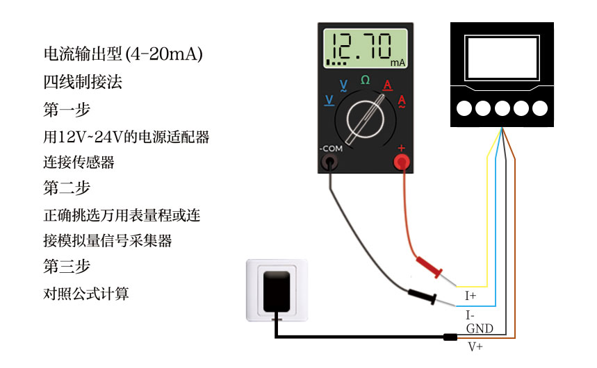
As shown in the following figure, the power line of the sensor (brown line and black line) is connected to the power supply, the yellow (gray) color line of the sensor is the signal positive and the yellow (gray) line voltage is the output voltage, the blue line of the sensor is the signal negative, the blue line is the reference voltage, and the black line voltage is 0 V.
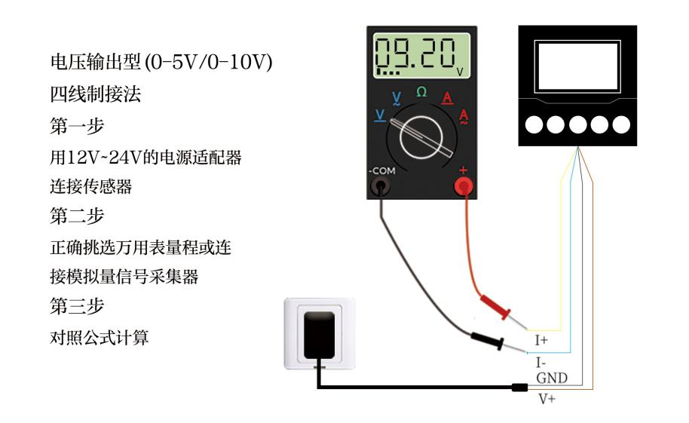

Typical 3-wire connection mode
For the typical three-wire connection, compared with the four-wire connection mode, the blue line can be omitted, and the blue line and the black line in the sensor are in the middle and short circuit of the sensor, so the blue line can be omitted.
For the three-wire current connection mode, after connecting the power line (brown wire and black line) of the sensor to the power supply, it is only necessary to take the yellow (gray) color line of the sensor as the signal of the signal positively connected to the current acquisition equipment.
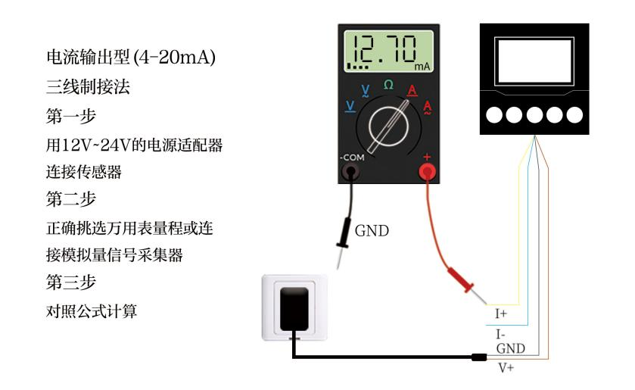
For the three-wire voltage connection mode, after the power line (brown wire and black line) of the sensor is connected to the power supply, it is only necessary to take the yellow (gray) color line of the sensor as the signal of the signal positively connected to the voltage acquisition equipment.
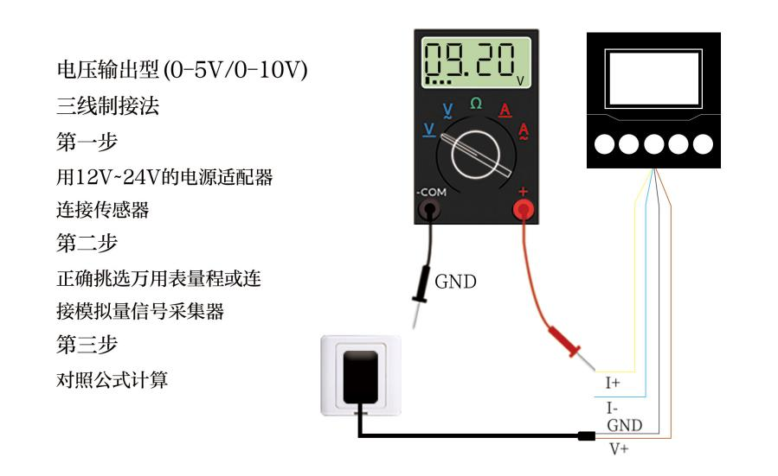

Meaning and Conversion of Analog Parameters

Analog 4-20 mA Current Output
Current value | Residual chlorine
mA 4 | 0
mA 20 | Full range
Calculation formula P₍Residual chlorine₎= I_{(Current)}-4 mA)* full range/16 mA
The I units are mA. units Take 4 mA for 0 points and 20 mA for maximum linear conversion.
Among them ,12 mA represent 7% residual chlorine.00

Analog 0-10 V Voltage Output
Voltage value | Residual chlorine
0V | 0
10V | Full range
Calculation formula P₍Residual chlorine₎=V_{(Voltage)}:: Full range/5000 mV
The V unit is mV, please use 0 V to represent 0 points and 10 points to represent the maximum range linear conversion.
mV 2500 represents 7% of the residual chlorine.00

Analog 0-5 V Voltage Output
Voltage value | Residual chlorine
0V | 0
5V | Full range
Calculation formula P₍Residual chlorine₎=V_{(Voltage)}:: Full range/10000 mV
The V unit is mV, please use 0 V to represent 0 points and 10 points to represent the maximum range linear conversion.
Among them ,5000 mV represent 7% residual chlorine.00

