Aqueous nitrate
Operation Manual of transmitter
JXBS-3001-Nitrate radical
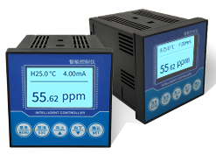
Ver2.0

Product introduction

Brief introduction
Nitrate Tester is one of the intelligent on-line chemical analysis instruments, it is widely used in thermal power, chemical fertilizer, metallurgy, environmental protection, pharmaceutical, biochemical, food and tap water and other solutions in the continuous monitoring of nitrate value and temperature. The monitoring data can be monitored and recorded remotely by a variable output connection recorder, or it can be connected to a computer via the RS485 interface via the MODBUS-RTU protocol. At the same time the equipment has 2-way relay interface, can set the alarm point output

Function
The probe is composed of glass nitrate electrode and silver chloride silver reference electrode. The signal is stable and the precision is high. With a wide measuring range, good linear, waterproof performance, easy to use, easy to install, board card Modular design, assembly configuration, using 2.4 inches 128 * 64 lattice screen, isolation transmission output, less interference, isolated RS485 communication, nitrate measurement, temperature measurement, upper and lower limit control, variable output, RS485 communication, configurable temperature manual, automatic compensation, high and low alarm setting, and hysteresis, can be set buzzer, LCD backlight switch function, increase the function of universal password

Main parameters
Parameter name | Options of parameters
DC power supply | 9-24V DC
Power usage | ≤0.15W（@12V DC , 25℃）
Measurement precision | 5%F.s
Nitrate radical range | 0-1000ppm(default）/0-5000ppm/0-10000ppm
Nitrate radical resolution | 0.1ppm（default）
Output signal | 485/4-20mA/0-10V
Temperature range | Continues 0~80℃，indirectly 81℃~100℃
Repeatability | ±4%
Product dimensions
Probe dimensions | 155mm*12mm（length*diameter）
PH range | 2~12
Interfering Ion | BF4-, Cl-, ClO4-, CN-，I-，NO2-, HCO3

·Note: The default length of probe cable is 5 meters

Product usage topology
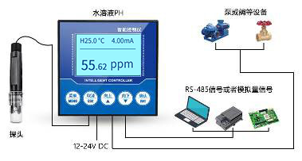
Typical aqueous solution control systems are shown below, including an integrated system with the control box as the core, in which the control box is connected to the nitrate probe and the output acquisition processing is shown, at the same time, the device can output RS-485 signal or analog signal to the computer, PLC, SCM, etc. . At the same time, the back-end of the relay can do a variety of relay control and alarm, can control the pump or valve and other equipment.

Hardware connection

Check of pre-install equipment
Pre-install equipment check list：
Name | Number
LCD Instrument Control Box | 1 piece
Electricity probe | 1 piece
12V waterproof power supply | 1 piece（choice）
USB into 485 equipment | 1 piece（choice）
Warranty card/certificate of compliance | 1 piece

Interface description（main function）
On the back of the instrument, there are 14 terminals. Next to each terminal is printed the number of terminals. The terminals have different functions, as shown in the following table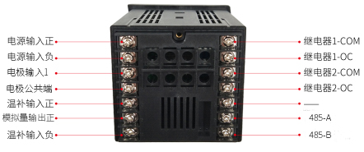
Terminal Primary function：
Terminal | Main function | Terminal | Main function
8 | Power input plus | 1 | Relay 1-COM
9 | Power input minus | 2 | Relay 1-OC
10 | Electricity input 1 | 3 | Relay 2-COM
11 | Electrode common terminal | 4 | Relay 2-OC
12 | Warm input plus | 5 | -
13 | Analog output plus | 6 | 485-A
14 | Warm input minus | 7 | 485-B

When in use, there will be a label on the probe wire. Please follow the label and connect the warm-up wire to terminals 12 and 14(regardless of polarity) , and connect the electrode to terminal 6 positively, the electrode negative to Terminal 7, the electrode is connected with polarity, so please do not reverse, if there is a shielded line, just need to shield line connected to 14 terminals can be.

Please take care not to connect in the wrong order, the wrong wiring will cause the equipment to burn out. Please do not put live products near the signal terminal, may cause failure.

Interface function（second function）
Because the control box has a wide range of uses and functions, there is a second function definition in some interfaces. Please note that the second function is optional in certain situations.
Terminal function：
Terminal | Second function | Terminal | Main function
8 | 无 | 1 | 无
9 | 无 | 2 | 无
10 | 无 | 3 | 无
11 | 无 | 4 | 无
12 | 无 | 5 | Electrode input 2
13 | Analog output | 6 | 无
14 | 无 | 7 | Common Terminal

Control box installation
The installation mode of the control box sensor is the embedded installation mode. The dimensions of the product are shown in the figure below.
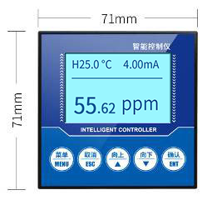
Front dimension of Transmitter

Side dimension of transmitter
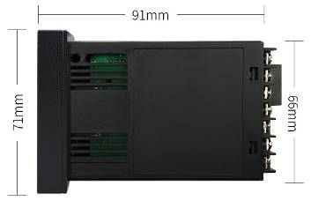

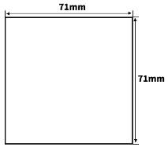
Make a rectangular incision in the instrument panel or mounting panel during installation, as shown below. The instrument can be installed by inserting the instrument into the instrument cabinet and fixing it with the mounting frame of the instrument on the back.
This instrument is disk mounted. Please install it indoors, away from wind, rain and direct sunlight. In order to prevent the instrument internal temperature rise, please install in a well-ventilated place. When installing this instrument, please do not tilt left or right, as far as possible horizontal installation. Special attention: The function of this instrument is mainly detection and transmission function, not specially used for control instrument, this instrument is equipped with relay switch output, generally used for alarm prompt primarily, if users use this function to participate in loop control, if the instrument failure may lead to major accidents or damage to other equipment, it is necessary to set up an emergency stop circuit and protection circuit complementary, otherwise the consequences, the company will not be responsible.

Electrode mounting
The electrode is a very precise assembly and must be installed in the correct way, which can lead to damage or irreversible damage to the electrode. The electrode is installed by pipeline. Immersion. Flange can be installed.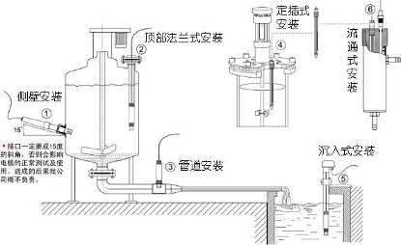
Please do not put the electrode directly into the water, should choose the electrode mounting bracket or flow cup fixed. Before installation, please make sure to use raw material tape (3/4 thread) to do waterproof sealing work, to avoid water into the electrode, resulting in electrode cable short circuit. During the water cut-off period, to ensure that the electrode is immersed in the liquid under test or wear a protective cap with built-in protective liquid, low temperature in winter long-term water cut-off to add anti-freezing device or withdraw indoor water storage. Otherwise, it will shorten the service life.

Function and use of instrument

Product home screen and buttons
The first line shows the current temperature and analog current，

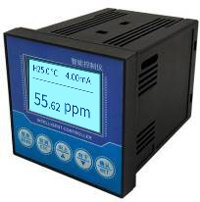
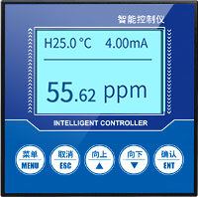
标识 | 按键名 | 功能描述
MENU | Menu | "monitor interface" press enter menu"menu interface" press exit menu can be in
ESC | Cancel | You can return to the upper layer between the relevant upper and lower layers of the "menu interface"
↑ | Up | scroll the data under "monitor interface"  select the relevant menu under "menu interface"  modify the relevant values under "settings status"
↓ | down | "monitoring interface" scroll data display  "menu interface" to select the relevant menu  Set Status to modify the associated value
NET | Confirm | "monitor interface" under the lock data display  "menu interface" under the sub-menu or confirm changes

Settings menu
In the normal display interface, use the [ menu ] key to enter the "password" interface, the default password is four 0. Enter your password correctly, then press the "confirm" button to enter the "menu" interface，

"system settings" : including, Buzzer and backlight settings, password changes and factory settings. "Signal Setting" : including signal one, Signal Two; signal includes: electrode type and temperature compensation. "equipment calibration" includes nitrate calibration, nitrate calibration, ORP calibration, ORP calibration, EC calibration, EC modification. "Remote Setting" includes RS485 and current transmission; "alarm setting" includes nitrate level alarm, ORP level alarm and EC level alarm. "Information Query" includes hardware and software versions.
4.2.1 System setting
"BUZZER setting" : set the alarm buzzer switch. "backlight settings" : You can set the background brightness and brightness screen time. "Password Modification" : You can turn your password on or off and change it. Whether factory settings reverts to their pre-factory settings
4.2.2 Signal setting
ELECTRODE TYPE: set the type of electrode, nitrate electrode and conductivity electrode two types. Temperature compensation: set automatic or manual temperature compensation, temperature range-20-80 °C

4.2.3 On-line calibration
Nitrate calibration: After entering the nitrate calibration screen, the nitrate electrode is first placed in the 4.00 nitrate standard solution, and is left for a while. After the display is stable, press the confirmation key, and then the nitrate electrode is placed in the 6.86 nitrate standard solution, the nitrate electrode is placed in 9.18 nitrate solution. The nitrate electrode is placed in the standard solution. After the display is stable, the confirmation key is pressed to show that the calibration is successful, nitrate calibration complete. Nitrate Correction: The measured nitrate can be corrected.
4.2.4 Remote setting
"Remote Settings" : contains 485 and analog communication mode. RS485: Sets the address and Baud rate of the 485 communication. Electrorheological transmission: Set 4-20 Ma output to 4 ma and 20 MA output.

4.2.5 Alarming setting
Nitrate overstatement: When the measured value is greater than the overstatement suction value, the overstatement relay suction, when the measured value is less than the overstatement opening value, the overstatement relay disconnect. UNDERREPORTING OF NITRATE: When the measured value is less than the underreporting value, the underreporting relay attracts, when the measured value is greater than the underreporting value, the underreporting relay disconnects.
4.2.6 Information getting
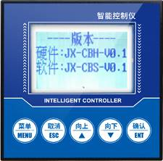
Version Information: Query the current version of hardware and software, strong traceability.

第5章 485 interface communication protocol

Primary communication parameter
Parameter | Option
Cod | 8 bit Binary system
Data bit | 8 bit
Parity bit | None
Stop bit | 1 bit
Miscalibration | CRC Redundant Cyclic Code
Baud rate | 2400bps/4800bps/9600 bps built, default output 9600bps
Cod | 8 bit Binary system

Data frame format definition
Using Modbus-RTU communication protocol,
the format is as follows:
Initial Structure & GT; = 4 Byte Time
Address code = 1 byte
function code = 1 byte
data area = N byte
error check = 16 Bit
Code End Structure & GT; = 4 Byte
Time Address Code: Address of transmitter, is Unique in a pass-through network (factory default 0x01).
Function Code: The instructions sent by the host function prompt, this transmitter only use function code 0x03(read memory data) .
Data Area: Data area is the number of specific queries area, Note 16 bits of data high bytes before CRC Code: Two Bytes of parity code.
问询帧
地址码 | 功能码 | 寄存器起始地址 | 寄存器长度 | 校验码低位 | 校验码高位
1字节 | 1字节 | 2字节 | 2字节 | 1字节 | 1字节
应答帧
地址码 | 功能码 | 有效字节数 | 数据一区 | 第二数据区 | 第N数据区
1字节 | 1字节 | 1字节 | 2字节 | 2字节 | 2字节

寄存器地址
寄存器地址 | PLC组态地址 | 内容 | 操作
0001H | 40002 | 温度(单位0.1℃) | 只读
0002H | 40003 | 硝酸根值（单位0.01硝酸根） | 只读
0100H | 40101 | 设备地址(0-252) | 读写
0101H | 40102 | 波特率(2400/4800/9600) | 读写

通讯协议示例以及解释

读取设备地址0x01的硝酸根值
问询帧
地址码 | 功能码 | 起始地址 | 数据长度 | 校验码低位 | 校验码高位
0x01 | 0x03 | 0x00,0x02 | 0x00,0x01 | 0x25 | 0xCA
应答帧(例如读到硝酸根值为189NTU)
地址码 | 功能码 | 有效字节数 | 硝酸根值 | 校验码  低位 | 校验码  高位
0x01 | 0x03 | 0x02 | 0x00 0xBD | 0x78 | 0x35
硝酸根：
00BD H(十六进制)=189=>硝酸根=1.89硝酸根

读取设备地址0x01的温度值
问询帧
地址码 | 功能码 | 起始地址 | 数据长度 | 校验码低位 | 校验码高位
0x01 | 0x03 | 0x00,0x01 | 0x00,0x01 | 0xd5 | 0xca
应答帧
地址码 | 功能码 | 有效字节数 | 温度值 | 校验码  低位 | 校验码  高位
0x01 | 0x03 | 0x02 | 0x00  0xAF | 0xDB | 0xBF
温度：
00AF H(十六进制)=175=>温度=17.5℃

读取设备地址0x01温度、硝酸根浓度值
问询帧
地址码 | 功能码 | 起始地址 | 数据长度 | 校验码低位 | 校验码高位
0x01 | 0x03 | 0x00,0x01 | 0x00,0x02 | 0x95 | 0xCB

应答帧
地址码 | 功能码 | 有效字节数 | 温度值 | 硝酸根值 | 校验码  低位 | 校验码  高位
0x01 | 0x03 | 0x04 | 0x01  0x1b | 0x00  0x28 | 0xDB | 0xBF
温度：
011B H(十六进制)=283=>温度=28.3℃
硝酸根：
0028 H(十六进制)=40=>硝酸根=0.40硝酸根

模拟量接线说明
模拟量型传感器接线简单，只需要将线与设备的指定端口连接即可。设备支持3/4线制接线方式。

典型四线制接线方式
如下图所示为电流型传感器接线方式，将传感器的电源线(棕线与黑线)接入电源；传感器的黄(灰)色线为信号正接入采集设备的信号正，电流流向为传感器到采集设备；传感器的蓝色线为信号正接入电流采集设备的信号负，电流流向为采集设备到传感器；
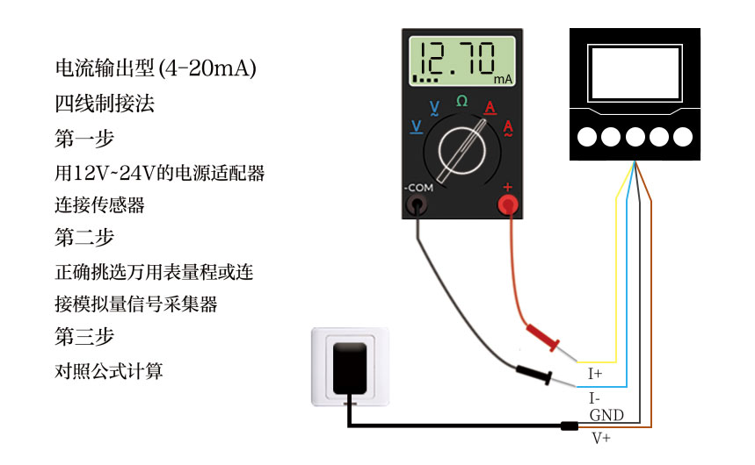
如下图所示为电压型传感器接线方式，将传感器的电源线(棕线与黑线)接入电源；传感器的黄(灰)色线为信号正接入采集设备的信号正，黄(灰)线的电压为输出电压；传感器的蓝色线为信号正接入电压采集设备的信号负，蓝线的电压为参考电压，与黑线电压一致为0V。
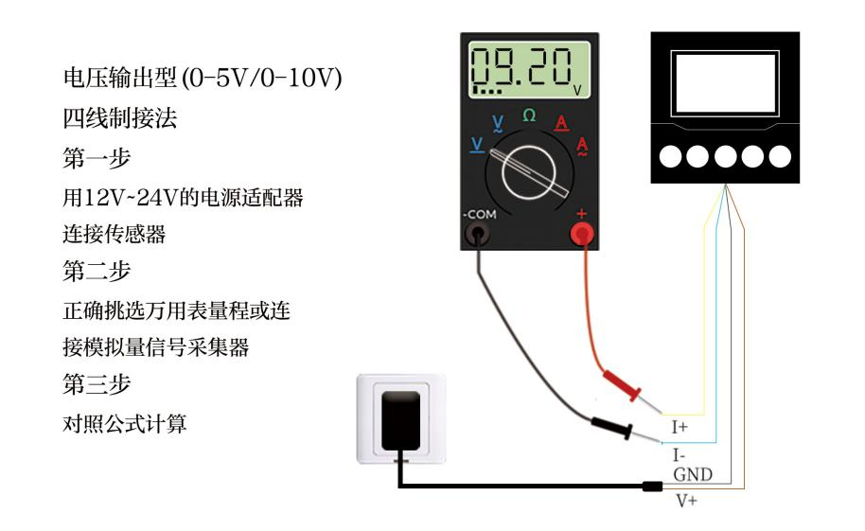

典型三线制接线方式
对于典型的三线制接线，相较于四线制接线方式，省略蓝线即可，在传感器中蓝线与黑线在传感器中短路，因此可以省略蓝线。
对于三线制电流接线方式，将传感器的电源线(棕线与黑线)接入电源后，只需要将传感器的黄(灰)色线为信号正接入电流采集设备的信号正即可。
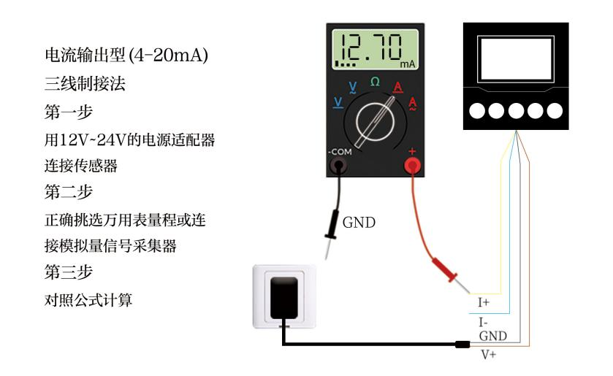
对于三线制电压接线方式，将传感器的电源线(棕线与黑线)接入电源后，只需要将传感器的黄(灰)色线为信号正接入电压采集设备的信号正即可。
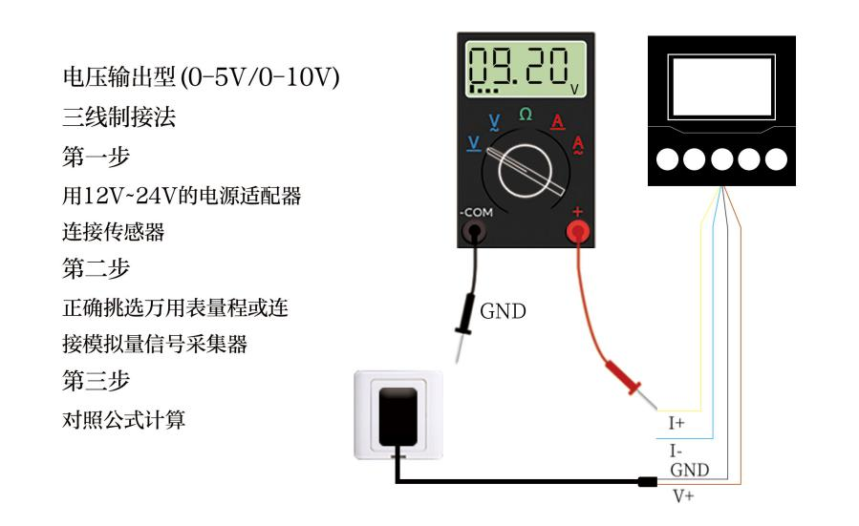

模拟量参数含义与换算

模拟量4-20mA电流输出
电流值 | 硝酸根
4mA | 0
20mA | 满量程
计算公式为P₍硝酸根₎=(I_{(电流)}-4mA)*满量程/16mA
其中I的单位为mA。以4mA代表0点，20mA代表最大量程线性换算即可。
其中12mA代表硝酸根为7.00

模拟量0-10V电压输出
电压值 | 硝酸根
0V | 0
10V | 满量程
计算公式为P₍硝酸根₎=V_{(电压)} *满量程/5000mV
其中V的单位为mV,请以0V代表0点，10V代表最大量程线性换算即可。
其中2500mV代表硝酸根为7.00

模拟量0-5V电压输出
电压值 | 硝酸根
0V | 0
5V | 满量程
计算公式为P₍硝酸根₎=V_{(电压)} *满量程/10000mV
其中V的单位为mV,请以0V代表0点，10V代表最大量程线性换算即可。
其中5000mV代表硝酸根为7.00

