
485 Type
Input liquid level transmitter
Instruction Manual
JXBS-3001-Level
Ver2.0

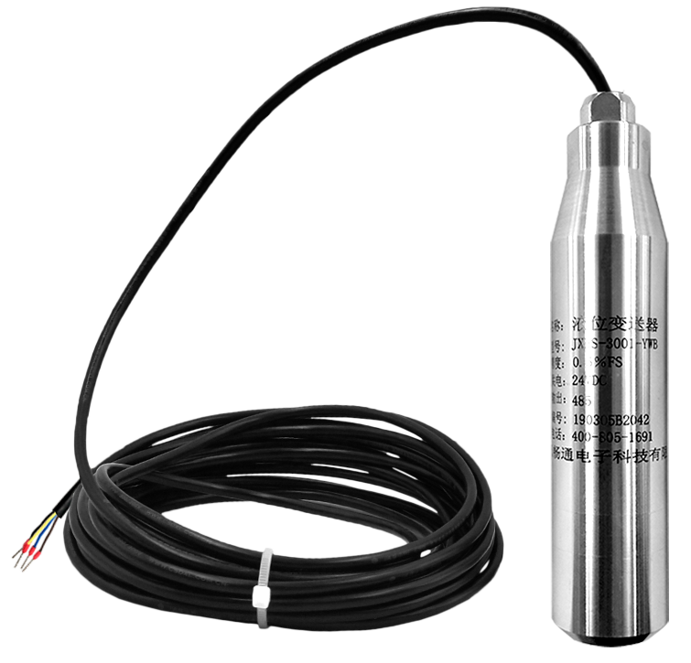

Chapter 1 Product Overview
JXBS-3001-Level series transmitters are mainly composed of imported pressure measuring element sensors, measuring circuits and process connectors. It can convert the pressure signal parameters felt by the pressure measuring element into the standard liquid level signal.
When the sensor is put into a certain depth of the liquid under test, the pressure of the medium under test
The force is introduced into the positive pressure chamber of the sensor, and the atmospheric pressure Po on the liquid level is connected with the negative pressure chamber of the sensor through the cable duct to counteract the Po, on the front of the sensor so that the pressure can be measured. The depth of the liquid level can be obtained.

Feature
This product adopts imported diffusion silicon pressure detection sensor, the signal is stable and the precision is high. Anti-interference, small temperature drift, high stability, high measurement accuracy, is an ideal liquid level measuring instrument in the field of industrial automation.

Main Character
Parameter | Technical indicators
Measuring medium | water (H2O) or compatible with contact material
Type of probe | Imported diffused silicon
Precision | Level 0.5(default)/0.3/0.1
Medium temperature | 0-70℃
Output signal | 485
Working voltage | 9-24V DC
Stability | ±0.1% FS/year
Unsensitive area | ≤±1.0%Fs
Range | 1~50meter

Wiring extension structure
The transmitter can be connected to separate use, first using 12 V DC power supply, the equipment can be directly connected with 485 interface PLC, can be connected through 485 interface chip MCU. The MCU and PLC can be programmed with the transmitter through the modbus protocol specified later. At the same time, use USB to 485 to connect with the computer, using our company to provide transmitter configuration tools for configuration and testing.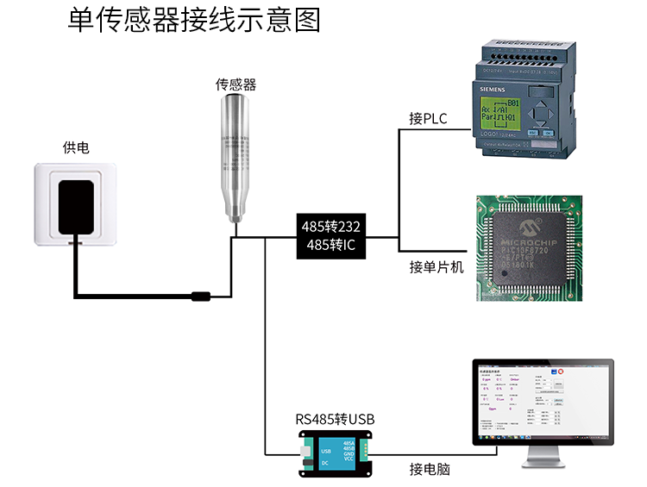

This product can also be used by multiple transmitters in a 485 bus. Please follow the 485 bus field wiring code (see appendix). Theoretically, a bus can connect more than 16 485 transmitters. If more 485 transmitters are needed ,485 repeaters can be used to expand more 485 devices, and the other end is connected to a single chip through a 485 interface chip. Or use USB to 485 to connect to the computer, using our transmitter configuration tools for configuration and testing.
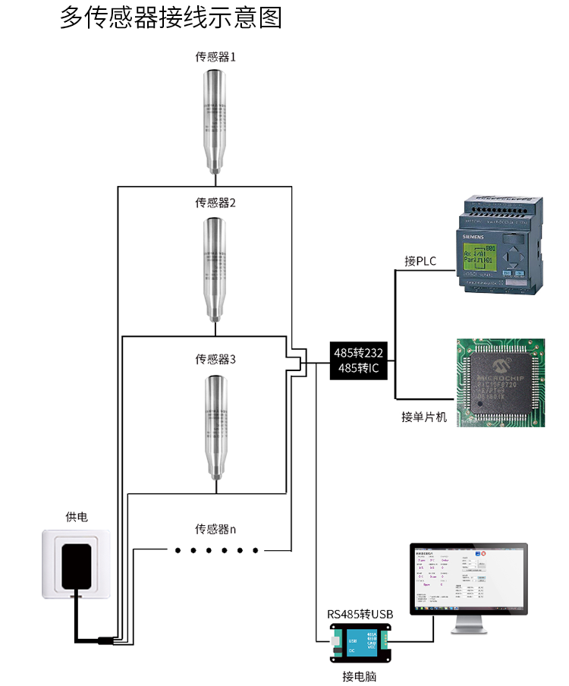

Chapter 2 Hardware connection

2.1 Inspection of equipment before installation
Check the equipment list before installing the equipment:
Name | Quantity
Level transmitter equipment | 1pc
12VWaterproof power | 1pc（optional）
USB to 485 equipment | 1pc（optional）
Warranty card/certificate | 1pc

2.2 Product size
This product support size diagram is shown below:
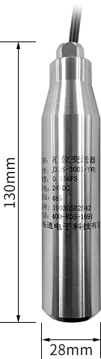

2.3 Interface description
Product default wiring for measuring range length of 0.6 meters, line sequence definition as shown in the following table:
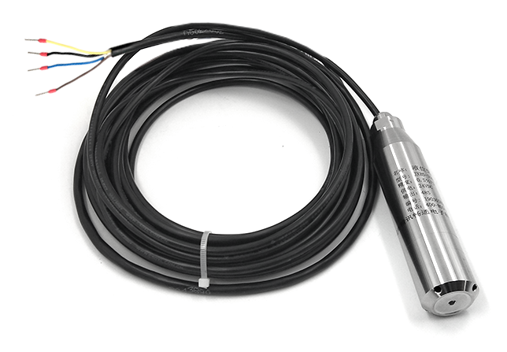

 | Line colour | Note
Power | Brown | Positive Power(9-24VDC)
Power | Black | Negative Power
Communications | Yellow(gray) | 485-A
Communications | Blue | 485-B

2.4 Product installation
The transmitter can be installed vertically, tilted or horizontally in the tank and tank. It is necessary to install the transmitter to the bottom of the medium under test, while ensuring that impurities such as sediment are not buried or blocked in the probe part of the transmitter. Do not throw it at will. Do not use brute force when installing the transmitter.
In addition to power supply and signal transmission, the air conduction cable also plays a key role in atmospheric compensation. When installing, it should avoid locking the cable too tight or bending too sharp angle to prevent the gas conduction pipe from breaking or breaking.

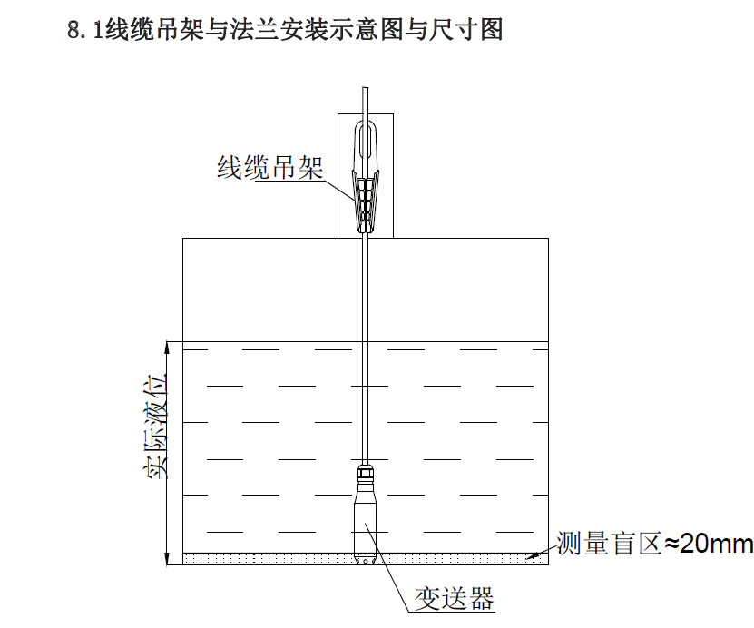

Chapter 3 Configuration Software Installation and Use
Our company provides supporting "sensor monitoring software", which can easily use the computer to read the transmitter's parameters, and flexibly modify the transmitter's device ID and address.

3.1 Transmitter to computer
When the transmitter is connected to the computer through the USB to 485 correctly and provides power supply, you can see the correct COM port in the computer (see the COM port in my computer-property-device manager-port).
。
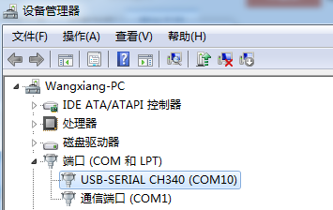
As shown above, your serial number is COM10, remember this serial port, you need to fill in the transmitter monitoring software.
If no COM port is found in the device manager, it means that you did not insert USB turn 485 or install the driver correctly. Please contact the technician for help.

3.2 Use of transmitter monitoring software
The configuration interface is shown in figure. First, the serial port number is obtained according to the method of section 3.1 and the correct serial port is selected. Then, all devices and baud rates on the current 485 bus can be automatically detected by clicking to automatically obtain the current baud rate and address. Note that there is only one transmitter on the 485 bus when using software automatic acquisition.
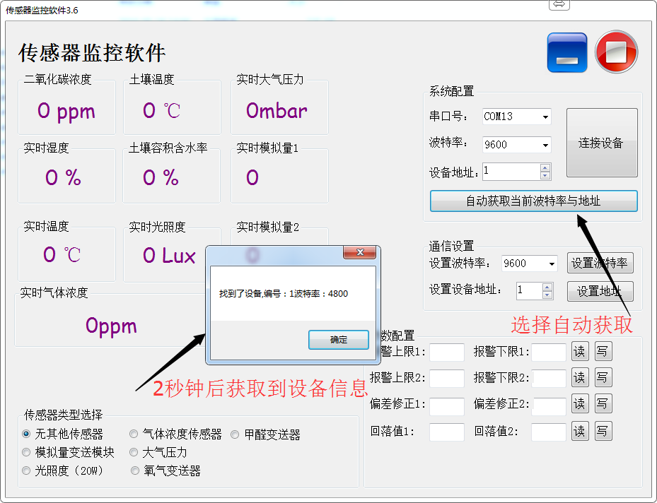
Then click on the connection device to obtain transmitter data information in real time.
If your equipment is a gas concentration transmitter, select "gas concentration transmitter" at transmitter type, formaldehyde transmitter "formaldehyde transmitter ", analog transmitter" analog transmitter ", atmospheric pressure transmitter "atmospheric pressure transmitter ", illuminance transmitter" illuminance 20 W", oxygen transmitter "oxygen transmitter ", other transmitters choose default" no other transmitter ".

4.3 Change baud rate and equipment ID
When disconnecting the device, click on the device baud rate and setting address in the communication settings to complete the relevant settings. Please restart the device after setting up. Then "automatically get the current baud rate and address" you can find that the address and baud rate have been changed to the address and baud rate you need.

Chapter 5 Communication protocol

5.1 Basic communications parameters
Parameter | Content
Code | 8-bit binary
Data bits | 8 bit
Parity bit | none
Stop position | 1bit
Error calibration | CRC Long loop code
baud rate | 2400bps/4800bps/9600bps Can be set, factory default is 9600 bps

5.2 Data frame format definition
Adopt the Modbus-RTU communication protocol in the following format:
Initial structure ≥4 bytes time

Address =1 byte

Function =1 byte

Data =N bytes

Error check =16-bit CRC code

End structure ≥4 bytes of time

Address code: for transmitter function indication, this transmitter only uses function code 0 x03( read register data).

Data area: the data area is a specific address, unique in the communication network (factory default 0 x01).

Function code: the host issued instructions to communicate data, pay attention to 16 bits data high bytes in front!

CRC code: two-byte check code.

Question frame
Address Code | Functional Code | Register address | Register Length | Check code low bit | Check code high bit
1bytes | 1bytes | 2bytes | 2bytes | 1bytes | 1bytes
Response frames
Address Code | Functional Code | Effective  bytes | First  Data area | Second  Data area | Data area
1bytes | 1bytes | 1bytes | 2bytes | 2bytes | 2bytes

5.3 Register address
Register address | PLC Configuration address | Content | Operation
0000H | 40001 | Liquid level (0.01 m) | Read only
0100H | 40101 | Device address(0-252) | Read and write
0101H | 40102 | baud rate(2400/4800/9600) | Read and write

5.4 Examples of communication protocols and explanations
Read the level value of the device address 0x01：
Question frame
Address Code | Functional Code | Starting address | Data length | Check code low bit | Check the high bit
0x01 | 0x03 | 0x00,0x00 | 0x00,0x01 | 0x84 | 0x0A
Response frame (assuming reading level is 2.09 m)
Address Code | Functional Code | Effective bytes value | TVOC  value | Check code low bit | Check code high bit
0x01 | 0x03 | 0x02 | 0x00  0xD1 | 0x78 | 0x18
00D1 H(Hexadecimal)=209=>Level value=2.09m

Appendix

5.5 Product Additional Instructions
485 Equipment Field Wiring Manual: describes 485 product wiring guidelines, please check and follow the guidelines, otherwise may lead to communication instability and so on.

Revision of temperature and humidity deviation of 485 Transmitter: Describes how to confirm and adjust temperature and humidity deviation when you feel that there is a deviation in temperature and humidity.

Using modbus Modifying Device baud rate and address: describes using modbus instructions to modify baud rate and slave number if software is not used.

"How to use single-chip microcomputer for 485 communication ": describes how to use 51 single-chip microcomputer read out transmitter information, and some basic knowledge of popular science.

"How to compute CRC16》： describes how to compute CRC16 in a modbus RTU protocol and how to use examples C language programs.

How to use USB to 485 auxiliary debugging when there is a communication problem with the read transmitter: describes how to use auxiliary tools to solve and check when there is a communication problem.

"How to use and set up product alarm function ": describes the optional product alarm function, how to use, how to connect and so on.

5.6 Quality Assurance and After-sale
Quality assurance terms follow Weihai JXCT Electronic Technology Co., Ltd. Transmitter after-sale terms, for transmitter mainframe circuit part of the warranty for two years, gas sensor quality assurance for one year, accessories (shell / plug / cable, etc.) warranty for three months.

