
Input liquid level transmitter
Instruction Manual
JXBS-3001-Level
Ver2.0

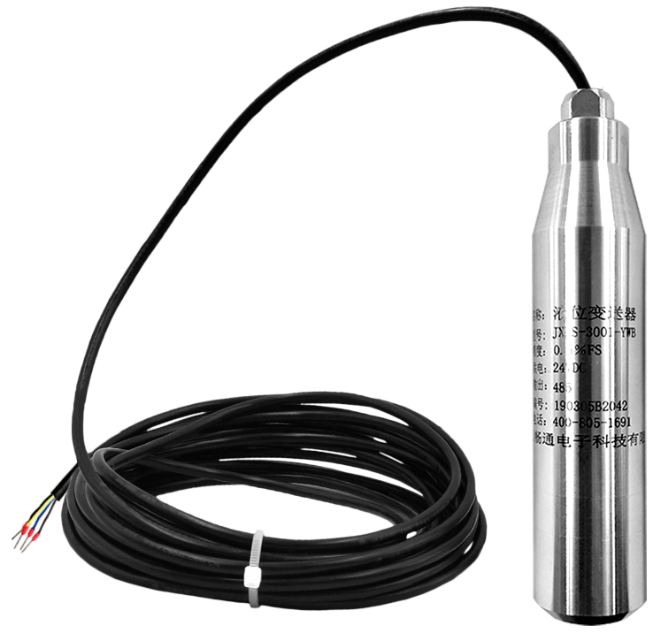

Product Overview
JXBS-3001-Level series transmitters are mainly composed of imported pressure measuring element sensors, measuring circuits and process connectors. It can convert the pressure signal parameters felt by the pressure measuring element into the standard liquid level signal.
When the sensor is put into a certain depth of the liquid under test, the pressure of the medium under test is introduced into the positive pressure chamber of the sensor, and the atmospheric pressure Po on the liquid level is connected with the negative pressure chamber of the sensor through the cable duct.

Feature
This product adopts imported diffusion silicon pressure detection sensor, the signal is stable and the precision is high. Anti-interference, small temperature drift, high stability, high measurement accuracy, is an ideal liquid level measuring instrument in the field of industrial automation.

Parameter
Parameter | Technical indicators
Parameter | Technical indicators
Measuring medium | Water（H₂O）or Compatible with contact materials
Type of probe | Imported diffused silicon
Precision | Level 0.5(default)/0.3/0.1
Medium temperature | 0-70℃
Output signal | 4-20mA
Working voltage | 9-24V DC
Stability | ±0.1% FS/year
Unsensitive area | ≤±1.0%Fs
Load resistance | 500 Ohmm

Inspection of equipment before installation
Check the equipment list before installing the equipment:
Name | Quantity
Pressure transmitter equipment | 1PC
12V Waterproof power | 1PC（optional）
USB to 485 equipment | 1（optional）
Warranty card/certificate | 1pc

Product size
The product support dimensions are shown below：
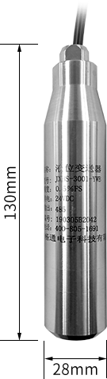

Interface description
Product factory default wiring for measuring range length of 0.6 meters, line sequence definition as shown in the following table:：
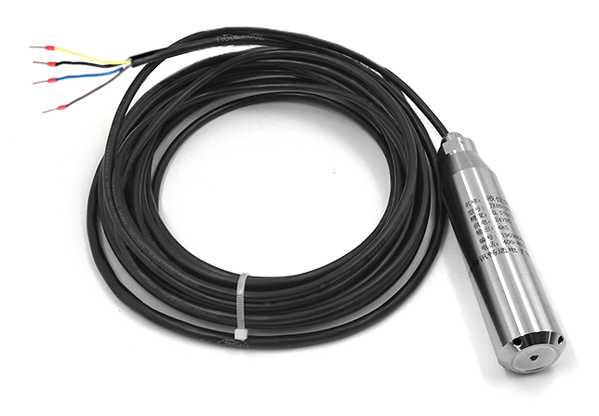

 | Line colour | Note
Power supply | Brown | Power supply(9-24VDC)
Power supply | Black | Negative power
Communications | Yellow(gray) | 485-A
Communications | Blue | 485-B

Product installation
The transmitter can be installed vertically, tilted or horizontally in the tank and tank. It is necessary to install the transmitter to the bottom of the medium under test, while ensuring that impurities such as sediment are not buried or blocked in the probe part of the transmitter. Do not throw it at will. Do not use brute force when installing the transmitter.
In addition to power supply and signal transmission, the air conduction cable also plays a key role in atmospheric compensation. When installing, it should avoid locking the cable too tight or bending too sharp angle to prevent the gas conduction pipe from breaking or breaking.

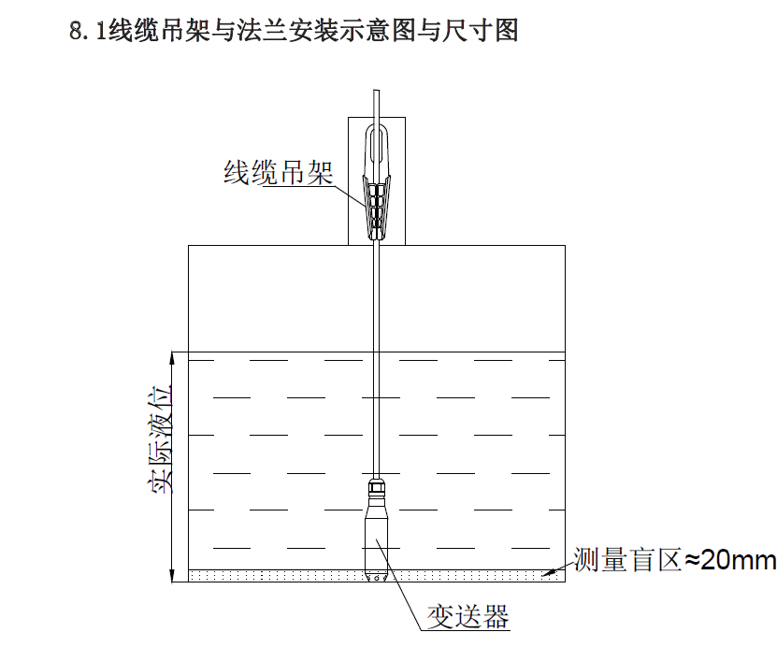

Wiring Test Mode
Range calculation:
Current value | Level value
4mA | 0
20mA | Full range
The formula is L=(I( current)-4 mA)* full range /16 mA.

Assuming that the product you buy is a 10 meter range and the current measured is 11.35 mA, the pressure can be calculated:

P=(11.35 mA-4mA)10/16mA =4.59 m

With regard to the 4-20 mA two-wire system, the basic measurement method can be completed by using 24 V power supply and ammeter, which are connected as follows:

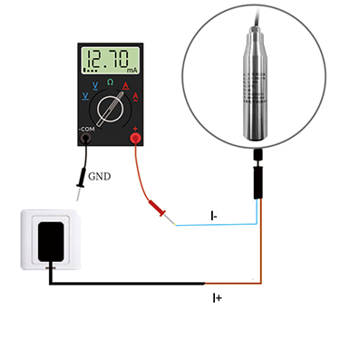

Notes
Before 1. installation and use, be sure to read the instructions carefully.

2. installation and use, be sure to pay attention to the temperature of the medium under test.

3. installed in a ventilated, dry, corrosion-free environment.

4. power off when installed and removed.

5. please do not open the transmitter shell, let alone adjust the potentiometer.

6. installation with a wrench to clamp the lower nut into, do not use the hand to twist the watch.

