Model 485 wind speed sensor an instruction manual
JXBS-3001-FS
Ver1.0

Chapter 1 product introduction

  - Product overview

Jxbs-3001-fs series wind speed sensor is small and light in appearance, easy to carry and assemble. The three cup design concept can effectively obtain the external environment information. The shell is made of high-quality polycarbonate material, and the internal smooth bearing system ensures the accuracy of information collection. It is widely used in greenhouse, environmental protection, weather stations, ships, docks, aquaculture and other environment wind speed measurement.

Main parameter
Parameter Technical index

Wind speed measurement range
Wind speed measurement accuracy
0-30m/s

±1m/s

response time less than5seconds
Baud rate 9600

Communicati on port

RS485

Power supply 12V-24V DC

consume power Operating temperature
<1W

-30-80℃

Working humidity environment
0-100%RH（15-95%RH）

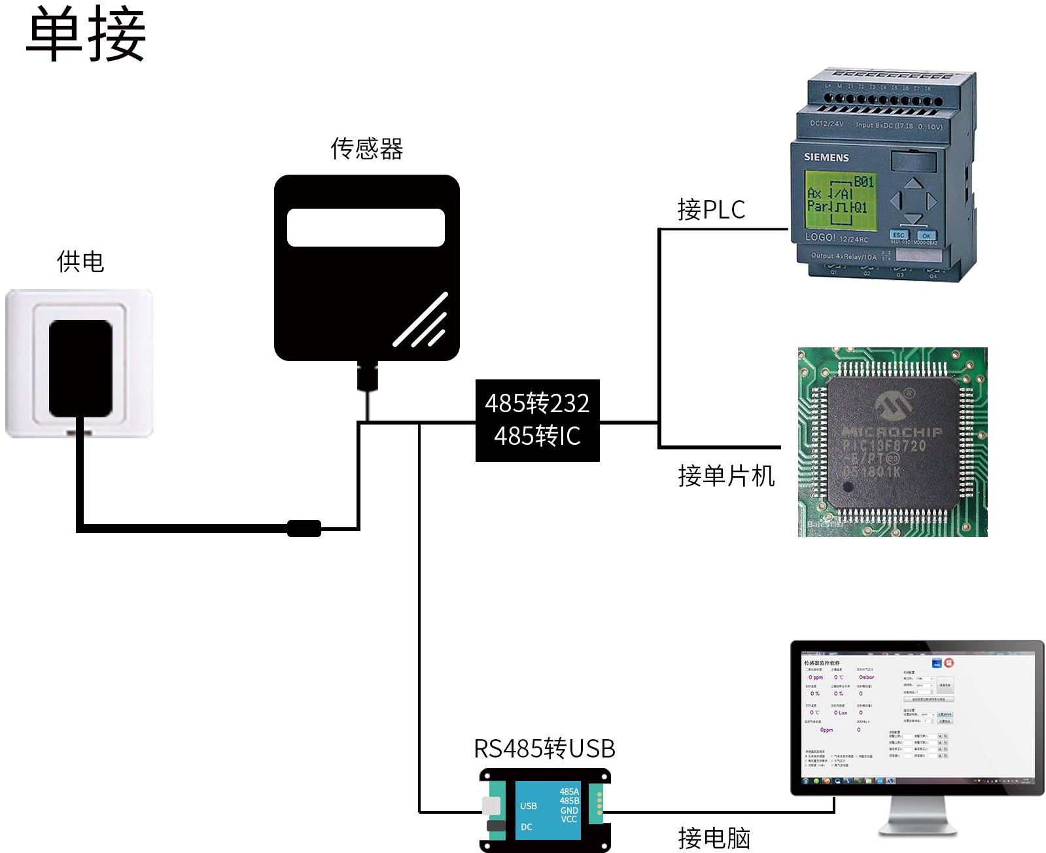
  - system framework diagram

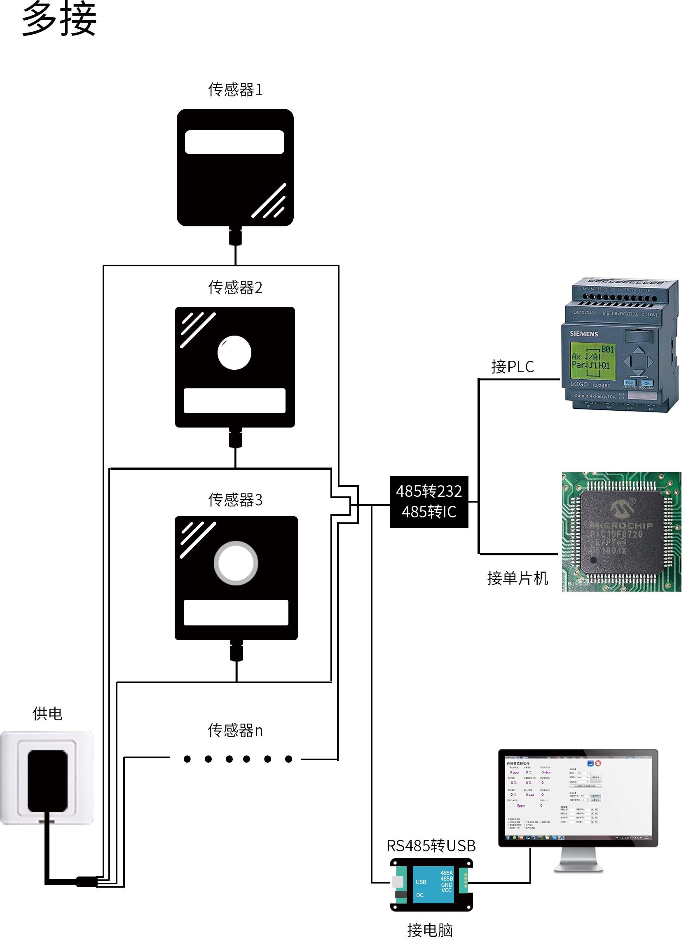

Chapter 2 hardware connection

  - inspection before equipment installation
Please check the equipment list before installing the equipment:
Name number

High precision sensor
Wind speed 485 line
12V waterproof power supply
1 set

1 wire 1(optional)

USB to 485 device 1(optional)
Warranty card / 1 copy
certificate

    - wiring：

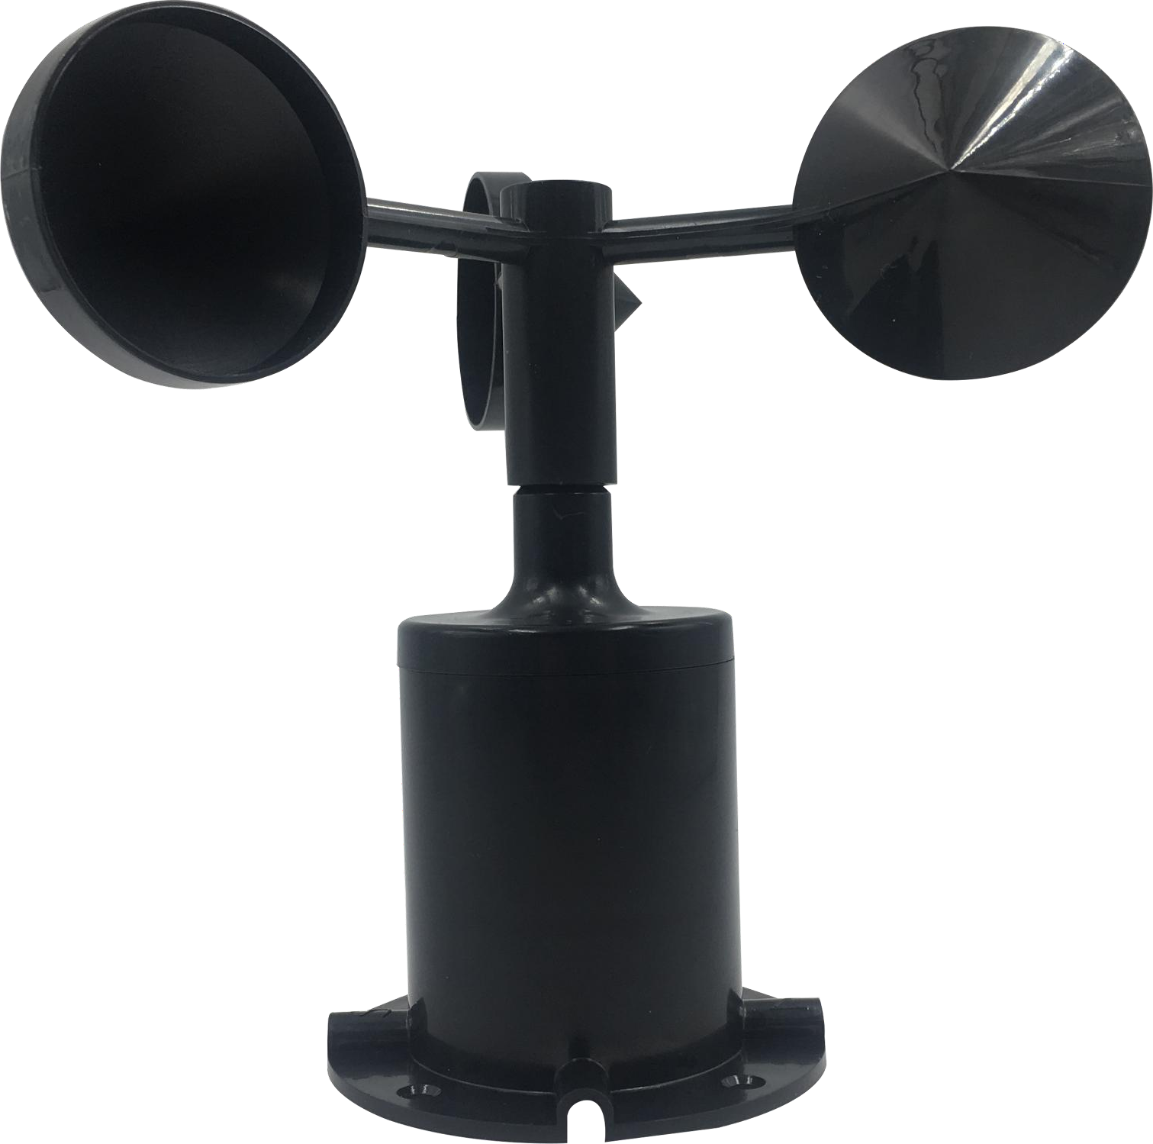

Line colou r
Note

Powe r suppl y Com
munic ations
Red Positive power
Black Negative power

Yellow 485A 485B
Green

Factory default to provide 0.6 meters long wire, customers can extend wire or sequential wiring as needed.

  - Installation mode
Using flange installation, threaded flange connection makes the lower pipe fittings of wind speed sensor firmly fixed on flange, four mounting holes are opened on the circumference of chassis, and bolts are used to fasten them tightly to the support. Ensure the accuracy of wind direction data, flange connection easy to use, can withstand greater pressure.
    - fixation

The sensor size is shown

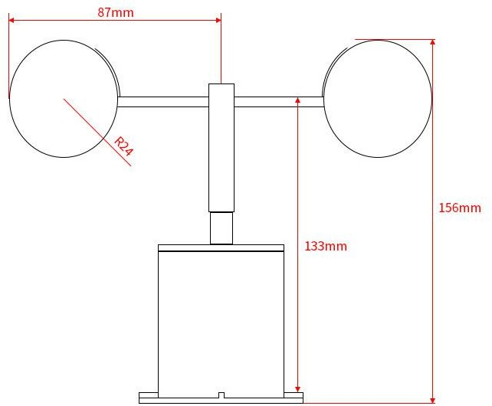

below:

Main Drawing

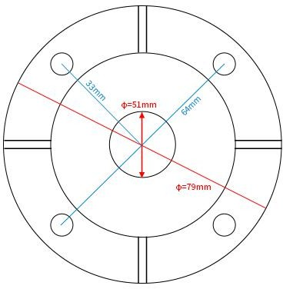
Dimensions

Base dimensions
According to the size of the sensor, you can install the sensor to the right position 。
Chapter 3 Communications Agreements
  - Basic communication parameters
Parameters Content
Code 8-bit binary
Data bits 8-bit
parity bit No
Stop position 1 bit
Error calibration
Error
calibration
baud rate 2400bps/4800bps/9600 bps Available,

factory default is 9600 bps
Code 8 Bit binary

  - Data frame format definition

Adopt the Modbus-RTU protocol as follows:
Initial structure >=4 bytes time Address =1 byte
Function =1 byte Data =N bytes
Error check =16-bit CRC code End structure >=4 bytes of time
Address code: the address of the transmitter, unique in the inquiry network (factory default 0 x01).
Function code: the host sends the instruction function prompt, this transmitter only uses the function code 0 x03( reads the memory data).
Data area: data area is a specific query area, note that 16 bits data high byte before CRC code: two-byte check code.

Question frame

Register
Check theCheck the high

Address Functi Functional length
low bit
bit

code onal code
code

1 bytes 1 bytes 2 bytes 2 bytes 1 bytes 1 bytes
Response frames

Function Number ofData area I Second Data N data area

Address al code code
valid bytes
Area

1bytes 1bytes 1bytes 2bytes 2bytes 2bytes

  - Register address
Register address | PLC  Configura tion Address | content | Operatio n
0000H | 40001 | Wind speed (0.1m/s ) | Read
0100H | 40101 | Device address(0-252) | only  Read

0101H 40102 baud rate
(2400/4800/9600)
and write Read and write

  - Examples of communication protocols and explanations
    - read the wind speed value x01 device address 0 Question frame
Addre ss code | Funct ional code | Starting address | Data length | Check the low bit | Check  the high bit
0x01 | 0x03 | 0x00,0x00 | 0x00,0x01 | 0x84 | 0x0A
Answer frame (e.g. reading wind speed2.3 m/s )
Addre ss code | Funct ional code | Number of valid bytes | Wind speed | Low Checkin g code | High Checking code
0x01 | 0x03 | 0x02 | 0x00 0x17 | 0xB8 | 0x41
Wind speed:
0017H( hexadecimal)=23=> wind speed =2.3 m/s

  - Notes:

Please check that the package is in good condition and check that the transmitter model and specifications are in accordance with the products you choose. If you have any questions, please contact us as soon as possible.
Please confirm before use: whether the output voltage of the power supply is correct; the positive and negative connection mode of the power supply with the product; and read the product specification or consult our company in detail. Any wiring error will cause irreversible damage to the transmitter.

  - Quality Assurance and After-sale
Quality assurance terms follow Weihai Jingxun unblocked Electronic Technology Co., Ltd. Sensor after-sale terms, for sensor mainframe circuit part of the warranty for two years, gas sensor quality assurance for one year, accessories (shell / plug / cable, etc.) warranty for three months.

