Manual for 485 total solar radiation sensor
JXBS-3001-ZFS
Ver1.1

Chapter 1 Product Introduction

1.1 Product overview
JXBS-3001-ZFS Total Solar Radiation Sensor (Transmitter) is a sensor that can measure total solar radiation with a spectral range of 0.3-3μm. If the sensing surface is facing downwards, it can measure reflected radiation, and a light-shielding ring can also measure scattering radiation.
The core component of the radiation sensor is a high-precision photosensitive element, which has good stability and high accuracy. At the same time, a quartz glass cover made of precision optical cold processing is installed outside the sensing element to effectively prevent environmental factors from affecting its performance. The product can be widely used in meteorology, energy, agriculture, construction and other fields.

1.1 main parameters

parameter name Parameter content
DC power supply (default） 9-24V DC
Power consumption ≤0.15W（@12V DC , 25℃）
Measuring range 0-1500W/m²
Spectral range 0.3-3um
Resolution 1 W/m²
output signal RS485 output (Mondbus protocol)
working environment -45-85℃ 0-100%RH
responding speed ≤5s

1.1 System framework diagram

This sensor can be connected and used alone, first use 12V DC power supply Power supply, the device can be directly connected to a PLC with a 485 interface, through
The 485 interface chip is connected to the microcontroller. The single-chip microcomputer and PLC can be programmed through the modbus protocol specified later to cooperate with the sensor. use simultaneously
USB to 485 can be connected to the computer, use the sensor configuration tool provided by our company to configure and test.
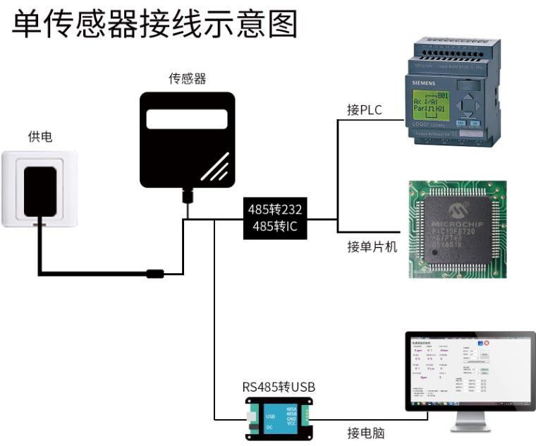

This product can also be used by combining multiple sensors on a 485 bus,
Please observe "485 Bus Field Wiring Rules" when performing 485 bus combination
(See Appendix). In theory, one bus can connect more than 16 485 sensors
If you need to connect more 485 sensors, you can use a 485 repeater to expand
Charge more 485 devices, connect the other end to the PLC with 485 interface, connect the MCU through the 485 interface chip, or use USB to 485 to connect to the computer, and use the sensor configuration tool provided by our company to configure and test.

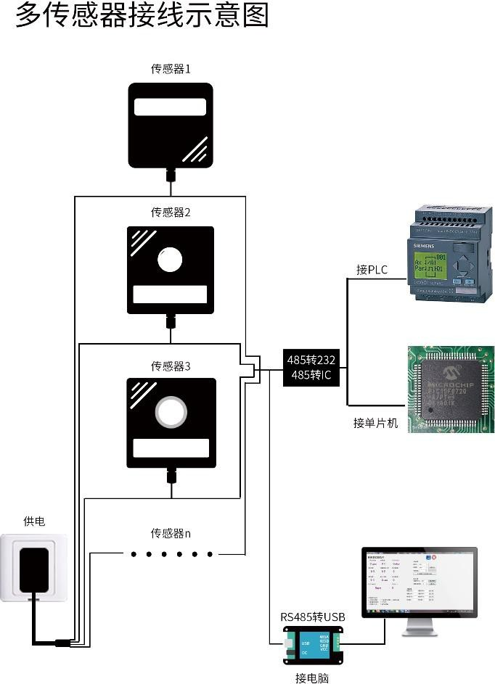

Chapter 2 Hardware Connection

2.1 Inspection before equipment installation

Please check the equipment list before installing the equipment:

name | Quantity
Total solar radiation sensor | 1 set
12V waterproof power supply | 1 set（Optional）
USB to 485 device | 1 set（Optional）
Warranty card/certificate | 1 serving

Wide voltage power input is 12-24V. Note when wiring the 485 signal line
The two wires A/B cannot be reversed, and the addresses of multiple set devices on the bus cannot be conflicted

Thread color Description
power supply brown Power is positive （12-24V DC）
black Power negative
Communication Yellow (gray) color 485-A
blue 485-B

Note: Please be careful not to connect the wrong wiring sequence, the wrong wiring will cause the equipment to burn.
The factory default provides 0.6m long wire, customers can extend the wire as needed or wire in order.
Note that there is no yellow line in the line sequence that may be provided in some factory batches. At this time, the gray line is equivalent to replacing the yellow line.

2.3 Product size and installation instructions
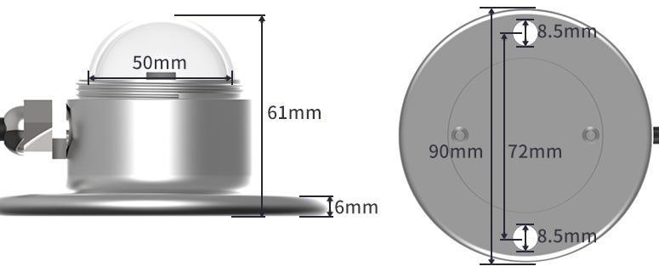
(1) Ensure that the mounting bracket is parallel to the ground;
(2) Use M6 screws and nuts to fix the sensor on the cross arm through the 2 mounting holes on the sensor;
(3) Please avoid disassembling the sensor during installation.
(4) Please unscrew the protective cover above the sensor when using it. In order to protect the sensor, tighten the protective cover above the sensor when it is not in use or during transportation.

Chapter 3 Configuration Software Installation and Use
Our company provides supporting "sensor monitoring software", which can easily use the computer to read the sensor parameters, and flexibly modify the device ID and address of the sensor.

3.1 Connect the sensor to the computer
After the sensor is correctly connected to the computer via USB to 485 and supplied with power, you can see the correct COM port ("My Computer—Properties"
—Device Manager — Port” to view the COM port).
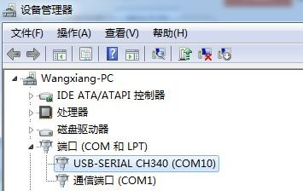
As shown in the figure above, your serial port number is COM10 at this time, please remember this serial port, you need to fill in this serial port number in the sensor monitoring software.
If the COM port is not found in the device manager, it means that you have not inserted the USB to 485 or the driver has not been installed correctly, please contact the technical staff for help.

3.1 Use of sensor monitoring software
The configuration interface is as shown in the figure. First, obtain the serial port number and select the correct serial port according to the method in chapter 3.1, and then click to automatically obtain the current baud rate and address to automatically detect all devices and baud rates on the current 485 bus . please
Note that you need to ensure that there is only one sensor on the 485 bus when using the software for automatic acquisition.

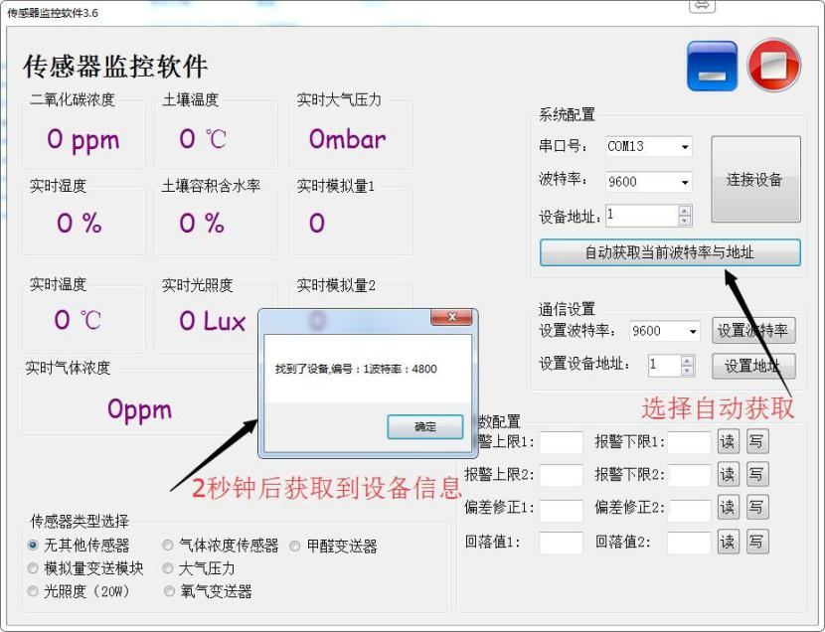
Then click to connect the device to get the sensor data information in real time. If your device is a gas concentration sensor, please specify the sensor type
Select "gas concentration sensor", formaldehyde sensor select "formaldehyde transmitter", analog transmitter select "analog transmitter module", atmospheric pressure sensor select
"Atmospheric pressure sensor", illuminance sensor selects "Illuminance 20W", oxygen sensor selects "Oxygen transmitter", and other sensors select the default
"No other sensors".

3.1 Modify the baud rate and device ID
When the device is disconnected, click the device baud rate and set address in the communication settings to complete the related settings. Please note that after setting, please restart the device, and then "automatically obtain the current baud rate and address" to find the address And the baud rate has been changed to the address and baud rate you need.
If you need to use modbus command to modify baud rate and address, you can refer to the appendix "How to use modbus command to modify baud rate and address"

Chapter 4 Communication Protocol

4.1 Basic communication parameters

parameter content
coding 8-bit binary

Data bit 8-bit
Parity bit no Stop bit 1-bit
Wrong calibration CRC lengthy cyclic code
Baud rate 2400bps/4800bps/9600bps can be set ,the factory default is 9600bps

4.1 Data frame format definition
Adopt Modbus-RTU communication protocol, the format is as follows: Initial structure ≥ 4 bytes of time
Address code = 1 byte Function code = 1 byte Data area = N bytes
Error check = 16-bit CRC code end structure ≥ 4 bytes time
Address code: It is the function indicator of the transmitter, this transmitter only uses the function code
0x03 (read register data).
Data area: The data area is the specific address, which is unique in the communication network
(The factory default is 0x01).
Function code: command communication data sent by the host, pay attention to the 16bits data high byte first!
CRC code: two-byte check code.

Interrogation frame
Address code Features

Register start address

Register length
Check code low

High bit of proof code

1 byte 1 byte 2 byte 2 byte 1 byte 1 Reply frame

address Features
Code Code
Valid byte
number
First number
According to the distrit
Second number

According to the district
1 byte 1 byte 2 byte 2 byte 2 byte

4.2 Register address
Register | PLC groupv content content 操作
address
0000H | 40001 | Total solar radiation (1W/m2) | Read only
0100H | 40101 | Device address (0-252) | Read and write
0101H | 40102 | Baud rate (2400/4800/9600) | Read and write

  - 通讯协议

4.3 Examples and explanations
Read the total solar radiation value of the device address 0x01Interrogation frame

address code | function code | initial address | Data length | Check code low bit | Check code high
0x01 | 0x03 | 0x00  0x00 | 0x00  0x01 | 0x84 | 0x0A

Response frame (for example, the total solar radiation value is 71 W/m2)
address code | function code | Returns the number of valid bytes | Data area | Check code low bit | Check code high
0x01 | 0x03 | 0x02 | 0x00  0x47 | 0xD8 | 0x15
 | 9

Explanation of total solar radiation calculation:
0047H(Hexadecimal)=71=>Total solar radiation=71 W/m2

Chapter 5 Appendix

5.1 Product additional instructions
"485 Device Field Wiring Manual": Describes the wiring guidelines for 485 products. Please check and follow the guidelines, otherwise it may cause unstable communication.
"Revision of temperature and humidity deviation of 485 sensor": Describes how to confirm and adjust temperature and humidity deviation when you feel that there is a deviation in temperature and humidity.
"Using modbus to modify device baud rate and address": describes if you do not use software, use modbus commands to modify the baud rate and slave station number.
"How to Use Single Chip Computer for 485 Communication": describes how to use 51
The one-chip computer reads the sensor information, and carries on the science popularization to some basic knowledge.
"How to calculate CRC16": Describes the modbus RTU protocol
How to calculate CRC16 and an example C language program.
"How to use USB to 485 auxiliary debugging when reading sensor communication has problems": describes how to use auxiliary tools to solve and troubleshoot when there are communication problems.
"How to use and set the product alarm function": Describes the Optional product alarm function, how to use it, how to wire and other issues.

5.1 Warranty and after-sales

The warranty clauses follow the sensor after-sales clauses of Weihai Jingxun Changtong Electronic Technology Co., Ltd., two years for the sensor host circuit part, one year for gas-sensitive probes, and three months for accessories (housing/plugs/cables, etc.)

11

