Analogue UV Transmitter
Instruction Manual
JXBS-3001-UV
Ver1.1

PRODUCT BRIEF INTRODUCTION

Product Overview
This sensor is widely used in agricultural greenhouses, flower cultivation and other occasions that require ultraviolet and temperature and humidity monitoring. The sensor's internal input power, sensor probe, and signal output are completely isolated. It is safe and reliable, beautiful in appearance and easy to install.

Functions and Features
This product uses high-sensitivity photosensitive probe with stable signal and high precision. It has the characteristics of wide measurement range, good linearity, good waterproof performance, convenient use, easy installation, and long transmission distance.

Main Parameters
Parameter | Content
DC power supply | 12V-24V DC
Max power consumption | 0.4W
Communication port | Analog interface (voltage type or current type)
UV accuracy | ±3% (25°C)
UV measurement range | 0-150W/m²
Long-term stability of UV | ≤5%/y
Current output type | 4-20mA
Current output load | ≤600Ω
Voltage output type | 0-5V/0-10V
Voltage output load | ≤250Ω
Power consumption | ≤0.3W（@12V DC , 25℃）
Work pressure range | 0.9-1.1atm

UV Parameters
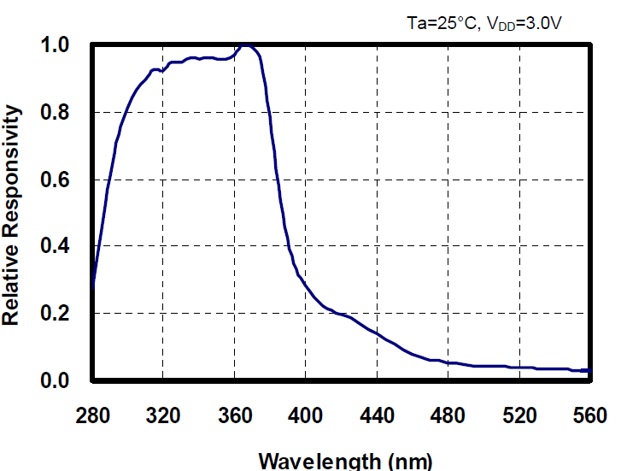
Figure 1. The influence of different wavelengths of light on the intensity of ultraviolet rays
As shown in Figure 1, the most accurate wavelength is around 370nm, and the scale factor is 1.

System Framework Diagram
When the system needs to connect to an analog version sensor, you only need to supply power to the device, connect the analog output line to the DI interface of the microcontroller or PLC, and write the corresponding acquisition program according to the conversion relationship below.
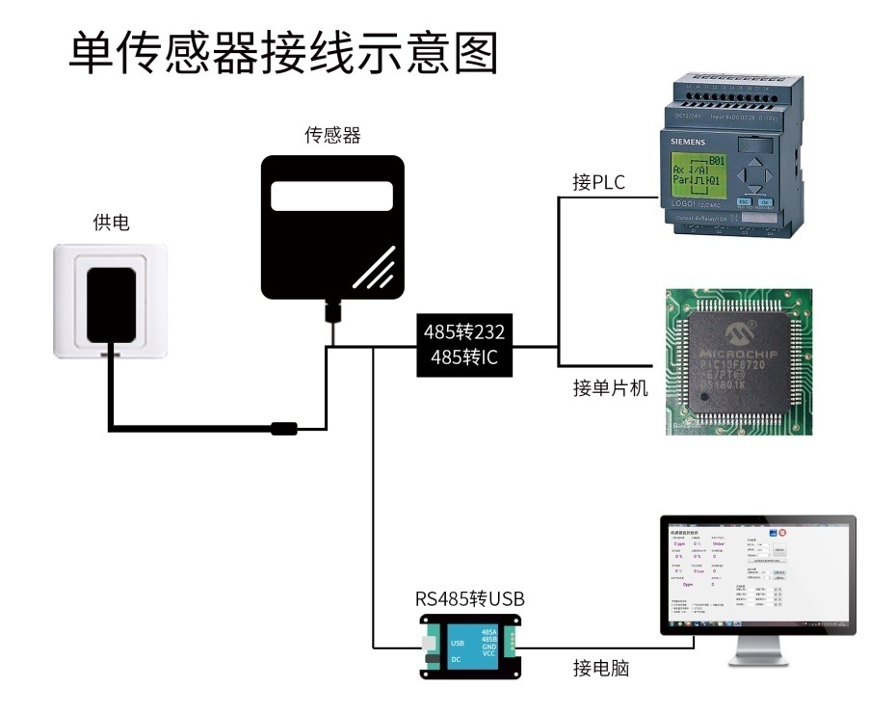

This product can also be used by combining multiple sensors on a single 485 bus. Please follow the "485 bus field wiring rules" (refer to the appendix) when performing 485 bus combination. In theory, one bus can be connected to more than 16 485 sensors. If you need to connect more 485 sensors, you can use a 485 repeater to expand more 485 devices, and the other end is connected to a PLC with a 485 interface through a 485 interface chip. Connect the single-chip microcomputer, or use USB to 485 to connect to the computer, and use the sensor configuration tool provided by our company for configuration and testing.
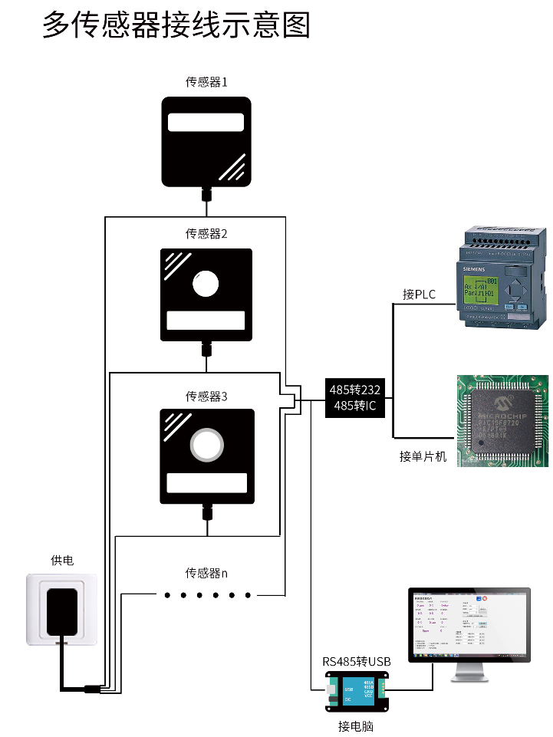

HARDWARE CONNECTION

Checking Before Equipment Installation
Please check the equipment list before installing the equipment:
Name | Quantity
High precision sensor | 1
12V waterproof power supply | 1(Optional)
Warranty card/certificate | 1

Interface Description
The power interface is a wide-voltage power input that can be 12-24V. For analog products, pay attention to the positive and negative signal wires, and do not reverse the positive and negative current/voltage signal wires.
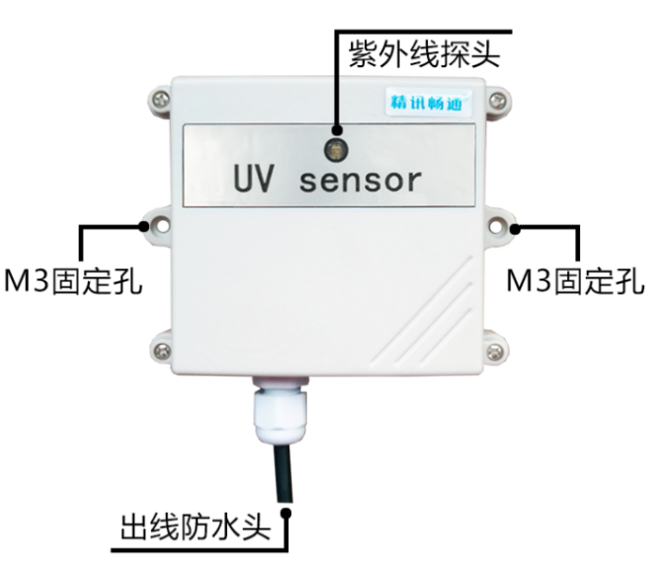
 | Wire color | Description
Power supply | Brown | Positive power supply (12-24VDC)
 | Black | Negative power supply
Communication | Yellow(gray) | Voltage/current output positive
 | Blue | Voltage/current output negative
Note: Please be careful not to connect the wrong wiring sequence, the wrong wiring will cause the equipment to burn. At the same time, it must be noted that the voltage/current positive output is an active output, and the voltage/current positive output must not be connected to the positive position of the power supply, which will definitely cause burnout.
The factory default provides 0.6 meters long wire, customers can extend the wire as needed or wire in order.
Note that there is no yellow wire in the wire sequence that may be provided in some factory batches. At this time, the gray wire is equivalent to replace the yellow wire.

Installation Instructions
The UV transmitter is greatly affected by the incident angle, so the following two installation forms are recommended:
1. Install horizontally with the ground plane so that the photosensitive position faces the sky. Can be used as a fixed location for all-day measurements.
2. If you need to measure the current real-time UV intensity, you can make the photosensitive position face the sunlight incident position.

WIRING INSTRUCTION
The analog sensor wiring is simple, only need to connect the wire to the designated port of the device. The equipment supports 3/4 wire connection.

Typical Four-wire Wiring Method
The following figure shows the wiring method of the current sensor. Connect the sensor's power cord (brown wire and black wire) to the power supply; the yellow (gray) wire of the sensor is the signal positive when the signal is connected to the acquisition device, and the current flow is the sensor To the acquisition device; the blue line of the sensor is the negative signal when the signal is connected to the current acquisition device, and the current flow is from the acquisition device to the sensor.
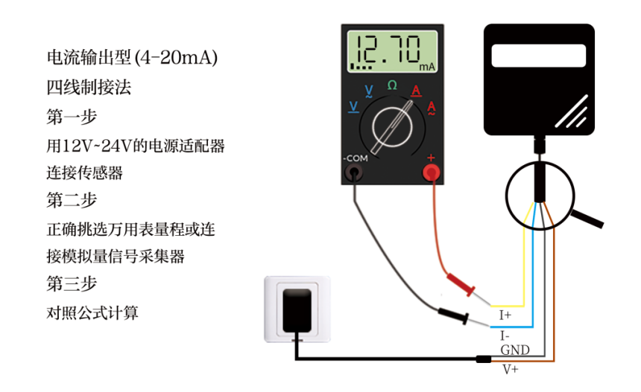
The following figure shows the wiring method of the voltage sensor. Connect the power cord (brown wire and black wire) of the sensor to the power supply; the yellow (gray) wire of the sensor is the signal positive when the signal is connected to the acquisition device, and yellow (gray) The voltage of the line is the output voltage; the blue line of the sensor is the negative signal when the signal is connected to the voltage acquisition device, and the voltage of the blue line is the reference voltage, which is 0V consistent with the voltage of the black line.
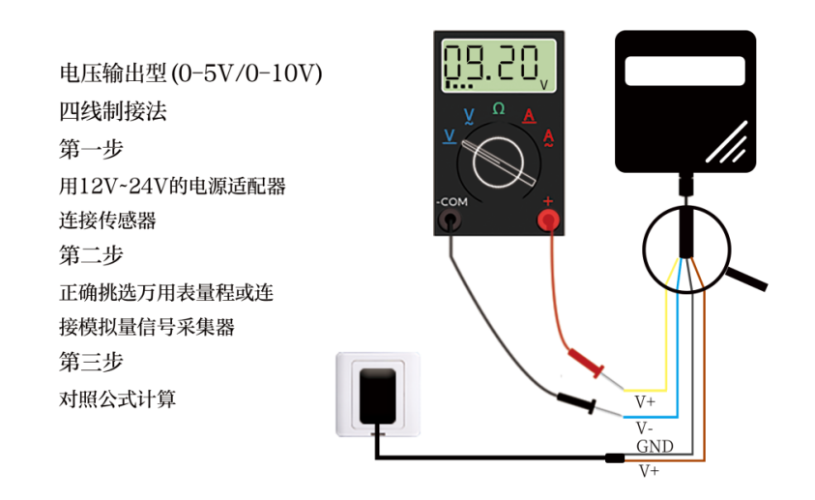

Typical Three-wire Wiring Method
For typical three-wire wiring, compared to four-wire wiring, the blue wire can be omitted. In the sensor, the blue wire and the black wire are short-circuited in the sensor, so the blue wire can be omitted.
For the three-wire current wiring method, after connecting the power cord (brown wire and black wire) of the sensor to the power supply, just turn the yellow (gray) wire of the sensor to the positive signal of the current collecting device.
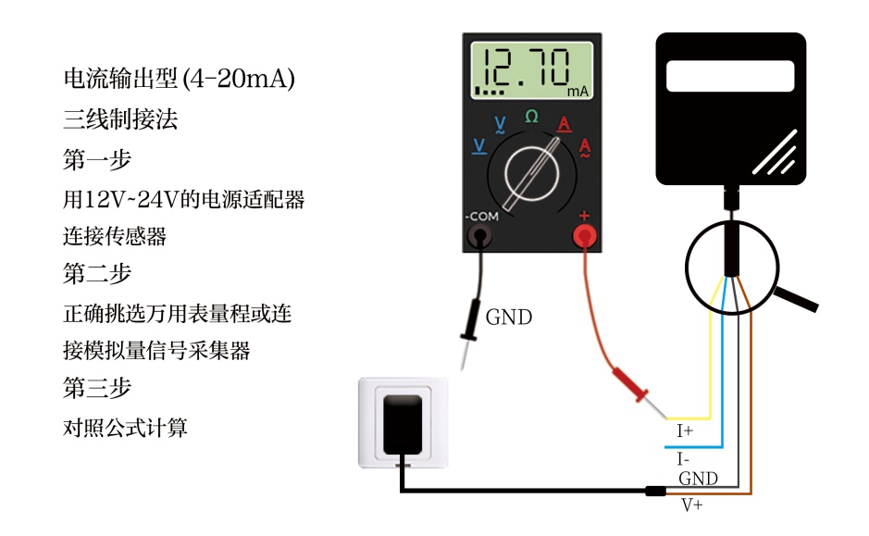
For the three-wire voltage connection mode, after connecting the sensor's power cord (brown wire and black wire) to the power supply, only the yellow (gray) wire of the sensor is connected to the signal positive of the voltage acquisition device.
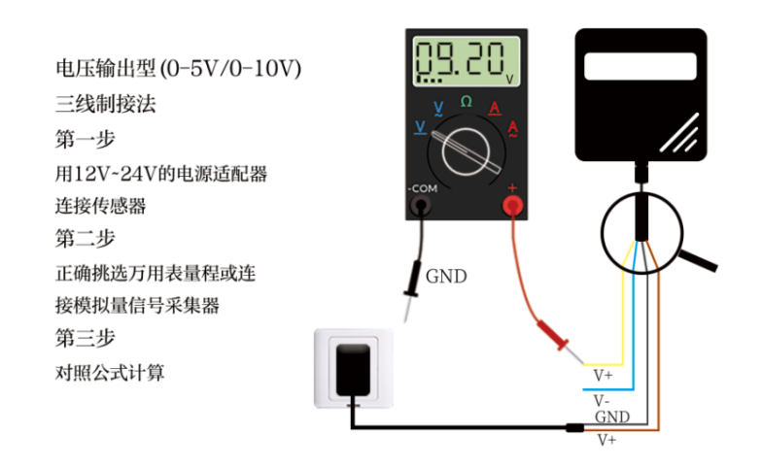

MEANING AND CONVERSATION OF ANALOG PARAMETER

Analog 4-20mA Current Output
Current value | UV value
4mA | 0W/m²
20mA | 150W/m²
The calculation formula is P_{(UV)}=(I_{(current)}-4mA)*9.375W/m2
The unit of I is mA.
For example, the current collected under the current situation is 8.25mA, and the value of the ultraviolet light is calculated to be 39.84W/m2.

Analog 0-10V Voltage Output
Voltage value | UV value
0V | 0W/m²
10V | 150W/m²
The calculation formula is P_{(UV)}=V_{(voltage)}*0.015W/m2
The unit of V is mV.
For example, the voltage collected under the current situation is 3510mV, and the calculated wet ultraviolet value is 52.65W/m2.

Analog 0-5V Voltage Output
Voltage value | UV value
0V | 0W/m²
5V | 150W/m²
The calculation formula is P(UV)=V(voltage)*0.03W/m2
The unit of V is mV.
For example, the voltage collected under the current situation is 4220mV, and the calculated UV value is 126.6W/m2.

APPENDIX

Product Additional Instructions
How to use a multimeter to assist debugging: The multimeter is a very important auxiliary debugging tool. Once you find that there is an error between the reading and your own expectations, it is very necessary to use the multimeter to assist the debugging.
Description of the quantization accuracy and resolution of analog products: The concept of quantization accuracy and resolution of analog products, how to calculate, and how to choose the correct range.
Analog Product Deviation Sources and Deviation Elimination: When analog products have errors in the readings, the reasons for the errors, the types of errors and how to eliminate them.

Warranty and After-sales
The warranty clauses follow the sensor after-sales clauses of Weihai Jingxun Changtong Electronic Technology Co., Ltd., two years for the sensor host circuit part, one year for gas-sensitive probes, and three months for accessories (housing/plug/cable, etc.)

