INSTRUCTION MANUAL
TEMPERATURE AND HUMIDITY TRANSMITTER

Weihai JXCT Electronic Technology Co., Ltd.
Ⅰ Brief Introduction
1.1 Product overview
The transmitter is widely used in agricultural greenhouses, flower culture and other occasions need temperature and humidity monitoring. Three parts of the sensor input power supply, induction probe, signal output are completely isolated. safe and reliable, beautiful appearance and convenient installation.

1.2 Functional features
The temperature and humidity transmitter adopts high sensitivity probe, the signal is stable and the precision is high. It has the characteristics of wide measuring range, good linearity, good waterproof performance, convenient use, easy installation, long transmission distance and so on.

1.3 Primary parameters
PARAMETERS | TECHNICAL SPECIFICATIONS
TEMPERATURE MEASUREMENT RANGE | -40℃-80℃(Customizable)
HUMIDITY MEASUREMENT RANGE | 0-100% RH
TEMPERATURE ACCURACY | ±0.5℃(25℃ Typical value)
HUMIDITY ACCURACY | ±3%RH(5%RH`-95%RH,25℃ Typical value)⁽¹⁾
LONG TERM TEMPERATURE STABILITY | ≤0.1℃/y
HUMIDITY LONG TERM STABILITY | ≤1%/y
COMMUNICATION PORT | Analog quantity interface (voltage type or current type)
POWER SUPPLY | 12V-24V DC
MAXIMUM POWER CONSUMPTION | ≤0.3W（@12V DC , 25℃）
BOUNDARY DIMENSION | 110×85×44mm3
CURRENT OUTPUT TYPE | 4-20mA
CURRENT OUTPUT LOAD | ≤600Ω
VOLTAGE OUTPUT TYPE | 0-5V/0-10V
VOLTAGE OUTPUT LOAD | ≤250Ω
WORKING PRESSURE RANGE | 0.9-1.1atm

1.4 Probe parameters and selection
Product Type | Probe Type |  | Temperature Accuracy | Humidity Accuracy
-S20 type (default) | SHT20 | ±0.3℃ |  | ±3-7%
-S30 type | SHT30 | ±0.3℃ |  | ±2-4.5%
-S31 type | SHT31 | ±0.3℃ |  | ±2%
-S75 type | SHT75 | ±0.3℃ |  | ±1.5-3%
The above life is the reference value under the condition of temperature 23 ± 3 ℃ and humidity 40 ± 10% RH.

1.5 Temperature parameters (- S20 type)
Content | Minimum | Typical Value | Maximum | Unit
Resolution (14bit) | - | 0.01 | - | ℃
Linear deviation | - | ±0.3 | See Table 1 below | ℃
Repeatability | - | ±0.1 | - | ℃
Scope of work | -40 | - | 125 | ℃
Response time (63%) | 5 | - | 30 | 秒
Long term drift | - | <0.04 | - | ℃/ year

Table 1: temperature measurement accuracy under different temperatures
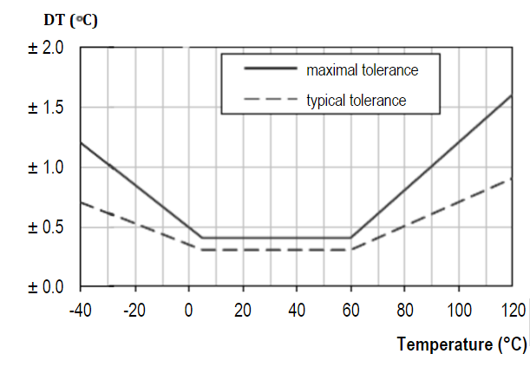
As shown in the above table, the maximum deviation in the range of 5-60°C is within±0.5, and the deviation increases when it is lower than 0°C and higher than 60°C.

1.6 Humidity parameters (- S20 type)
Content | Minimum | Typical Value | Maximum | Unit
Resolution (12bit) | - | 0.04 | - | %RH
Linear deviation | - | ±3.0 | See Table 2 below | %RH
Repeatability | - | ±0.1 | - | %RH
Scope of work | 0 | - | 100 | %RH
Response time (63%) | - | 8 | - | s
Long term drift | - | <0.5 | - | %RH /year
Hysteresis | - | ±1 | - | %RH
Nonlinearity | - | <0.1 | - | %RH

Table 2: humidity measurement accuracy under different humidity
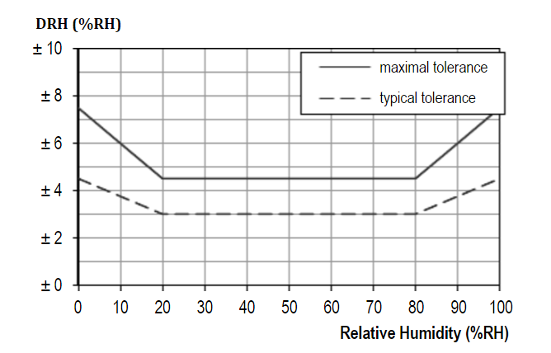
As shown in the above table, the typical deviation is ± 3% in the range of 20-80% RH, and the deviation increases when the humidity is less than 20% and more than 80%.

1.7 Effect of temperature on humidity measurement (- S20 type)
Table 2 above describes the influence of different humidity conditions on humidity measurement, and the table below describes the influence of different temperatures on humidity measurement accuracy.
Table 3: relative humidity at different temperatures
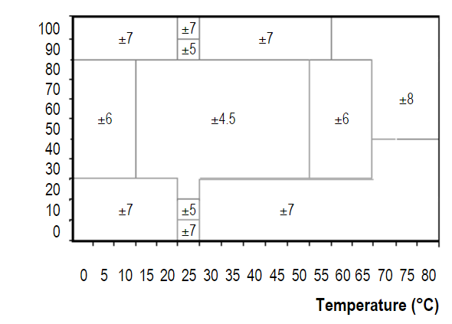
As shown above, in the humidity range of 15°C to 55°C, 30 to 80°C, the accuracy of humidity is the highest, which is ± 4.5%. In other cases, the humidity increases gradually.

1.8 System frame diagram
When the system needs to connect an analog quantity version sensor, you only need to supply power to the equipment, at the same time, connect the analog quantity output line to the DI interface of the single-chip microcomputer or PLC, and write the corresponding acquisition program according to the conversion relationship in the following paper.
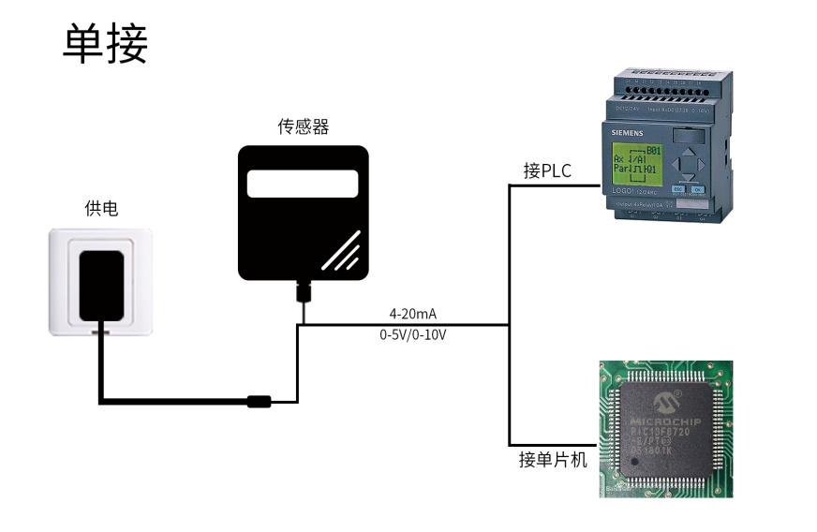
When the system needs to access multiple analog quantity versions of sensors, it needs to connect each sensor to each different analog quantity acquisition port of single-chip computer or the DI interface of PLC, and write the corresponding acquisition program according to the conversion relationship in the following paper.
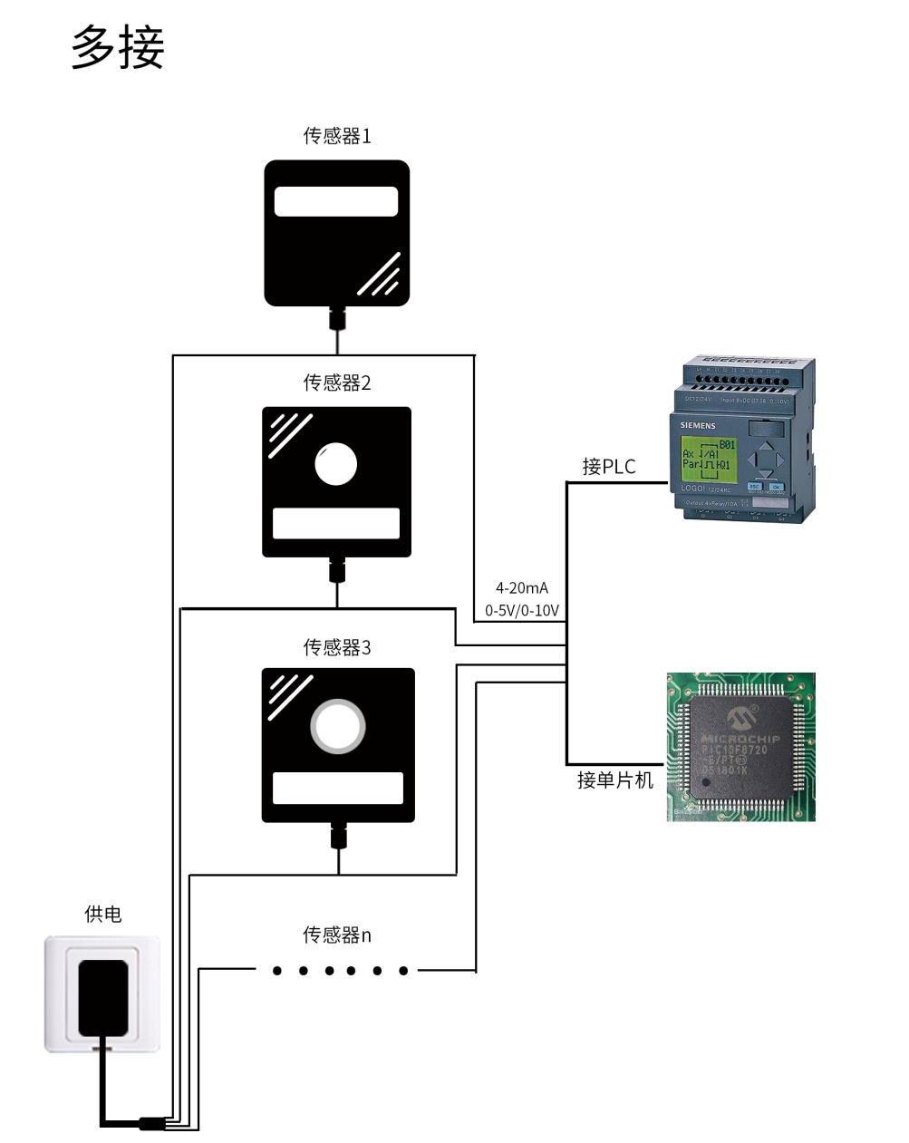

Ⅱ HARDWARE CONNECTIONS
2.1 Checking before installation
Check the list of devices before installation:
Name | Number
THE SENSOR DEVICE | 1
12V POWER ADAPTER（Optional） | 1
WARRANTY CARD / CERTIFICATE | 1
2.2 Interface description
The power interface is wide-voltage power input 12-24V. Analog products should pay attention to the positive and negative signal lines. Do not reverse the positive or negative of the current/voltage signal lines.
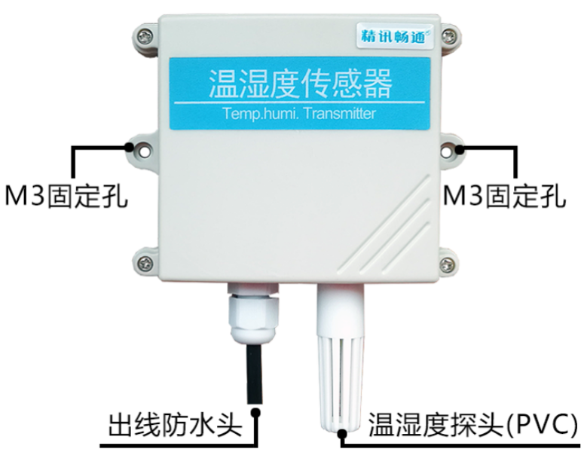
 | Line Color | Description
Power | Brown | Power supply Positive ( 12-24V DC )
 | Black | Power supply Negative
Communication | Yellow(Gray) | Voltage/current output Positive
 | Blue | Voltage/current output Positive

Caution: please be careful not to connect the wrong wire sequence, which will cause the equipment to burn down. At the same time, it must be noted that the positive output of voltage / current is an active output, and the positive output of voltage / current must not be connected to the positive position of power supply, which will definitely lead to burnout.
0.6m long wire is provided by default, and customers can extend the wire or wire in sequence as required.
Note that there is no yellow line in the line sequence that may be provided in some factory batches. At this time, the gray line is equivalent to replace the yellow line.

2.3 Installation instructions
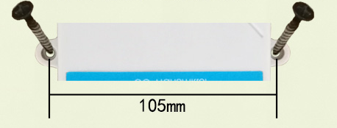
The wall hanging King shell is wall hanging installation. The installation hole is located in the middle of both sides of the equipment. The installation hole diameter is less than 4mm, and the hole distance is 105mm. 3mm self tapping screws can be used for installation.

Ⅲ WIRING INSTRUCTIONS
Analog sensor wiring is simple, only need to connect the wire with the designated port of the equipment. The equipment supports 3-wire wiring mode.

3.1 Typical three wire wiring mode
For a typical three wire system, omitting the blue wire is enough. In the sensor, the blue wire and the black wire are short circuited in the sensor, so the blue wire can be omitted.
For the three wire current wiring mode, after connecting the power line (brown line and black line) of the sensor to the power supply, only the yellow (gray) color line of the sensor is used as the positive temperature signal and the blue line is used as the positive humidity signal to connect the signal of the current acquisition equipment.
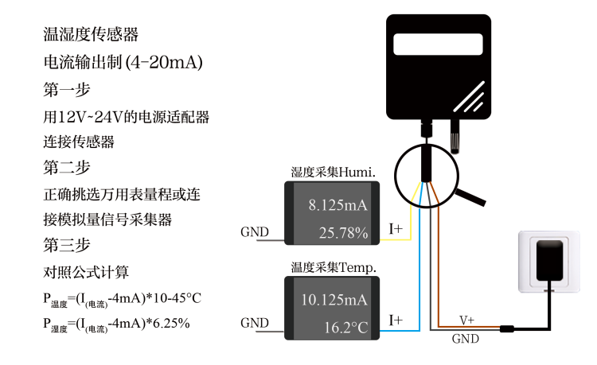
For the three wire voltage connection mode, after connecting the power line (brown line and black line) of the sensor to the power supply, only the yellow (gray) line of the sensor needs to be taken as the positive temperature signal and the blue line as the positive humidity signal to be taken as the positive signal of the voltage acquisition equipment.
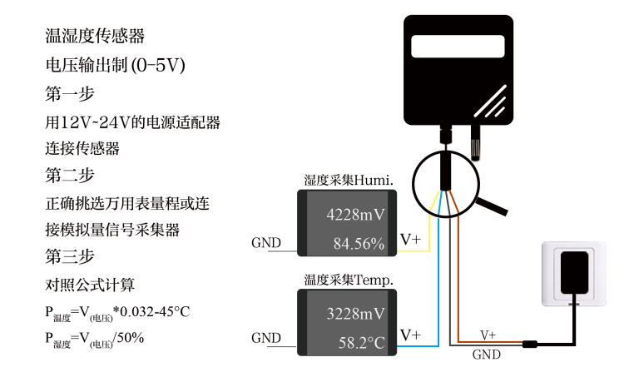
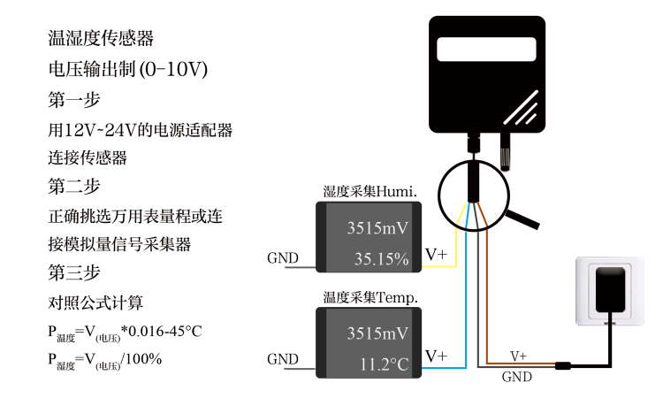

Ⅳ ANALOG PARAMETERS MEANING
4.1 Analog 4-20mA Current Loop
Current Value | Temperature | Humidity
4mA | -45℃ | 0%
20mA | 115℃ | 100%
The formula is P temperature = (I (current) -4mA) *10-45 °C
The formula is P Humidity=(I(Current)-4mA)*6.25%
Where I is in mA.
For example, the humidity of the data collected in the current situation is 8.125mA, and the calculated humidity is 25.78%. The temperature is 10.125mA, and the calculated temperature is 16.2°C.
4.2 Analogue 0-10V voltage output
Voltage Value | Temperature | Humidity
0V | -45℃ | 0%
10V | 115℃ | 100%
The formula is P temperature = V (voltage) * 0.016-45 °C
The formula is P humidity=V(voltage)/100%
Where V is in mV.
For example, the humidity of the data collected in the current situation is 3515mV, and the calculated humidity is 35.15%. The collected data temperature is 3515mV, and the calculated temperature is 11.2°C.
4.3 Analogue 0-5V voltage output
Voltage Value | Temperature | Humidity
0V | -45℃ | 0%
10V | 115℃ | 100%
The formula is P temperature=V(voltage)*0.032-45°C
The formula is P humidity=V(voltage)/50%
Where V is in mV.
For example, in the current situation, the humidity of the collected data is 4228 mV, and the calculated humidity is 84.56%. The collected data temperature is 3228mV, and the calculated temperature is 58.2°C.

