Manual for analog quantity solar total radiation sensor
JXBS-3001-ZFS
Ver1.1

Chapter 1 Product Introduction

1.1 Product overview
JXBS-3001-ZFS Total Solar Radiation Sensor (Transmitter) is a sensor that can measure total solar radiation with a spectral range of 0.3-3μm. If the sensing surface is facing downwards, it can measure reflected radiation, and a light-shielding ring can also measure scattering radiation.
The core component of the radiation sensor is a high-precision photosensitive element, which has good stability and high accuracy. At the same time, a quartz glass cover made of precision optical cold processing is installed outside the sensing element to effectively prevent environmental factors from affecting its performance. The product can be widely used in meteorology, energy, agriculture, construction and other fields.

1.1 main parameters

parameter name Parameter content
DC power supply (default) 12-24V DC
Power consumption ≤0.15W（@12V DC , 25℃）
Measuring range 0-1500W/m²
Spectral range 0.3-3um
Resolution 1 W/m²
Communication port Analog quantity interface (voltage type or current type)
working environment -45-85℃ 0-100%RH
responding speed ≤5s

1.1 System framework diagram

This sensor can be connected and used alone, first use 12V DC power supply power on, and at the same time connect the analog output line to the DI interface of the microcontroller or PLC, and write the corresponding acquisition program according to the conversion relationship below.

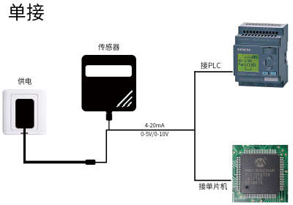

When the system needs to connect to multiple analog quantity version sensors, it is necessary to connect each sensor to each different MCU analog quantity acquisition port or
For the DI interface of the PLC, at the same time, write the corresponding acquisition program according to the conversion relationship described later.

Chapter 2 Hardware Connection

2.1 | Inspection before equipment installation  Please check the equipment list before installing the equipment:
 | name | Quantity
 | Total solar radiation sensor | 1 set
 | 12V waterproof power supply | 1 set（Optional）
 | USB to 485 device | 1 set（Optional）
 | Warranty card/certificate | 1 serving
2.2Interface Description
The power interface is a wide-voltage power input that can be 12-24V. For analog products, pay attention to the positive and negative signal wires, and do not reverse the positive and negative current/voltage signal wires.

Thread color Description
power supply brown Power is positive（12-24V DC）
black Power negative
Communication Yellow (gray） Voltage/current output positive
blue Voltage/current output negative
Note: Please be careful not to connect the wrong wiring sequence, the wrong wiring will cause the equipment to burn.
The factory default provides 0.6m long wire, customers can extend the wire as needed or wire in order.
Note that there is no yellow line in the line sequence that may be provided in some factory batches. At this time, the gray line is equivalent to replacing the yellow line.

2.3 Product size and installation instructions
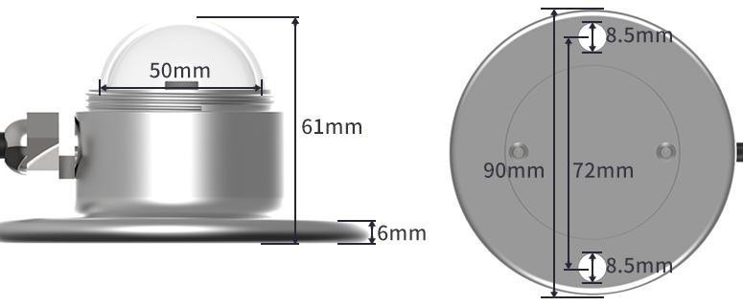
(1) Ensure that the mounting bracket is parallel to the ground;
(2) Use M6 screws and nuts to fix the sensor on the cross arm through the 2 mounting holes on the sensor;
(3) Please avoid disassembling the sensor during installation.
(4) Please unscrew the protective cover above the sensor when using it. In order to protect the sensor, tighten the protective cover above the sensor when it is not in use or during transportation.

Chapter 3 Wiring Instructions
The analog sensor wiring is simple, only need to connect the wire to the designated port of the device. The device supports 4-wire wiring.

Typical four-wire wiring method
The following figure shows the wiring method of the current sensor. The power supply of the sensor
The wire (brown wire and black wire) is connected to the power supply; the yellow (gray) wire of the sensor is the signal positive when the signal is connected to the collecting device, and the current flow is from the sensor to the collecting device; the blue wire of the sensor is the signal positive being connected to the current The signal of the acquisition device is negative, and the current flows from the acquisition device to the sensor.
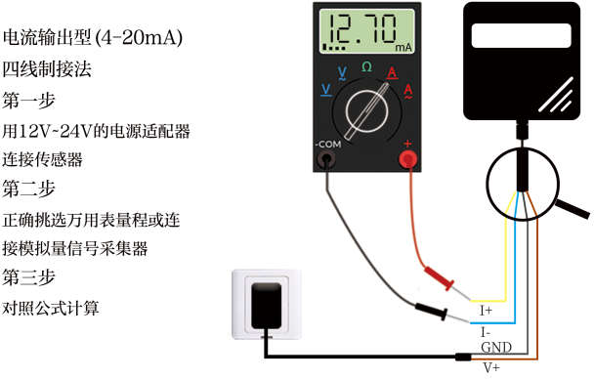
The following figure shows the wiring method of the voltage sensor. Connect the power cord (brown wire and black wire) of the sensor to the power supply; the yellow (gray) wire of the sensor is the signal positive when the signal is connected to the acquisition device, and the yellow (gray) The voltage of the line is the output voltage; the blue line of the sensor is the negative signal when the signal is connected to the voltage acquisition device, and the voltage of the blue line is the reference voltage, which is 0V consistent with the voltage of the black line.

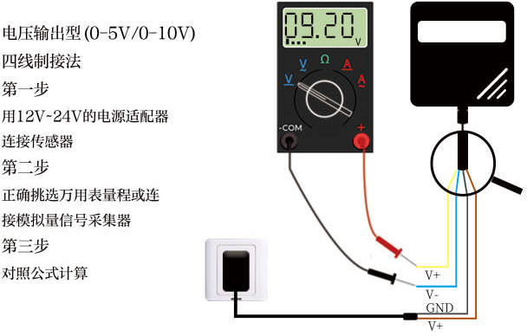

Chapter 4 The meaning of analog parameters

4.1 Analog 4-20mA current output
Current value | Corresponding value
4mA | 0W/m²
20mA | 1500W/m²

The calculation formula is P (total radiation value) = (I (current)-4mA) *93.75W/m2
The unit of P is W/m2, and the unit of I is mA.
For example, the data collected in the current situation is 7mA, and the calculated total radiation value is 281W/m2.

4.1 Analog 0-10V voltage output
Voltage value | Corresponding value
0V | 0W/m²
10V | 1500W/m²

The calculation formula is P (total radiation value) = V (voltage) * 150W/m2
The unit of P is W/m2, and the unit of V is V.
For example, the data collected under the current situation is 4V, and the total radiation
The value is 600W/m2.

4.1 Analog 0-5V voltage output
Voltage value | Corresponding value
0V | 0W/m²
5V | 1500W/m²
The calculation formula is P (total radiation value) = V (voltage) * 300W/m2
The unit of P is W/m2, and the unit of V is V.
For example, the data collected in the current situation is 3V, and the total radiation
The value is 900W/m2.

Chapter 5 Appendix

Product additional instructions
"How to use a multimeter to assist debugging": The multimeter is a very important auxiliary debugging tool. Once you find that the readings are in error with your own expectations, it is very necessary to use the multimeter to assist in debugging.
"Analog Product Quantification Accuracy and Resolution Description": The concept of quantification accuracy and resolution of analog products, how to calculate, and how to choose the correct range.
"Analog Product Deviation Sources and Deviation Elimination": When there is an error in the analog product reading, the cause of the error, the type of error and how to eliminate it.

5.2 Warranty and after-sales

The warranty clauses follow the sensor after-sales clauses of Weihai Jingxun Changtong Electronic Technology Co., Ltd., the sensor host circuit part is guaranteed for two years, the gas-sensitive probe is guaranteed for one year, and the accessories (shell/plug/cable, etc.) are guaranteed for three months.

